Table of Contents

[LATEX TUTORIAL 4](https://d.docs.live.net/29dbfb3176b4ce2d/Desktop/My_Notes_storage/SELFMADE_Tutorials.docx#_Toc146388994)

TUTORIAL 1 5

CREATING A LATEX DOCUMENT 5

TUTORIAL 2 9

COMMON MATHEMATICAL NOTATION 9

TUTORIAL-3 14

BRACKETS, TABLES AND ARRAYS 14

TUTORIAL 4 CREATING LISTS 19

TUTORIAL-05 22

TEXT AND DOCUMENT FORMATTING 22

TUTORIAL-6 25

PACKAGES, MACROS & GRAPHICS 25

Tutorial-7 29

Errors and Debugging 29

TUTORIAL-8 32

TEXMAKER AND OVERLEAF TIPS 32

TUTOtial-9 36

Calculus Notations 36

TUTORIAL_10 39

HOW TO FORMAT A MATH PAPER? 39

Tutorial 11 47

Beamer presentation 47

[MATLAB 57](https://d.docs.live.net/29dbfb3176b4ce2d/Desktop/My_Notes_storage/SELFMADE_Tutorials.docx#_Toc146389016)

[TUTORIAL 57](https://d.docs.live.net/29dbfb3176b4ce2d/Desktop/My_Notes_storage/SELFMADE_Tutorials.docx#_Toc146389017)

%% BUILDING ARRAYS 58

LINUX TUTORIALS (Code with Harry) 65

Users in Linux: 68

Absolute and Relative path: 69

To change the ownership of a file: 83

To zip and unzip any file 85

To display network connection information 87

To display running processes 88

To kill any current running process: 89

Control system services and settings. 90

To create a new user: 90

Switch user 92

Display disk space usage: 92

Display disk usage by file or directory 92

To mount a file in a other location 93

To see the date: 93

Xmgrace 95

Lecture 1 95

To open a file: 95

To change the range of the axes: 97

Label the axes: 98

save the file: 99

100

Lecture 2 100

Changing frame width 100

Changing tick properties: 101

Changing axis label size: 102

To move the axis ticks outside: 103

Changing size of symbols ( i.e points on graph): 104

Changing line of graph: 104

cleaning out white spaces 105

Lecture 3 105

How to make multiple plots in a single paper? 105

Shifting 1st graph to top left: 105

Plot 2nd graph: 106

put the 2nd graph in bottom left corner. 107

Plot the 3rd graph at top right corner: 107

Plot the 4th graph at top right corner: 107

How to remove a particular tick level only: 110

Lecture 4: Bar plots 112

To change the bar width 114

Lecture 5- Customize structure of each bar 118

Process for superimposing: 128

Lecture 6 – Histogram: 133

Tutorial 7: Making overlapping graphs using xmgrace: 141

# LATEX TUTORIAL

## TUTORIAL 1

## CREATING A LATEX DOCUMENT

\documentclass[11pt]{article}

\begin{document}

Hello! This is my first code in LaTeX.

\end{document}

Output:

Hello! This is my first code in LaTeX.

\documentclass[11pt]{article}

\begin{document}

Hello! This is my first code in \LaTeX\ software.

\end{document}

Output:

Hello! This is my first code in LATEX software.

\documentclass[11pt]{article}

\begin{document}

Hello! This is my first code in \LaTeX\ software.

A rectangle has a length of (x+1) and (x+3).

\end{document}

Output:

Hello! This is my first code in LATEX software. A rectangle has a length  
of (x+1) and (x+3).

*#2nd sentence is just continued. Not started from another line.*



\documentclass[11pt]{article}

\begin{document}

Hello! This is my first code in \LaTeX\ software.





A rectangle has a length of (x+1) and (x+3).

\end{document}

Output:

Hello! This is my first code in LATEX software.  
A rectangle has a length of (x+1) and (x+3).

*%If we give give a blank line in between two sentences, compiler gives a* ***hard return*** *.i.e, new paragraph*.

\documentclass[11pt]{article}

\begin{document}

Hello! This is my first code in \LaTeX\ software.\\

A rectangle has a length of (x+1) and (x+3).

\end{document}

Output:

Hello! This is my first code in LATEX software.  
A rectangle has a length of (x+1) and (x+3).

*%2 back-slash are used when you want* ***soft return****. Then only line will go to the next , paragraph will not change. It looks like this , because new paragraphs are* ***intend.***

\documentclass[11pt]{article}

\begin{document}

Hello! This is my first code in \LaTeX\ software.

A rectangle has a length of **$$**(x+1)**$$** and **$$**(x+3)**$$.**

\end{document}

Output:

Hello! This is my first code in LATEX software.  
A rectangle has a length of  
(x + 1)  
and  
(x + 3)  
.  
*%After providing $ signs in both sides, words in between them becomes maths, not text anymore. If becomes in ‘Itallic’ letter.*

\documentclass[11pt]{article}

\begin{document}

Hello! This is my first code in \LaTeX\ software.

A rectangle has a length of (x+1) and (x+3).

The Equation A(x)=x^2+4x+3 gives the area of the rectangle.

\end{document}

Output:

Hello! This is my first code in LATEX software.  
A rectangle has a length of (x+1) and (x+3). The Equation A(x)=x2 +  
4x + 3givestheareaof therectangle.

*%This thing does not look good. Because , the equation is not in the same line.*

\documentclass[11pt]{article}

\begin{document}

Hello! This is my first code in \LaTeX\ software.

A rectangle has a length of (x+1) and (x+3).

The Equation **$${A(x)=x^2+4x+3}$$** gives the area of the rectangle.

\end{document}

Output:

Hello! This is my first code in LATEX software.  
 A rectangle has a length of (x+1) and (x+3). The Equation  
 A(x) = x2 + 4x + 3  
gives the area of the rectangle.

*%This 2nd bracket pushes the equation characters in one line,*

*$ sign gives ‘math’ like look of equation characters* ***(Displayed math mode).*** *It keeps the equation in the same line with other texts.*

*and $$ sign gives math like look as well as seperates the equation from texts and equation got centered on its own line* ***(in-line math mode).***

## TUTORIAL 2

## COMMON MATHEMATICAL NOTATION

SUPERSCRIPTS:

\documentclass**[12pt]{article}**

This sign shows error if not in math mode.

It shows the font size

It may be ‘beamer’(for power point presentation, exam (for test and quizzes).

\begin{document}

superscripts $2x**^**3$

\end{document}

Output:

superscripts 2x3

\documentclass[12pt]{article}

\begin{document}

superscripts **$$**2x^3**$$**

\end{document}

Output:

superscripts  
 2x3*%Double dollar sign separates and centres the equation.*

\documentclass[12pt]{article}

\begin{document}

$$2x^34$$

\end{document}

Output:

2x34

In 34, 3 went to power, but 4 not. So you need to use 2nd bracket to put ‘34’ in the power.

\documentclass[12pt]{article}

\begin{document}

$$2x^{34}$$

$$2x^{3x+4}$$

$$2x^{3x^{4x+5}}+5$$

\end{document}

Output:

2x34

2x3x+4

2x3x4x+5

SUBSCRIPTS:

\documentclass[12pt]{article}

\begin{document}

Subscripts $$x_1$$ Subscripts  
 x1

$$x_1_2$$ *%It gives error message*

$$x_{1_2}$$ x12

$$x_{1_{2_3}}$$ x123 *%So we need 2nd bracket for each subscript.*

$$a_0,a_1,a_2,\**ldots**,a_{100}$$ a0, a1, a2, . . . , a100 *%ldots gives 3 dots at lower portion. ‘cdots’ give dots in the central portion.*

\end{document}

GREEK LETTERS

\documentclass[12pt]{article}

\begin{document}

$$\**p**i$$ π *%Small pi*

$$\**P**i$$ Π *%Capital pi*

$$\alpha$$ α

$$A=\pi r^2$$ A = π r2 *%this space is required. Because, \pir is an invalid latex format*

\end{document}

TRIGNOMETRIC, LOGARITHMIC FUNCTIONS:

\documentclass[12pt]{article}

\begin{document}

Trigonometric functions Trigonometric functions

$$y=sinx$$ *y* = *sinx %It is not the correct way of representing. Because compiler is in math mode here. So, it thinks all the letters as variables.*

$$y=\sin x$$ *y* = sin *x %Here, ‘sin’ is a trigonometric function, not italicised.*

$$y=\tan \theta$$ *y* = tan *θ*

$$y=\sin^{-1}x$$ y = sin−1 *x*

Log functions Log functions

$$y=\log x$$ y = log x

$$y=\log_5 x$ y = log5 x

$$y=\ln x$ y = ln x

\end{document}

ROOTS & FRACTIONS:

\documentclass[12pt]{article}

\pagestyle{empty} *% This will remove page number from the pdf*

\usepackage{amsmath,amssymb,amsfonts} *%These packages are useful for using different shortcut commands*.

\begin{document}

Roots Roots

$$\sqrt2$$



$$\sqrt25$$



$$\sqrt{25}$$



$$\sqrt[3]{12}$$



$$\sqrt{x^2+y^2}$$



$$\sqrt{1+\sqrt{1+x^2}}$$



fractions fractions



$$\frac{2}{3}$$



About $\frac{2}{3}$ of the glass is full About 2/3 of the glass is full *Here fraction has the same size of the text.*

[**\\16pt****]** About **$\displaystyle** \frac{2}{3}$ of the glass is full**.\\[10pt]** About 2/3 of the glass is full. *Here, fraction has bigger size than text. It is called display math mode. Same size as within double dollar sign.*

*This command will maintain* ***16 pt*** *distance of this line with previous line, vertically. \\[10pt] command at last will maintain distance with next line(both the styles can be used).*

*Note that, if we leave an* ***empty line****, it will start a new paragraph which is indented.* ***Only \\*** *will go to next line with default spacing.*

About $**\dfrac**{2}{3}$ of the glass is full About 2/3 of the glass is full *‘\dfrac’ and ‘\displaystyle \frac’ both do the same work. But, to use \dfrac ,we need to use package command at the first of the code, i.e,\usepackage{amsmath,amssymb,amsfonts}*



$$\frac{\sqrt{x+1}}{x^2+2}$$



$$\frac{1}{1+\frac{1}{x^2}}$$



\end{document}

## TUTORIAL-3

## BRACKETS, TABLES AND ARRAYS

BRACKETS:

\documentclass[24pt]{article}

\pagestyle{empty}

\usepackage{amsfonts,amssymb,amsmath}

\usepackage{float} *%Package to keep table at the proper place*

\parindent 0px *%This command is to make* ***zero indent*** *of the paragraph*

\begin{document}

The distributive property states that $a(b+c)=ab+ac$, for all $a,b,c \in \mathbb{R}$.\\[6pt] The distributive property states that a(b + c) = ab + ac, for all a, b, c ∈ R.

The equivalence class of $a$ is $[a]$.\\[6pt] The equivalence class of a is [a]

The set $A$ is defined as ${1,2,3}$.\\[6pt] The set A is defined as 1, 2, 3. *%Curly bracket is a part of coding in latex. So, it was not shown in pdf output.*

The set $A$ is defined as $\{1,2,3\}$.\\[6pt] The set A is defined as {1, 2, 3}. *%This is the way to show the* ***curly bracket or second bracket.***

The movie ticket cost $\$11.50$ The movie ticket cost $11.50 *Generally,* ***$ sign*** *is used to denote ‘math mode’ in latex code. Here, how to represent it in pdf output.*

$$2(\frac{1}{x^2-1})$$ % *Brackets covering the fraction is too small. Looks unsatisfactory.*



$$2\left(\frac{1}{x^2-1}\right)$$ *%Now, looks bigger. ‘\left’ before opening bracket and ‘\right’ before closing bracket.*



$$2\left\{\frac{1}{x^2-1}\right\}$$ As curly *(i.e. second) bracket is as syntax of latex code, it needs special treatment also.*



$$2\left[\frac{1}{x^2-1}\right]$$



$$2\left\langle\frac{1}{x^2-1}\right\rangle$$ *To get angular bracket, we use ‘\langle’ in place of left bracket and ‘\rangle’ in place of right bracket*.



$$2\left|\frac{1}{x^2-1}\right|$$ *To get modulus sign.*



$$\frac{dy}{dx}|_{x=1}$$ *The “****pipe symbol (i.e. | )****” looks too small.*



$$\left.\frac{dy}{dx}\right|_{x=1}$$ *%To increase the size of the*



*bracket, we used ‘\left’ and ‘\right’ before that. But, here we need large ‘pipe’ symbol at right end only. So, we used* ***‘\left.****’ Which returns null.*



$$\left(\frac{1}{1+\left(\frac{1}{1+x}\right)}\right)$$



TABLES:

\begin{tabular}{cccccc} *%{cccccc} represents 6 nos. cell-centred columns. {lllll} represents left centred and {rrrrrr} represents right- centred. But, we prefer{cccccc}.*

x&1&2&3&4&5 x 1 2 3 4 5 *%If we don’t include ‘&’ in between the digits, it will remain in the same column.*

\end{tabular}

\begin{tabular}{rrrrrr}

x1&23&45 x1 23 45

\end{tabular}

\begin{tabular}{|c|c|c|c|c|c|}  *% If you need vertical lines separating your table column, you should put pipe symbol in between them.*

x&1&2&3&4&5 |x | 1 | 2 | 3 | 4 | 5 |

\end{tabular}

\begin{tabular}{|c||c|c|c|c|c|} *%Double pipe symbol returns double vertical lines after 1st column*



hline *%Returns horizontal line in table*



x$&1&2&3&4&5\\\hline



$f(x)$ &10& $\frac{1}{2}$ &12&13&14\\\hline

\end{tabular}

*% Sometimes, it happens, you are making a table at one place ; but it goes to any other random place. Because, the compiler decides where to fit the table. But, it is undesirable for us. So, to put the table at the proper place we need to use a package (\usepackage{float}) at the starting portion of the document and use following commands:*

\vspace{1cm} %*Used to maintain 1 cm distance with previous table*

\begin{table}[H] %*These commands are used to place table in the* ***right place****. But we need* ***‘float’*** *package to use this. But table looks same as previous table.*

\centering  *%This command takes the table at the* ***centre*** *of the page*

\def\arraystretch{1.5} %*Using this command, you can change the* ***cell height*** *of the table.*

\begin{tabular}{|c||c|c|c|c|c|}



\hline



$x$&1&2&3&4&5\\\hline

$f(x)$ &10& $\frac{1}{2}$ &12&13&14\\\hline Table 1: These values represent the function f (x).

\end{tabular}

\end{table}

\caption{These values represent the function $f(x)$.}  *% Add captions below the table*

Table 2: These values represent the function f (x) and f ′(x).

*# This example represents a table with some texts in it*

\vspace{1cm}  **f (x) f ′(x)**



\begin{table}[H]  **for x > 0 The function f (x) is increasing(8 times)**.



\centering

\**caption**{These values represent the function $f(x)$ and $f'(x)$.} %*To get the caption above the table, place it here.*

\def\arraystretch{1.5}

\begin{tabular}{|c|**p{6cm}**|} %*in place of ‘c’, we replaced it with ‘p{6cm}’. It means, text in the 2nd column will be written as* ***paragraph*** *(Because, we cannot accommodate a large sentence in a line) with 6 cm width.*

\hline .

$f(x)$ & $f'(x)$\\\hline

for $x>0$ & The function $f(x)$ is increasingThe function $f(x)$ is increasingThe function $f(x)$ is increasingThe function $f(x)$ is increasingThe function $f(x)$ is increasingThe function $f(x)$ is increasingThe function $f(x)$ is increasingThe function $f(x)$ is increasingThe function $f(x)$ is increasing\\\hline

\end{tabular}

\end{table}

EQUATION ARRAY:

Arrays: Arrays:

\begin{align} *# When you are inside the* ***align environment****, you are already in* ***math mode****. So, no need to use $ sign. Remember, the letters in math mode are designated by* ***green colour****.*

5x^2-9=x+3 \text{is the given equation.}\\ 5x2 − 9 = x + 3is the given equation. (1)



*# inside the* ***align environment****, you are already in* ***math mode****. So, we need ‘\text’ command to enter the text. In math mode, compiler ignores spaces. That’s why in soite of giving spaces, output is not showing any space in between ‘3 and is’.*

5x^2-9=x+3 \text{ is the next line.}\\ 5x2 − 9 = x + 3 is the next line. (2)



5x^2-9=x+3\, \text{is the next line.} 5x2 − 9 = x + 3 is the next line. (3)

*# These above two commands need to follow, if you want* ***space between math and text*** *inside the align environment.*

\end{align}

\begin{align}

5x^2-9&=x+3\\ 5x2 − 9 = x + 3 (4)

*# ‘&’ is used before equal sign to align all equals in a same line.*

5x^2-x-12&=0\\ 5x2 − x − 12 = 0 (5)

&=12+x-5x^2 = 12 + x − 5x2 (6)

\end{align}

\begin{align*}

5x^2-9&=x+3\\ 5x2 − 9 = x + 3

*Using {align*} in place of*

*{align}* ***removes*** *the* ***numbering of the equations***

5x^2-x-12&=0\\ 5x2 − x − 12 = 0

&=12+x-5x^2 = 12 + x − 5x2

\end{align*}

\end{document}

## TUTORIAL 4 CREATING LISTS

\documentclass[24pt]{article}

\pagestyle{empty}

**\usepackage{enumerate}** *%This package is required for user controlled numbering.*

\begin{document}

\begin**{enumerate}**  *%Command for beginning the numbering of a list. We need to use this for starting of all lists and sub-lists. Sub-lists start from a little bit right to the list.*

**\item** Pencil

\item Calculator OUTPUT

\item ruler

1. Pencil  
2. Calculator  
3. ruler  
4. notebook  
(a) notes  
(b) homework  
(c) assignments  
i. tests  
ii. quizzes  
iii. journal entries  
5. highlighters

\item notebook

\begin{enumerate}

\item notes

\item homework

\item assignments

\begin{enumerate}

\item tests

\item quizzes

\item journal entries

\end{enumerate}

\end{enumerate}

\item highlighters

\end{enumerate}

\vspace{1cm}

\begin{enumerate}[A.] *%It means numbering should be like A.B.C.D…..But, for this , we need to use package {enumerate}.*

\item Pencil

OUTPUT:

A. Pencil  
B. Calculator  
C. ruler  
D. notebook

\item Calculator

\item ruler

\item notebook

\end{enumerate}

\vspace{1cm}

\begin{enumerate}[i.] *%It means numbering should be like i.ii.iii.iv….*

\item Pencil

OUTPUT:

i. Pencil  
ii. Calculator  
iii. ruler  
iv. notebook

\item Calculator

\item ruler

\item notebook

\end{enumerate}

\vspace{1cm}

\begin{enumerate}\**setcounter{enumi}{5}** *%It means, numbering should* ***start after 5.***

\item Pencil

OUTPUT:  
6. Pencil  
7. Calculator  
8. ruler  
9. notebook

\item Calculator

\item ruler

\item notebook

\end{enumerate}

**\pagebreak**  *% This is used when we need to show the output at a new page of the pdf.*

**\begin{itemize}**  *%‘Itemize’ is used , when do not use numbering for listing purpose. Use bullets, stars and other items.*

OUTPUT:

Pencil

Calculator  
• ruler  
• notebook  
– notes  
– homework  
– assignments  
∗ tests  
∗ quizzes  
∗ journal entries  
• highlighter



\item Pencil

\item Calculator

\item ruler

\item notebook

\begin{itemize}

\item notes

\item homework

\item assignments

\begin{itemize}

\item tests

\item quizzes

\item journal entries

\end{itemize}

\end{itemize}

\item highlighters

\**end{itemize}**

\vspace{1cm}

\begin{enumerate}

\item[one.] Pencil *%Using these square (i.e., 3rd) bracket, we can do any type of numbering manually. Though, it is tedious.*

\item[two.] Calculator

OUTPUT:

one. Pencil  
two. Calculator  
three. ruler  
four. notebook

\item[three.] ruler

\item[four.] notebook

\end{enumerate}

\end{document}

## TUTORIAL-05

## TEXT AND DOCUMENT FORMATTING

TEXT FORMATTING:

\documentclass[24pt]{article}

**\usepackage{hyperref}** *%This package is useful for hyperlink*.

\title{My **\LaTeX\** Document} *% ‘\’ before LaTeX to type the word in special form ( i.e. My LATEX Document) and ’\’ after LaTeX to make a gap between ‘X’ and ‘D’.*

\author{Sayak Karmakar}

Contents  
1 Linear functions 3  
1.1 Slope-intercept form . . . . . . . . . . . . . . . . . . . . . . . . . 3  
1.2 Standard form . . . . . . . . . . . . . . . . . . . . . . . . . . . . 3  
1.2.1 Example 1 . . . . . . . . . . . . . . . . . . . . . . . . . . . 3  
1.2.2 Example 2 . . . . . . . . . . . . . . . . . . . . . . . . . . . 3  
1.3 Point-slope form . . . . . . . . . . . . . . . . . . . . . . . . . . . 3  
2 Quadratic equations 3  
2.1 Vertex form . . . . . . . . . . . . . . . . . . . . . . . . . . . . . . 3  
2.2 Factored form . . . . . . . . . . . . . . . . . . . . . . . . . . . . . 3

\date**{\today** } *%This command shows the current dat*e.

\parindent 0px

\begin{document}

**\tableofcontents**

**\maketitle** *%This command (Written after \begin{document}) helps to show the title portion of the document. Otherwise, title portion would be hidden.*

My LATEX Document  
Sayak Karmakar  
June 16, 2023

This will produce **\textit**{italicised} text.\\ This will produce *italicised* text.

This will produce \**textbf**{bold face} text.\\ This will produce **bold face** text.

This will produce **\textsc**{small caps} text.\\ This will produce SMALL CAPS text.

This will produce \texttt{typewriter font} text.\\ This will produce typewriter font text.

Please visit iit kgp's website at **\url**{www.iitkgp.ac.in}\\ Please visit iit kgp’s website at [**www.iitkgp.ac.in**](http://www.iitkgp.ac.in) *%You can visit the website by clicking the url.*

Please visit iit kgp's website at **\href**{www.iitkgp.ac.in}{this link}\\ Please visit iit kgp’s website at this link  *%You can visit the website by clicking ‘this link’. But, you need to use package.*

\vspace{1cm}

dear aunt sally\\ dear aunt sally

\begin{large}dear aunt sally\end{**l**arge}.\\ dear aunt sally.

\begin{Large}dear aunt sally\end{**L**arge}.\\ dear aunt sally

\begin{huge}dear aunt sally\end{**h**uge}.\\ dear aunt sally. *See only the use of ’h’ and ‘H’ effects the size of fonts.*

\begin{Huge}dear aunt sally\end{**H**uge}.\\ dear aunt sally.

\begin{normalsize}dear aunt sally\end**{normalsize**}.\\ dear aunt sally.

\begin{small}dear aunt sally\end{small}.\\ dear aunt sally.

\begin{scriptsize}dear aunt sally\end{scriptsize}.\\ dear aunt sally.

\begin{tiny}dear aunt sally\end{tiny}. dear aunt sally.

\vspace{1cm}

\begin{center} This line is centered.\end{center}

This line is centered.

This line is left justified.  
 This line is right justified.

\begin{flushleft} This line is left justified.\end{flushleft}

\begin{flushright} This line is right justified.\end{flushright}

**\large** *# If we use this command and write all things below that , we will get all outputs of pdf in large text format. But, we should prefer “\begin{Large}, \end{Large}” format.*

My name is Sayak Karmakar  
My name is Sayak Karmakar

My name is Sayak Karmakar\\

My name is Sayak Karmakar\\

\**tiny**

My name is Sayak Karmakar  
My name is Sayak Karmakar

My name is Sayak Karmakar\\My name is Sayak Karmakar\\

\center**\normalsize**

This line is centered.  
This line is centered.  
1

This line is centered.\\This line is centered.

\vspace{1cm}

DOCUMENT FORMATTING:

\flushleft *%This is used here, because we want to turn off previous ‘\center’ command.*

**\section**{Linear functions} *%There are sections, sub-sections, and sub-sub-sections in a document.*

1 Linear functions  
1.1 Slope-intercept form  
1.2 Standard form  
1.2.1 Example 1  
1.2.2 Example 2  
1.3 Point-slope form  
2 Quadratic equations  
2.1 Vertex form  
2.2 Factored form

\subsection{Slope-intercept form}

**\subsection**{Standard form}

**\subsubsection**{Example 1}

\subsubsection{Example 2}

\subsection{Point-slope form}

\section{Quadratic equations}

\subsection{Vertex form}

\subsection{Factored form}

\section * {Linear functions} *%If you want to remove the numbering of the sections, sub-sections, and sub-sub-sections; use’*’ before the curly bracket.*

Linear functions  
Standard form  
Example 1  
Example 2  
Point-slope form  
Quadratic equations  
Vertex form  
Factored form

\subsection*{Standard form}

\subsubsection*{Example 1}

\subsubsection*{Example 2}

\subsection*{Point-slope form}

\section*{Quadratic equations}

\subsection*{Vertex form}

\subsection*{Factored form}

\end{document}

## TUTORIAL-6

## PACKAGES, MACROS & GRAPHICS

#Packages are used to load special instruction for the compilers.

# packages should be used at **preamble**. That means, in between ‘\documentclass{}’ and ‘\begin{document}’.

# opening curly brackets are used here because we need **to choose any one option** for a particular document.

\documentclass[10pt**,a4paper**]{article}

# Use any one of these two. These determines the size of the pdf paper.

\documentclass[10pt,**letterpaper]**{article}

\parindent 0px  *# To stop indention of 1st line in new paragraph. (Though, it’s not a package.)*

PACKAGES:

\usepackage{**fullpage**} *# To show the pdf output in minimum margin (i.e. in full page).*

\usepackage[top=1in, bottom=1in, left=0.5in, right=0.5in, paperheight=11in, paperwidth=8.5in**]{geometry}** *# User controlled/customized margin and paper size. Though, generally we prefer 1 inch margin in all sides.*

\usepackage{amsfonts, amssymb, amsmath} # *Package ‘amsfonts’ is used for writing specialized math notations.*

\usepackage{multicol}

\usepackage{changepage}

\usepackage{enumitem}

\usepackage{color}

\usepackage{array}

\usepackage{lastpage}

\usepackage{fancyhdr}

\usepackage{graphicx}

\usepackage{epstopdf}

\usepackage{tcolorbox}

\usepackage{background}

\usepackage{tikz,pgfplots} *%This package is necessary for showing calculator using ‘Macros’ code in the next page*

\usepackage{tabularx,booktabs}

\usepackage**{graphicx}** This package is required to insert graphics in the document.

\usepackage**{float}** *%This package is required to fix the* ***image and tables*** *in the proper position in the pdf document. particularly, to execute the* ***[H]*** *command (see graphics section).*

**MACROS:**

*# producing an user-defined function and call it later at any part of the document. These are called* ***customed commands****.*

\def**\eq1**{$y=\frac{x}{3x^2+x+1}$} *# If we write ‘\eq1’ anywhere , this will give ‘$y=\frac{x}{3x^2+x+1}$’ as output.*

\newcommand**{\set}**[1]{\setlength\itemsep{#1 em}} *# This command will change the gap between the lines in the desired portion of the document. Eg.* ***‘\set{1.2}’*** *will give 1.2 unit gap between the lines. (see below).*

\newcommand**\calculator**{\tikz{

\node (c) [inner sep=0pt, draw, fill=black, anchor=south west]{\phantom{N}};

\begin{scope}[x=(c.south east),y=(c.north west)] \fill[white] (.1,.7) rectangle (.9,.9);

\foreach \x in {.1, .33, .55, .79}{

\foreach \y in {.1, .24, .38, .53}{

\fill[white] (\x,\y) rectangle +(.11,.07);}}

\end{scope} }}

\def\calcicon#1{\noindent#1 \calculator\ } *# Command ‘\calculator’ will draw a calculator.*

\begin{document}

**GRAPHICS:**

*#* ***In texmaker****, To insert the image files like png, jpeg etc. It is suggested to save the image files in a same folder where tex files are saved to use them in LaTeX. Here, we need* ***‘graphicx’*** *package.*

*# In* ***Overleaf,*** *at ‘file tree’ (left to code editor), we need to rename the ‘main.tex’ as per file name (Here, ‘****TUTORIAL_6’****). Then we should upload the file in the ‘file tree’. Then all things are same as texmaker.*

*# Here, some ways of inserting graphics have been listed. You may choose any one of these as per your requirement.*

\includegraphics**[scale=0.5]{**flower}  *# In square bracket, scale represents the relative size of the image to be inserted wrt original one. So, it may vary from 0 to 1. In curly bracket, it is the name of the image file (written without file category like jpg, png etc). Here, ‘****flower’ is the name of the file****.*

\includegraphics[width=3.5in, height=5in]{flower} *# You may customize the size of the image using this command .*

\includegraphics[width=0.25\textwidth]{flower} *# So the size of the image becomes= 0.25 × the width of the text portion of the pdf output.*

\begin{center}

*# This command takes the image at the centre of the page.*

\includegraphics[width=**0.25\textwidth**]{flower}

\end{center}

*# If we need more control over the image (in terms of captions or placement of it), we need to put that image inside of* ***‘figure’ environment*** *as shown below:*

\begin{figure}

\includegraphics[width=0.25\textwidth]{flower}

\end{figure}

*# This command may take the image any random place. We need further modification of command.*

*# This takes image at the top of the page.*

\begin{figure}[t]

\includegraphics[width=0.25\textwidth]{flower}

\end{figure}

**\begin{figure}[H]**

**\centering**

**\includegraphics[width=0.25\textwidth]{flower}**

**\caption{A beautiful flower}**

**\end{figure}**

*# [H] command places the image image at the right place as per the code (whether it fits there properly or not, that doesn’t matter). But here we need to use ‘float’ package.*

*# ‘\centering’ command aligns the figure along the centreline.*

*# As per my opinion, this is the complete and best way to represent graphics.*

*#This takes image at the bottom of the page.*

\begin{figure}[b]

\includegraphics[width=0.25\textwidth]{flower}

\end{figure}

*# Some important points:*

*Size of the letters using ‘\dfrac’>that using ‘\frac’.*

*If we use ‘$$’ sign, we don’t need to use ‘\\’. Because it takes the expression at the middle of a separate line. I think, for this case using \frac and \dfrac give same results.*

*‘\dfrac’ only works when {amsfonts, amssymb, amsmath} package is used.*

y = x  
 3x2+x+1  
y = x  
 3x2 + x + 1

y = x  
 3x2 + x + 1  
y = x  
 3x2 + x + 1

$y=\frac{x}{3x^2+x+1}$\\

$y=\dfrac{x}{3x^2+x+1}$\\

$$y=\frac{x}{3x^2+x+1}$$

$$y=\dfrac{x}{3x^2+x+1}$$

\begin{enumerate}

\set{1.2} *# 1.2 unit Space between the list items(Called from Macros)*

*# R,Z,Q these below-mentioned symbols can be displayed when ‘amssymb’ package is used at preamble.*

\item \**calculator**\ Let's examine the function **\eq1**  1. Let’s examine the function y = $\frac{x}{3x2+x+1}$



*# ‘\calculator’ and ‘\eq1’ are Macros, was called from previous section.*

\item This is the symbol for all real numbers: $\mathbb{R}$.\\ 1. This is the symbol for all real numbers: R.



\item This is the symbol for the set of integers: $\mathbb{Z}$.\\ 2. This is the symbol for the set of integers: Z.



\item This is the symbol for the set of rational numbers: $\mathbb{Q}$.\\ 3. This is the symbol for the set of rational numbers: Q.



\end{enumerate}

\end{document}

## Tutorial-7

## Errors and Debugging

*# If you can’t see the line numbering, go texmaker > preferences > editors > tick the checkbox ‘show line numbers’.*

*# If you can’t understand what is the error in a particular line, comment (using ‘%” sign ) all other lines and try to find out the error.*

*# Select a portion and type ‘t’. the section will be commented.*

*# Select a portion and type ‘u’. the section will be uncommented.*

*# Black coloured texts in texmaker are in ‘text mode’. Green coloured texts in texmaker are in ‘Math mode’.*

\documentclass{article}

\usepackage{amsmath,amsfonts,amssymb}

\begin{document}

~~% $$\left( \frac{x}{2} - x ) = 0$$~~

*%\right was not written before the closing parenthesis.*

$$\left( \frac{x}{2} - x \right) = 0$$

~~%$$x = \frac{b^2-4ac){2a}$$~~

*% 2nd bracket should be there in place of 1st bracket.*

$$x = \frac{b^2-4ac}{2a}$$

~~%$$t = \sqrt{\frac{x-z}{a}$$~~

*% one curly bracket was missing. If you click the opening curly bracket, you can see whether the closing curly bracket is present or not.*

$$t = \sqrt{\frac{x-z}{a}}$$

~~%\begin{enumerate}~~

~~%\item First~~

~~%\item Second~~

~~% \begin{enumerate}~~

~~% \item Sub1~~

~~% \item Sub2~~

~~%\item Third~~

~~%\end{enumerate}~~

%%Here one end{enumerate} is missing.

\begin{enumerate}

\item First

\item Second

\begin{enumerate}

1. First  
2. Second  
(a) Sub1  
(b) Sub2  
3. Third

\item Sub1

\item Sub2

\end{enumerate}

\item Third

\end{enumerate}

~~%$$\farc{3}{4}$$~~

*% Error message shows 'Undefined control sequence'. It happens when compiler does not recognize a command. This may occur due to 2 reasons. Firstly, you need to load a package to execute the command. secondly, there is typing error/misspelled.*

$$\frac{3}{4}$$

~~%The discriminant of a quadratic is $b^2 - 4ac. If that discriminant~~

~~%is negative, then there are no real roots.~~

*% one ending '$'sign is missing. Thats why everything after that became in math mode (i.e. green color and itallic font), which is not expected.*

The discriminant of a quadratic is $b^2 - 4ac$. If that discriminant

is negative, then there are no real roots.\\

The discriminant of a quadratic is b2−4ac. If that discriminant is negative, then there are no real roots.

*%See here are lots of spaces, but was not shown in output. Actually, compiler ignores blank spaces both in math mode and text mode. If you want blank space, you should type '\,' several times. see below:*

The discriminant of a quadratic is $b^2 - 4ac$. If that discriminant

is negative, then there\,\,\,\,\,\,\,\,\,\,\,\,\,\,\,\,\,\,\,\,\,\,\,\,\,\,\,\,\,\,\,\,\, are no real roots.

The discriminant of a quadratic is b2−4ac. If that discriminant is negative, then there are no real roots.

~~%\begin{align*}~~

~~%$x^2-1 &= 0$ \\~~

~~%(x+1)(x-1) &=0~~

~~%\end{align*}~~

*%% Everything between '\begin{align*}' and '\end{align*}' are already in math mode. So here opposite thing occurs i.e. everything in between $$ sign is in text mode.*

*% Also, for command {allign*} to compile, you need to load {amsmath} package.*

\begin{align*}

x^2-1 &= 0 \\

*x2 −1 = 0  
(x + 1) (x −1) = 0*

(x+1)(x-1) &=0

\end{align*}

\end{document}

## TUTORIAL-8

## TEXMAKER AND OVERLEAF TIPS

*# In Texmaker, at the structure panel, if we click ‘ this button, we can see a list of symbols and clicking any symbol we can load the code for that symbol.*



*# In Texmaker, we need to configure ‘Quick build’ so that we can compile code and view updated pdf just at one click. For that, follow this process:*

*Options> configure Texmaker > quick build > tick the checkbox ‘pdfLaTeX+view pdf’.*

*# To get pdf as coding output, follow this process:*

*Options> configure Texmaker > commands > pdf viewer > tick the checkbox ‘embed’.*

*To clean unnecessary help files, follow this process (Because we need only .tex and .pdf files; .cmproj , .aux , .log , .synctex.gz these four files are unnecessary):*

*Options> configure Texmaker >commands> tick the checkbox ‘launch the clean tool while exiting Texmaker’*

*# To prevent the storage of backup, follow this process:*

*Options> configure Texmaker > Editor > untick the checkbox ‘record backup of files’ files ( you can tick it if the file is important to you! But, it will generate one extra file with extension .bak, which will occupy storage space! Every time you compile a file, it is being automatically saved in the system. If you have a habit of compiling the file frequently, no need to do backup).*

*# In texmaker, we have different buttons in structure panel. Clicking those buttons, you can get their coding commands in code text editor portion directly. If you forget any command for writing any symbol, text formatting etc these things will be helpful.*

*#Opening the output pdf using other app outside Texmaker:*

*Options> configure Texmaker > commands > pdf viewer > tick the checkbox either ‘Built-in viewer’ or ‘External viewer’.*

*If you chose ‘External viewer’ option, the pdf may open with Microsoft edge/ Adobe acrobat or any other app which you select. But, ‘built in viewer’ is preferrable for constantly compiling the code and catch the error easily.*

*# under (Options> configure Texmaker > Editor), if you change “editor font family” or “editor font size” options, it will not affect the pdf output. It will only affect the text editor part of the screen.*

*under (Options> configure Texmaker > Editor), tick “word wrap” option. Then, it will automatically go to the next line when one line comes to the end. So, we can see all texts of “text editor part” on the screen.*

*under (Options> configure Texmaker > Editor), tick “completion” button. Then we get suggestions of command and can complete the coding fast.*

*under (Options> configure Texmaker > Editor), tick “show line number” option. It will help to find out compilation errors.*

*# To customize keyboard shortcut:*

*If you find something or some operation which you do frequently, but does not exist in keyboard shortcut (shown as “none”), you can customize keyboard shortcut by own:*

*Options> configure Texmaker >shortcuts > double click the shortcuts which are shown as “none” > create a shortcut.*

*You can also follow this (But, this is for MAC , I think; not for windows☹):*

*Texmaker>* ***PREFERENCES*** *>shortcuts > double click the shortcuts which are shown as “none” > create a shortcut.*

*# Some important operations:*

*Edit > comment (keyboard shortcut: crtl+t) /uncomment (keyboard shortcut: crtl+u) /indent (keyboard shortcut: shift+>) /unindent(keyboard shortcut: shift+<).*

*# Wizard > Quick start > a form appears and we fill it up with document class, papersize, author, title, required packages etc and we get a basic codes/stuff there to get started. (It’s a better way to start a document than to do manually 😊).*

\documentclass[12pt,letterpaper]{article}

\usepackage[utf8]{inputenc}

\usepackage{amsmath}

\usepackage{amsfonts}

\usepackage{amssymb}

\usepackage{graphicx}

\usepackage[margin=1in]{geometry}

\usepackage{pgfplots}

\pgfplotsset{compat=1.7}

\author{Michelle Krummel}

\title{IB Math Analysis and Approaches HL}

\begin{document}

\end{document}

*Similarly****, in overleaf****, if you click ‘New project’ you can see* ***templates*** *of different types of documents (like academic journal, book, formal letter, CV, Thesis etc) available at the left of the page.*

*# Wizard > Quick tabular > a form appears and we fill it up with no of rows, no of columns, alignment, borders etc and we get a table there to fill up and it is automatically gets converted to a ‘code for table’ in “text editor portion”.*

*# Never ever name a .tex or image file with space, always use underscore. It would make issues. 😐*

*# In overleaf, when we click ‘New Project’ and write ‘project name’; that is the “title of the project”, not the “file name”. Name of the file is shown as “main.tex” in the ‘file tree’(‘file tree’ is the similar thing in overleaf as ‘structure pan’ in Texmaker) portion of the page. Now, you should rename that file name.*

*# Sharing project in overleaf:*

*To share project in overleaf, click: share > Turn on link sharing > Anyone with this link can edit this project. Otherwise, a limited number of people only can see that project.*

SAMPLE DOCUMENT:

Code and comments PDF Output

\documentclass[20pt]{article}

\usepackage{amsfonts,amsmath,amssymb}

\parindent **0**ex *# This command will determine the indent in first line of a new paragraph.*

\begin{document}

\textbf{Critical Thinking Questions (CTQs)}

\section{section 1}

$\sqrt[3]{23}$

$\sqrt{23}$

\begin{enumerate}

**\setlength\itemsep{1em}** *#This command determines the vertical spacing between the items*.

\item Explain how the \textbf{chain rule} is used in implicit differentuiation. **L'H\^{o}pital** *# ‘\textbf’ this command makes word s ‘bold’. ‘L'H\^{o}pital’ We can get this code in texmaker from: Latex > International accents.*

\item Write a word problem starring YOU that requires the use of related rates to solve. Then explain how to solve the problem.

\item What does it mean to say that **$\lim\limits_{x \to \infty}f(x)=L**$ and $\lim\limits_{x \to a}f(x)=\infty$?

**Critical Thinking Questions (CTQs)**  
1 section 1

√23

1. Explain how the chain rule is used in implicit differentuiation. L’Hˆopital

2. Write a word problem starring YOU that requires the use of related rates  
to solve. Then explain how to solve the problem.

3. What does it mean to say that limx→∞ f (x) = L and limx→a f (x) = ∞?

4. Explain two different methods (the First Derivative Test and the Second Derivative Test) for finding relative extrema. Which do you prefer and why?

5. Explain how to use the Second Derivative Test to determine intervals of concavity for a function f (x).

6. When looking at the graph of f ′, explain how to find inflection points of f ? When looking at the graph of f ′, explain how to find local extrema for f .

7. Explain how to find absolute extrema on (a) a closed interval and (b) an open interval.

8. Write a word problem starring YOU that requires the use of optimization to solve. Then explain how to solve the problem.

\item Explain two different methods (the First Derivative Test and the Second Derivative Test) for finding relative extrema. Which do you prefer and why?

\item Explain how to use the Second Derivative Test to determine intervals of concavity for a function $f(x)$.

\item When looking at the graph of $f'$, explain how to find inflection points of $f$? When looking at the graph of $f'$, explain how to find local extrema for $f$.

\item Explain how to find absolute extrema on (a) a closed interval and (b) an open interval.

\item Write a word problem starring YOU that requires the use of optimization to solve. Then explain how to solve the problem.

\end{enumerate}

\end{document}

e

\end{document}

***# If you want different spacing, LaTeX provides the following four commands for use in math mode:***

1. *\; - a thick space.*
2. *\: - a medium space.*
3. *\, - a thin space.*
4. *\! - a negative thin space.*

*# In* ***Overleaf****, you can compile the code using keyboard shortcut “crtl+S”.*

## TUTOtial-9

## Calculus Notations

*# Here we will discuss about limit, integrals, summations and vector notations.*

\documentclass[11pt]{article}

\usepackage**{geometry}**

*%geometry package required for writing calculus notations*

\**usepackage{setspace}**

*% ‘setspace’ package is required for spacing.*

\spacing{1.8}

*% To set spacing between the lines in the whole document.*

\title{Tutorial_9}

\author{Sayak Karmakar}

\date{June 2023}

\begin{document}

\maketitle

*% command to show the title*

\section {Function}\\

The function $f(x)=(x-3)^2+\frac{1}{2}$ has domain $\mathrm{D}_f:(-\infty,\infty)$ and range$\mathrm{R}_f:\left[\frac{1}{2**},\infty**\right)$.\\

*%’\mathrm’ converts italicised to normal text. ‘\left’ & ‘\right’ to make brackets comparable size with texts inside it.*

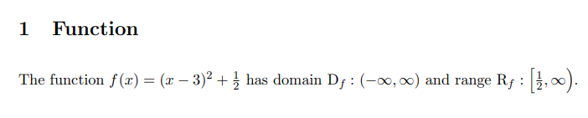

\section{Limit}

$\lim**\limits**_{x \to a} f(x)$\\

*% “_limit” command takes the subscript and superscripts at exact bottom and top of the word, not at the right bottom and right top.*

$\~~lim_{x~~ \to a} f(x)$\\

*% This is not correct. We need ‘\limits’*.

$\lim\limits_{x \to a^+} f(x)$\\

*%right hand limit.*

$\lim\limits_{x \to a^+} \frac{f(x)-f(a)}{x-a}=f'(a)$\\

$\displaystyle{\lim\limits_{x \to a^+} \frac{f(x)-f(a)}{x-a}=f'(a)}$\\

*% fraction looks bigger by \displaystyle.*

\vspace{1cm}

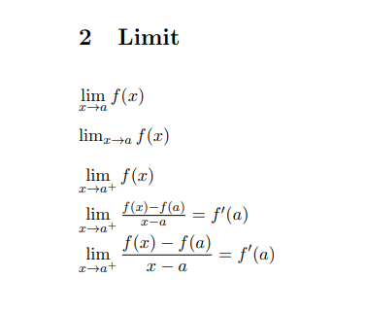

\section{Definite integral}

$~~\int_a^b~~$\\

*% but, a and b are at right side of integral symbol, not above and below. We need ‘\limits’.*

$\int**\limits**_a^b$\\

*% This is better looking.*

$\displaystyle{\int_a^b}$\\

$\displaystyle{\int\limits_a^b}$\\

*%\displaystyle elongates the integral symbol.*

$\displaystyle{\int\limits_2a^b}$\\

$\displaystyle{\int\limits_{2a}^{b+c}}$\\

*% When limits of the integral have more than one character, you should use the curly brackets.*

$\displaystyle{\int\limits_{2a}^{b+c}}x^2\,dx=\left[\frac{x^3}{3}\right]_{2a}^{b+c}=\frac{(b+c)^3}{3}-\frac{(2a)^3}{3}$\\

\vspace{1cm}

\pagebreak

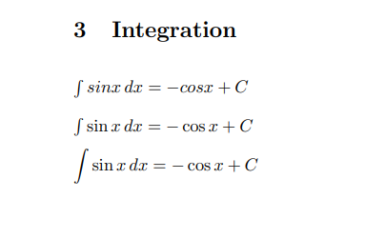

\section{Integration}

$\int ~~sin x\,~~dx=-cos x+C$ \\

*% sin is a trig function, not a variable. So, it should not be italicized*.

$\int **\sin x**\,dx=-\cos x+C$\\

*% this is the correct way.\, is used to give a space between sinx and dx.*

$\**displaystyle**{\int \sin x\,dx=-\cos x+C}$

*%\displaystyle elongates the integral symbol*.

\vspace{1cm}

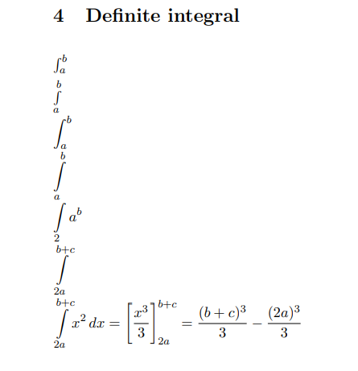

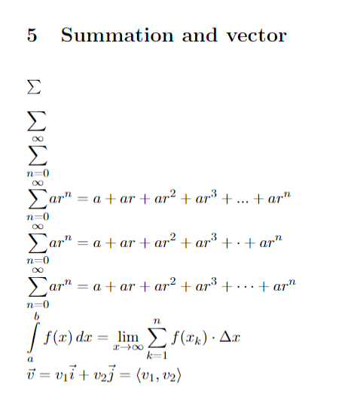

\section{Summations}

$\sum$\\

$\displaystyle{\sum}$\\

$\displaystyle{\sum\limits_{n=0}^{\infty}}$\\

*% You may choose the below ways to write 3 dots:*

$\displaystyle{\sum\limits_{n=0}^{\infty}}ar^n=a+ar+ar^2+ar^3+...+ar^n$\\

$\displaystyle{\sum\limits_{n=0}^{\infty}}ar^n=a+ar+ar^2+ar^3+**\cdot**+ar^n$\\

$\displaystyle{\sum\limits_{n=0}^{\infty}}ar^n=a+ar+ar^2+ar^3**+\cdots**+ar^n$\\

*% \cdot returns only one dot{.}; \cdots returns 3 %dots{...}*

$\displaystyle{\int\limits_a^bf(x)\,dx=\lim\limits_{x\to \infty}\sum\limits_{k=1}^nf(x_k)\cdot\Delta x}$\\

$\**vec{v**}=v_1\vec{i}+v_2\vec{j}=\langle v_1, v_2 \rangle$.

*% This is the command to write* ***vector****. \langle and \rangle returns angular bracket.*

\end{document}

## TUTORIAL_10

## HOW TO FORMAT A MATH PAPER?

**Some notes:**

*# In LaTeX, "1ex" and "1em" are units of measurement used to specify lengths. These units are relative and are based on the current font size. "1ex" represents the height of the lowercase letter "x" in the current font. It is typically used to define vertical lengths or spacings relative to the font size. "1em" represents the width of the capital letter "M" in the current font. It is often used to define horizontal lengths or spacings relative to the font size.*

\documentclass[11pt]{article}

\usepackage[margin=1in]{geometry}

\usepackage{amsfonts,amsmath,amssymb}

\usepackage**[none]{hyphenat}**

*% This package Prevents Latex of using hyphenated words. If the word is too large, it will go into the right margin. But, will never use hyphen.*

\usepackage{graphicx}

\usepackage{float}

*% For pictures and tables, {graphicx},{float} these two packages are required.*

\usepackage{**fancyhdr}**

*% This package will allow me to create custom header and footer.*

**\usepackage[nottoc,notlot,notlof]{tocbibind}**

*%This is a common command used in LaTeX to customize the table of contents (TOC)."nottoc": This option removes the "Table of Contents" entry from the TOC itself. "notlot": This option excludes the list of tables from the TOC."notlof": This option excludes the list of figures from the TOC.*

\pagestyle{fancy}

\fancyhead[]{}

\fancyfoot[]{}

*% These will show the default header and footer. Using “\fancyhead[]{}” and “fancyfoot[]{}”,page number at the bottom got vanished.*

\fancyhead[l]{**\slshape**\MakeUppercase{place title here}}

*% At the left side of the header, 'place title here' was written in italics and uppercase.*

\fancyhead[r]{\slshape Student Name}

*% shows the student name at the right side of the header.*

\fancyfoot[c]{\thepage}

*%Shows the page number at the center of the footer.*

*% In \fancyhead[l],\fancyhead[r] and \fancyfoot[c]; l,r,c can be capital letter also i.e.\fancyhead[L],\fancyhead[R] and \fancyfoot[C].*

\renewcommand{\headrulewidth}{5pt}

\renewcommand{\footrulewidth}{1pt}

*% You can customize the thickness of the lines of header and footer (i.e.top and bottom margins).*

**\parindent 0ex**

*%\"setlength{\parindent}{4em}" ---> this command gives 4 unit indention of a new paragraph. But, here we are not using it. because, we want 0 indent. I think, "\parindent 4ex" command also do the same!!*

\setlength**{\parskip**}{2em}

*% Spacing between the paragraphs.*

\renewcommand{\baselinestretch}{1.5}

*% Spacing between the lines of a paragraph.*

\begin{document}

\begin{titlepage}

\begin{center}

\vspace*{5cm}

*% Makes a vertical space of 5 cm from the top of the paper and then the first line starts.*

\Large{\textbf{IB MATHEMATICS SL}}\\

\Large{\textbf{Internal Assesment}}\\

\vfill

*% \vfill means vertical fill; which will automatically fill the amout of space between the items. The line after '\vfill' command will start from the bottom of the page.If any other '\vfill' command is added further, then that one will go to bottom and previous one will go up.*

\line(1,0){400}\\[10mm]

*%This command draw a straight line having slope=(0/1)=0 and length= 400 mm.'[10mm]' means the vertical spacing between this line and the next thing is 10 mm.*

\huge{\textbf{This is a sample title}}\\[5mm]

\large{\textbf{-This is a sample subtitle-}}\\[0pt]

\line(1,0){400}\\

\vfill

By student name\\

Candidate\#\\

\today\\

\end{center}

\end{titlepage}

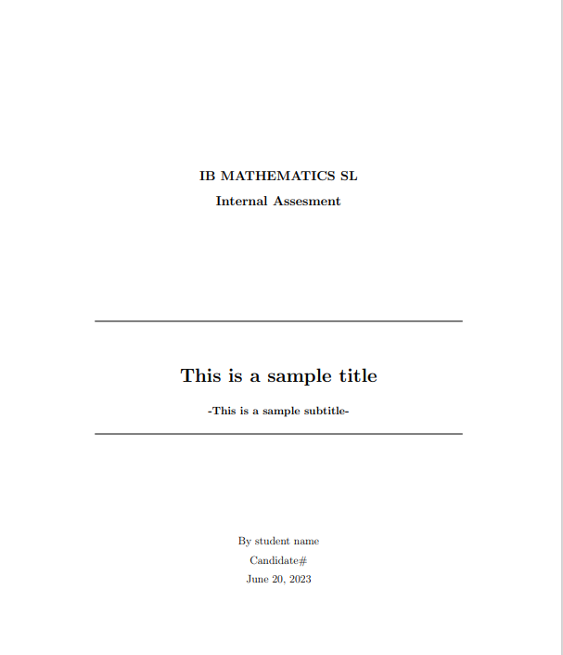

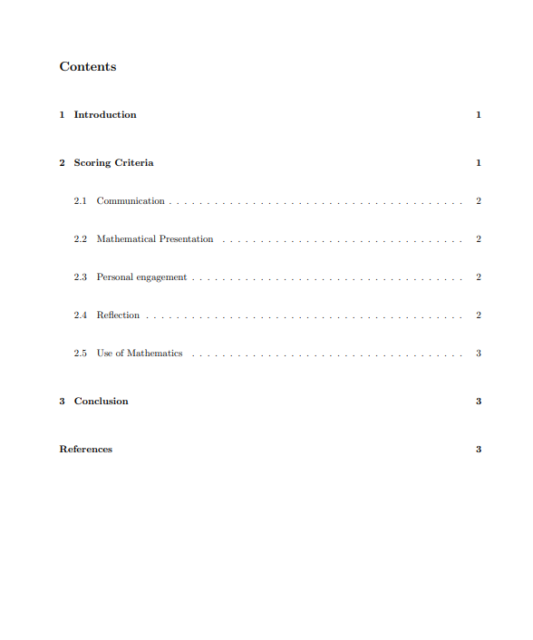

\tableofcontents

\thispagestyle{empty}

*%this comand will remove header and footer from this page.*

\clearpage

*%'\clearpage' command will not allow any text to enter this page other than 'table of content'.*

\setcounter{page}{1}

*% By use of this command, page numbering will start from the next page of table of content.*

\section{Introduction}

IVP and IBVP are types of initial value problems and boundary value problems, respectively, in the field of differential equations.

\textbf{Here is the use of the command "parindent 0ex" used in preamble}. That command will ensure zero paragraph indention i.e. all the paragraphs are flush left**.\footnote{An example footnote}**

*%this command adds a footnote.*

**\verb|\setlength{\parskip}{1em}}|** this command determines what will be the spacing between the paragraphs. Here, it's 1 unit.

*%"\verb|'command'|" --->in this way, we can write a command as it is (i.e. as a text, not as an code output).*

\section{Scoring Criteria}

In a steady-state problem, the goal is to determine the distribution of hydraulic head (pressure) in the aquifer under a given set of conditions.

\begin{figure}**[H]**

*% This 'H' is a float option, which takes the flower at the proper position of the code.*

\begin{center}

\includegraphics[width=0.25\textwidth]{flower}

\caption{A beautiful flower}

\**label{fig:flower}**

\end{center}

\end{figure}

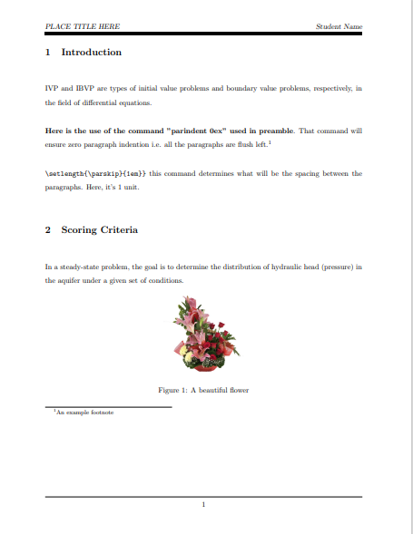

\subsection{Communication}

Typically, this involves solving the groundwater flow equation using numerical methods, such as the finite difference or finite element method.

\subsection{Mathematical Presentation}

The condition is a logical expression that is evaluated at the beginning of each iteration of the loop. If it evaluates to true, the statements inside the loop are executed.

\subsection{Personal engagement}

This continues until the condition becomes false, at which point the loop terminates and program control moves to the next statement after the loop.

\subsection{Reflection}

where h is the water depth, u and v are the horizontal and vertical velocities, respectively, and x and y are the horizontal and vertical coordinates, respectively.

\pagebreak

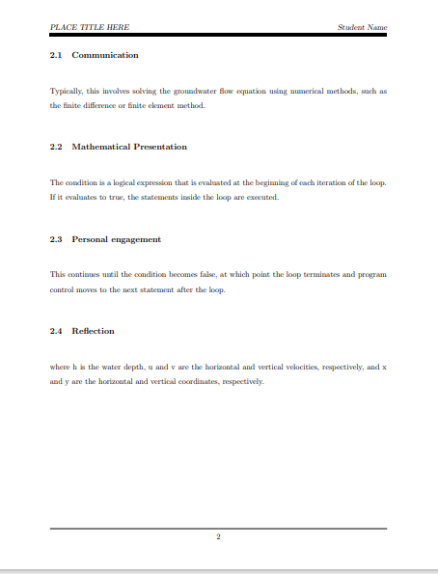

\subsection{Use of Mathematics}

This equation states that the rate of change of the product of water depth and horizontal velocity with time is balanced by the horizontal and vertical fluxes of this product. asdbfhfedbnbssbnbsdsbdnsbddbdhhbbnjasejjdkjmadjddtayagsdfndkxhwshsgsgsgfa

*% Here, you can see the effect of the package "\usepackage[none]{hyphenat}".*

\vspace{1cm}

\begin{table}[H]

\centering

\def\arraystretch{1.5}

\begin{tabular}{|c||c|c|c|c|c|}

\hline

$x$&1&2&3&4&5\\\hline

$f(x)$ &10& $\frac{1}{2}$ &12&13&14\\\hline

\end{tabular}

\caption{These values represent the function $f(x)$.}

**\label{tab:data1}**

*% Now, this table has been assigned as* ***"{tab:data1}"*** *this label. You can call this table anywhere in this document using* ***"\ref{tab:data1}"*** *command.*

\end{table}

\section{Conclusion}

All these things are random texts copied from different documents. see table **\ref{tab:data1}.** See figure **\ref{fig:flower}.**

*% labelling a figure as "\label{fig:flower}" and calling that as "\ref{fig:flower}". In code, we typed "See figure \ref{fig:flower}" and we got output as "See figure 1". If the figure number changes anyhow (let 'x'), it will show the output as "see figure x".*

See the reference to know more about Jadavpur University **\cite{JU}**

*% For citing a reference, we need to write "\cite{'name or label that I assigned to that citation}. And as output, it will show the number as per the list of references.*

\pagebreak

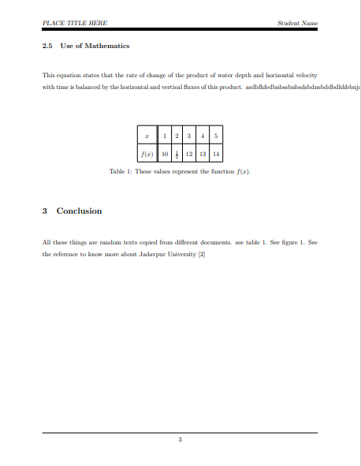

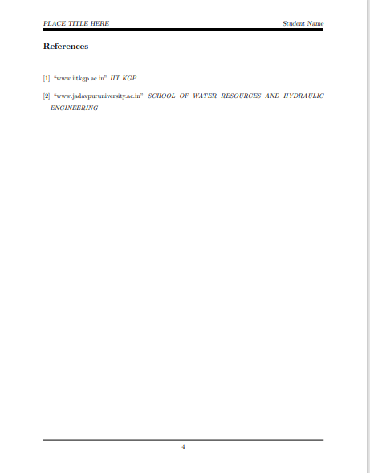

\begin{**thebibliography**}{}

\bibitem{IIT Kharagpur}

``www.iitkgp.ac.in"

**\textit{IIT KGP}**

\bibitem{JU}

*% Here, “JU” is the name or label assigned to the citation.*

``www.jadavpuruniversity.ac.in"

\textit{SCHOOL OF WATER RESOURCES AND HYDRAULIC ENGINEERING}

\end{thebibliography}

\end{document}

## Tutorial 11

## Beamer presentation

\documentclass{beamer}

\usepackage[none]{hyphenat}

\usepackage**{multicol}**

*% THis 'multicol' package will help to divide the items of a list in multiple columns.*

*%\usetheme{Warsaw}*

\usetheme[**progressbar=frametitle]**{metropolis}

*% It means, the 'progressbar'(nothing but an underline) will be there below the title of the frame.?!*

*% "Warsaw" and "Metropolis" are some of the predetermined themes which determines the formatting of the pages.*

*%Using 'Warsaw' theme, you can see the author name at the left bottom and title name of the right bottom of each page.Teacher likes "metropolis" theme.*

**\setbeamertemplate{frame numbering}[fraction]**

*% frame numbering is displayed as fraction.i.e. "page no/Total page"*

\useoutertheme{metropolis}

\useinnertheme{metropolis}

\usefonttheme{metropolis}

\usecolortheme**{spruce}**

\setbeamercolor{background canvas}{bg=white}

\definecolor**{mygreen}{rgb}{0.125,0.5,0.25}**

\usecolortheme[named=mygreen]{structure}

*%"\definecolor{mygreen}{rgb}{0.125,0.5,0.25} \usecolortheme[named=mygreen]{structure}" this command is used to get a customed color theme."{0.125,0.5,0.25}" is called 'RGB code', which is different for different colours. We can get this code from internet.*

*%\usecolortheme{crane}---> These types of standard colortheme can be used also.*

*% Used to change the colour theme of the whole presentation. Though, the style theme is yet ‘metropolis’.*

\title**[short title]{**Your title here}

*%If the title is too long, you can use "\title[short title]{Your title here}" in place of "\title{Your title here}". Then it will show the short title at the right bottom of each page.--->This statement is applicable if you use 'Warsaw' theme, not for 'metropolis' theme. In ‘metropolis’ theme, there is no ‘short title’ or ‘Author’s name’ in footer.*

\subtitle{subtitle here}

\author{Sayak Karmakar}

\institute{**\\[6pt]**property of elementary functions}

*% \\[6pt] means the vertical spacing between the lines. 1pt = 1/72 inch.*

\date{}

\**setbeamercovered{transparent=15}**

*%using this command, you can change the level of transparency of texts which are in between onslide command. Eg. "onslide<2->{texts}. Teacher prefers transparent=5.*

**\metroset{block=fill}**

*%This command fills the block of slide 3 with a specific color scheme.*

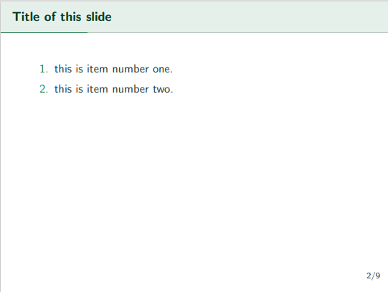

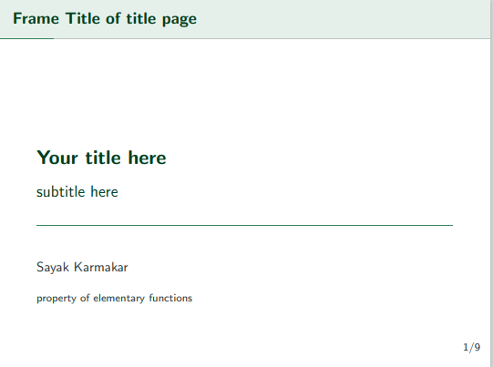

**\begin{frame}[t]{Title of this slide}\vspace{10pt}**

*%[t] means, the contents of this page will start from 10 pt from the top.*

\begin{enumerate}

\item this is item number one.

\item this is item number two.

\end{enumerate}

\end{frame}

\begin{document}

\begin{frame}{Frame Title of title page}

*% In Beamer, all the informations are hold in frame.*

\titlepage

*% For information regarding the title page, see the previous page.*

\end{frame}

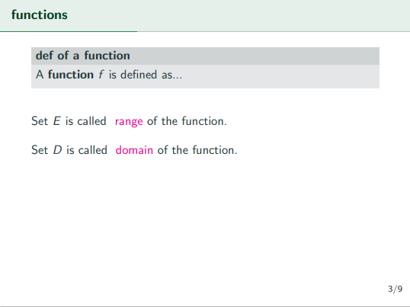

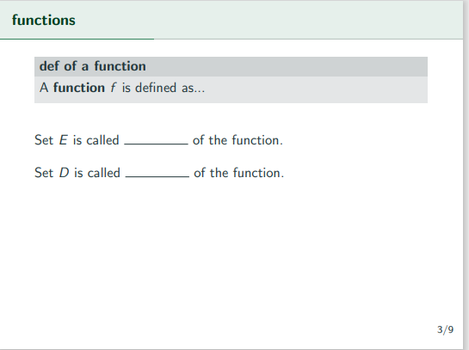

\begin{frame}[t]{functions}\vspace{4pt}

\begin{block}{def of a function}

A \textbf{function} $f$ is defined as...

\vspace{0.5em}

\end{block}

\vspace{10pt}

Set $E$ is called

\only<1>{\line(1,0){50}}

\only<2>{\textcolor{magenta}{range}}

of the function.\\[10pt]

Set $D$ is called

\only<1>{\line(1,0){50}}

\only<2>**{\textcolor{magenta}{domain}}**

of the function.\\[10pt]

*% "\line(1,0){50}" creats a line with slope=0/1=0 and length 50 unit.*

*% "\only<1>{contents}" command shows the contents (within curly bracket) at the 1st page."\only<2>{contents}" command shows the contents at the next page. There will be 2 slides but, their page numbering will be same; because we are generating two slides within one frame and number of a page is ‘frame number’, not ‘slide number’. (see both are 3/9).*

\end{frame}

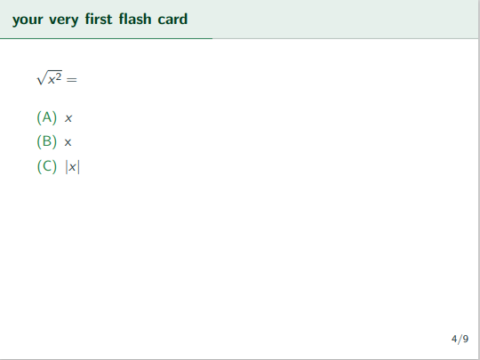

\begin{frame}[t]{your very first flash card}\vspace{10pt}

*% A new frame starts 10 pt space from the top of the page.*

$\sqrt{x^2}=$\\[10pt]

\begin{enumerate}**[(A)]**

*% This command makes the list numbering as A,B....instead of some default numbering.*

\item $x$

\item x

\item $|x|$

\end{enumerate}

\end{frame}

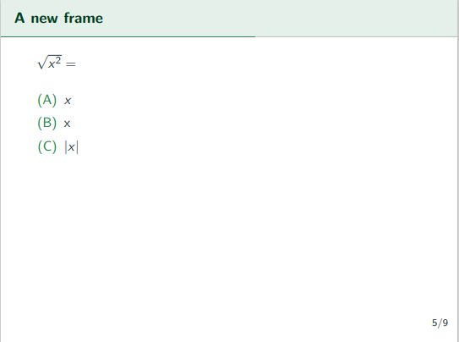

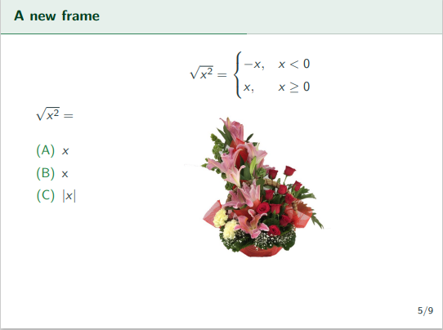

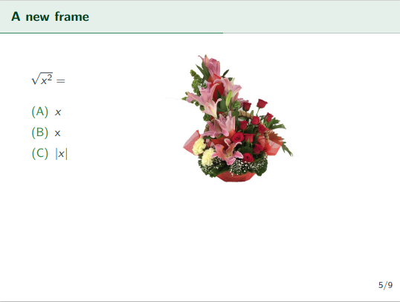

\begin{frame}[t]{A new frame}\vspace{10pt}

\begin{columns}[**onlytextwidth]**

*% "[onlytextwidth]" command helps to keep the column within the margin .*

\column{**0.4\textwidth**}

*% Defines width of 1st column as a fraction of total textwidth.*

$\sqrt{x^2}=$\\[10pt]

\begin{enumerate}[(A)]

\item $x$

\item x

\item $|x|$

\end{enumerate}

\column{0.6\textwidth}

**\only<3>{**

$\sqrt{x^2}=$

\begin{cases}

*% Required to show domain specific expression of a function.*

-x,& x<0\\

x,& x\geq 0

\end{cases}\\[10pt]**}**

**\only<2->{**

\includegraphics[scale=0.2]{flower}**}**

*% "\only<2->" means, 'the texts' within its curly bracket will be shown at 2nd slide and afterwards of this particular frame.*

\end{columns}

\end{frame}

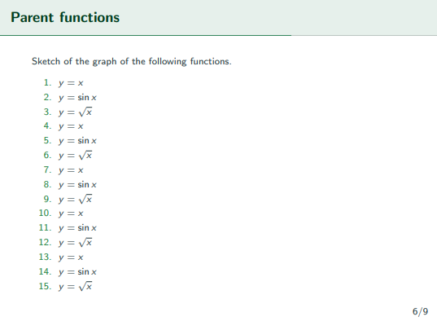

\begin{frame}[t]{Parent functions}\vspace{4pt}**\scriptsize**

Sketch of the graph of the following functions.

\begin{enumerate}

\item $y=x$

\item $y=\sin x$

\item $y=\sqrt{x}$

\item $y=x$

\item $y=\sin x$

\item $y=\sqrt{x}$

\item $y=x$

\item $y=\sin x$

\item $y=\sqrt{x}$

\item $y=x$

\item $y=\sin x$

\item $y=\sqrt{x}$

\item $y=x$

\item $y=\sin x$

\item $y=\sqrt{x}$

\end{enumerate}

*% There are a lot of items in this frame. So, it is not easy to accomodate all these items in one slide. For that, you may reduce the fontsize at \begin{frame} (i.e."\begin{frame}[t]{Parent functions}\vspace{4pt}\scriptsize" command). But, letter looks too* ***small****. So, we adopt another way to show these in 3 columns. (see next page).*

\end{frame}

\begin{frame}[t]{Parent functions}\vspace{4pt}

Sketch of the graph of the following functions.

\begin{enumerate}

**\begin{multicols}{3}**

\item $y=x$

\item $y=\sin x$

\item $y=\sqrt{x}$

\item $y=x$

\item $y=\sin x$

\item $y=\sqrt{x}$

\item $y=x$

\item $y=\sin x$

\item $y=\sqrt{x}$

\item $y=x$

\item $y=\sin x$

\item $y=\sqrt{x}$

\item $y=x$

\item $y=\sin x$

\item $y=\sqrt{x}$

\end{multicols}

\end{enumerate}

*% Now we are able to show all the items in multiple columns preserving the normal font size.*

\end{frame}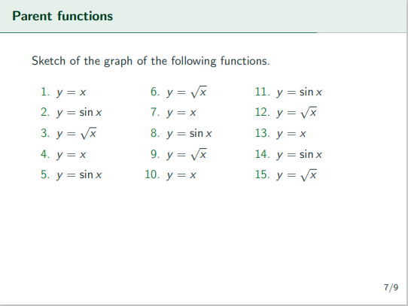



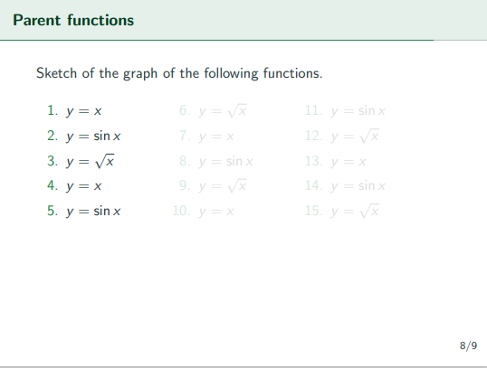

\begin{frame}[t]{Parent functions}\vspace{4pt}

Sketch of the graph of the following functions.

\begin{enumerate}

\begin{multicols}{3}

\item $y=x$

\item $y=\sin x$

\item $y=\sqrt{x}$

\item $y=x$

\item $y=\sin x$

**\onslide<2->{**\item $y=\sqrt{x}$

\item $y=x$

\item $y=\sin x$

\item $y=\sqrt{x}$

\item $y=x$**}**

**\onslide<3->{**\item $y=\sin x$

\item $y=\sqrt{x}$

\item $y=x$

\item $y=\sin x$

\item $y=\sqrt{x}$**}**

\end{multicols}

\end{enumerate}

*% "\onslide" divides the frame into multiple slides; disappears some portions and show in the next pages. works almost similar to "\only" command. But, here the major advantage is '\only' can chnge the place of items in differnt slides. But'\onslide' will keep them in the fixed place.*

\end{frame}

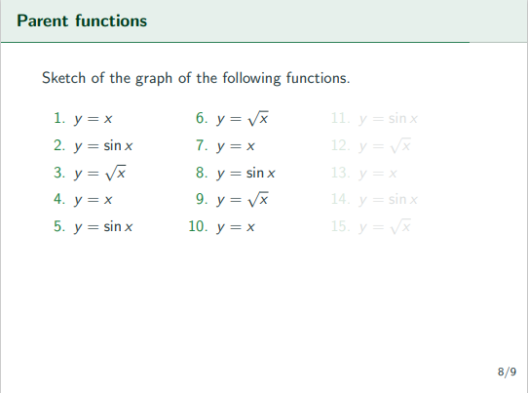

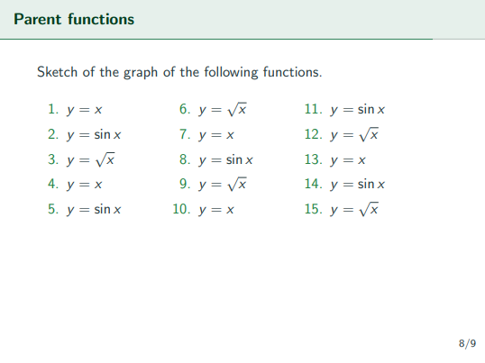

\begin{frame}{standout}

\flushleft\textbf{\huge{THANK YOU}}

\end{frame}

\end{document}



# MATLAB

# TUTORIAL

## %% BUILDING ARRAYS

a=[1,2,5]%row vector

b=[1;2;5] %column vector

c=eye(3) %gives an identity matrix

D=[a;c]%first row column a and others of matrix c

%E=[a,c] % array having 1 row combining with matrix with 3 row.

% which shows an error. this is called eeror due to HORIZONTAL CATENIATION.

E=[b,c] %same no of rows for b and c. so executed.

a' %to get TRANSPOSE

F=[a',c] % 3*1 array is horizontally catenated with 3*3 array

F(2,1) %to get the element of F row no 2 column no 1

%F(5,5) matrix dimension exceeds.@error

size(F) % gives row and column number of martix

%% COLON NOTATION TO GET ELEMENT, SUB VECTORS, SUB MATRICES IN AN PARTICULAR

% ARRAY

z=1:5 %matlab creates a row vector, not colum

y=[1:3:5] %increment is 3. 1st element 1, 2nd is 1+3=4. 3rd may be 7, not

% possible

y=[2:1] %gives empty vector

y=[]% empty matrix

F(2,2:3) %to get 2nd row and column number 2 and 3 of F matrix

F(2:3,2) % to get row number 2 and 3 and column number 2

p=3;q=3

F(p,q) %to get a particular element

p=[1,2];

F(p,q) %row no 1 and 2 and column 3

F(1:2,3:4)%row no 1 and 2 and column 3 and 4

%% ARRAY OPERATIONS

x=zeros(2,1) % creates an array having 2*1 all element 0

ones(2,4) %elements are 1

a*b % matrix multiplied

% a^2 % squae can be done only for square matrix

d=[1,0;2,1]

exp(d)

expm(d)

%exp(d) gives element by element exponent but expm(d) gives matrix

%exponent.both are different.

sum(a)

%sum of all elements (value)

cumsum(a)

%Cumulative sum of all elements (vector)

prod(a)

cumprod(a)

% gives product

a=[1 2;3 1]

a*a %normal matrix multiplication

a.*a %each element is multiplied with itself

a.^2 %each element is being squared

**%%** LECTURE 3: USING ARRAYS **(see page 1-15)**

%markslist

allmarks=[24 44 36;52 57 68;66 53 69;85 40 86;15 47 25;79 72 82];% contains

% marks of three subjects only

mechmarks=[36 76 73 72 28 91];

allmarks=[allmarks,mechmarks']%contains all four subjects

mechmarks=mechmarks*0.5 %sclaler multiplication with a vector

allmarks(:,4)=mechmarks'

% (: MEANS COLUMN 4 OF ALLMARKS WAS REPLACED BY MECHMARKS')

%% EXTRACTION OF CHETANS MARKS

chatanmarks=allmarks(3,1:4)

chatanmarks=allmarks(3,:)

%two lines have same output

sum(chatanmarks)

%% TO GET MARKS OF THREE SUBJECTS OF DEEPAK AND FARAH.

allmarks([4,6],1:3)

%% two get marks of 1st and 3rd subjects of Bhavna and alizabeth

allmarks([2,5],[1,3])

%% avg marks in each of the four courses

mean(allmarks,1)

% For matrices, mean(matrix,1) is ROW VECTOR CONTAINING THE MEAN VALUE

% OF EACH

% COLUMN.

%% average marks of each student

mean(allmarks,2)

% For matrices, mean(matrix,2) is column VECTOR CONTAINING THE MEAN

% VALUE OF EACH

% row.

%% avg of chetans marks

mean(chatanmarks)

% mean(X) is the mean value of the elements in X

% if X is a vector, not a matrix

%%

sum(allmarks,1)

% output is a row vector.sums marks of each column

sum(allmarks,2)

% output a column vector.sums marks of each row

%% to assign marks in 10 scale

%1st 3 subjects in 100 and last one is in 50. 1st 3 subjects are multiplied

%with 0.1 and last one with 0.2

diag([0.1,0.1,0.1,0.2])%BRACKETS ARE NECESSARY.WITHIN CIRCULR BRACKET THERE

%IS A SQUARE BRACKET. A VECTOR. BUT output is A DIAGONAL MATRIX.

allmarks * diag([0.1,0.1,0.1,0.2])

scalemarks=allmarks * diag([0.1,0.1,0.1,0.2]) %command to store 10 scale

%marks

%% Fibonnacci series using for loop

%any nth element of the fibonacci series is the sum of (n-1) th and (n-2)

% element of that series

n=10;

fibo=[1,1]; %to start the series

for i=3:n

fibo(i)=fibo(i-1)+fibo(i-2);

end

%% Fibonnacci series using while loop

fibo=[1,1]; %to start the series

while (fibo(end)<200)

fibonew=fibo(end)+fibo(end-1);

fibo=[fibo,fibonew];

end

fibo(end)=[];

%fibo=fibo(1:end-1);

% YOU MAY USE THIS COMMAND ALSO FOR PREVIOUS LINE

%ouput has a term 233. it comes because the loop was repeated

%again when the last term was already come. so the last term to be

%nullified

%% (page 1-16) location of a ballthrown upward is given by, y=v0t-0.5gt2. Calculation the location of the ballfor every 0.1 seconds untill it reaches the ground(i.e y>0)

%Display location of the ball vertically at every 0.1 sec

v0=20;

g=9.8;

y=0;

t=0;

while(y>=0)

t=t+0.1;

y=v0*t-g*t^2/2;

disp(['at t=', num2str(t),'location=', num2str(y)])

%num2str(A) converts a numeric array into a character array that

% represents the numbers.

end

%% calculate factorial of 6 using script

% It is a script because it doesnot start with a function call

n=6;

factvalue=1;

for i=1:6

factvalue=factvalue*i;

end

%% another way to do the same

n=6;

factvalue=prod(1:6);

%% Write a function to calculate f=C0+C1x+C2x^2+....+Cnx^n C0=1, where Cm=1/m

%% Write a function to calculate f=C0+C1x+C2x^2+....+Cnx^n C0=1, where Cm=1/m ????????

function result=myFunc(n,x,c,a)

c=[1];

vec=[1:n];

c=[c,1./vec]; %1./vec is a vector which has that operation in each

% element. Horizontal cateniation has been done here.

a=[1, x.^vec];

result=sum(c.*a);

%result=myFunc(n,x)

end %end id optional for function.

%% CONSIDER THE EXAMPLE OF AB= BALL THROWN VERTICALLY UPWARD. PLOT

% %LOCATION VS TIME

% LABELING THE AXES

% OTHER PLOTTING OPTIONS

% PLOTTING MULTIPLE LINES

% LOG-LOG PLOT

%% help plot

% plot(X,Y) plots vector Y versus vector X. If X or Y is a matrix,

% then the vector is plotted versus the rows or columns of the matrix,

% whichever line up.

%% (page 1-16) location of a ballthrown upward is given by, y=v0t-0.5gt2. Calculation the location of the ballfor every 0.1 seconds untill it reaches the ground(i.e y>0)

%Display location of the ball vertically at every 0.1 sec

v0=20;

g=9.8;

y=0;

t=0;

time=0;

location=0;

while(y>=0)

t=t+0.1;

y=v0*t-g*t^2/2;

disp(['at t=', num2str(t),'location=', num2str(y)])

%num2str(A) converts a numeric array into a character array that

% represents the numbers.

time=[time;t]

%at each time the while loop runs, the time t is going to be catenated

%to this vector time.

location=[location;y]

end

plot(time, location); %GRAPH PLOTTING FOR TWO DIFFERENT ROW MATRICES

xlabel('time (s)');

ylabel('location (s)');

% commands to label the axes.

plot(time,location, '-bo') %To plot points as circle

plot(time,location, '-.g') %To plot points as green colour

plot(time,location, '--r') %To plot points as red coluer

%% to put multiple things on the same plot

x=[0:0.1:5];

plot(x,sin(x),'-b',x,cos(x),'--r')

%plots y=sin(x) in blue colour and

%y=cosx in red colour in a single graph

%% Another way to put multiple things on the same plot

x=[0:0.1:5]; %Row matrix with 51 columns

y=[sin(x);cos(x)];

size(y) % => ans =2 51

% X matrix is row matrix and Y matrix of 2 rows and 51 columns.

plot(x,y) %Provides two curves simultaneously

%% Another graph

x=[0:0.1:5];

plot (x,sin(x)+cos(x),'-bo')

hold on

% hold ON holds the current plot and all axis properties, including

% the current color and linestyle, so that subsequent graphing commands

% add to the existing graph without resetting the color and linestyle.

plot(x,y)

%% plot log log

help plot

loglog(x,y) %Warning: Negative data ignored

%% Maclaurin series for exp(0.1)

% where e^a=1+a+a^2/2!+a^3/3!+a^4/4!+.....(SEE Page 1-17)

n=5;

a=0.1;

expval=1.0; % Initializing the value of the series

currentterm=1.0;

for i=1:n

currentterm=currentterm*a/i;

% 1st term

expval=expval+ currentterm;

end

trueval=exp(0.1);

err=abs(trueval-expval);

%% another way (Where expval and trueval are 1*6 vectors)

n=5;

a=0.1;

expval=1.0; % Initializing the value of the series

currentterm=1.0;

for i=1:n

currentterm=currentterm*a/i;

% 1st term

expval(i+1)=expval(i)+ currentterm;

end

trueval=exp(0.1);

err=abs(trueval-expval);

% err =

% 0.1052 0.0052 0.0002 0.0000 0.0000 0.0000

% While we calculating error trueval is a scaler and expval is a vector. If

% we subtract a scaler from a vector or a vector from a scaler, then there

% should not be much problem.resulting will be itself a vector.

eps

% gives the machine precisiom in Matlab. It has value as 2^-52.because,

% double precision real number that matlab uses 52 bit mantesa

%% To check the precision of matlab

2^-19

b=1+2^-19

b-1

% here b-1 does not give zero result

2^-53

a=1+2^-53

a-1

%here a-1 gives result=0. so our least count or machine precision of Matlab

%is 2^-53 or 2.2204*10^-16

# LINUX TUTORIALS (Code with Harry)

***#Unix is the foundation is linux.***

***Two types of interfaces are there. Command line interface and Graphical user interface. GUI is useful for task managering and system manager.***

**sayak@ubuntu:~$ ls *#ls command lists the diredtory contents.***

**Desktop Downloads Pictures snap Videos**

**Documents Music Public Templates**

**sayak@ubuntu:~$ pwd *#pwd means print working directory***

**/home/sayak**

***# In windows, we have different drives. But, in LINUX, we have tree structure of the files.***

**sayak@ubuntu:~$ cd / *# “/” is called the root node.***

**sayak@ubuntu:/$ ls**

**bin dev lib libx32 mnt root snap sys var**

**boot etc lib32 lost+found opt run srv tmp**

**cdrom home lib64 media proc sbin swapfile usr #*Bin, dev , lib libx32 are also some of the nodes within the root nodes. They may be some files, directories etc.***

***# pwd shows the parents of the current diredtory and ‘ls’ represents the childrens of the current directory.***

[**sayak@ubuntu**](mailto:sayak@ubuntu)**:/$ *#Here, sayak is the name of the user. And ubuntu is the name of the virtual box machine. ‘$’ sign means I am a regular user. ‘/’ means I am in the ‘/’ or root directory.***

***s*ayak@ubuntu:/$ cd bin *# If we click ‘cd bin’ then the next line comes. Means we are in the bin directory now.***

**sayak@ubuntu:/bin$**

***# If you write ‘cd bin’ it represents the relative path and ‘cd\bin’ it represent s the absolute path. So, cd<some directory name>’ takes you to that certain directory. Then if you write ‘ls’ it will print all the files under that directory only.***

**sayak@ubuntu:/bin$ cd .. *# If you write ‘cd ..’ command, it will take you back shown as below.***

**sayak@ubuntu:~$ cd Downloads/**

**sayak@ubuntu:~/Downloads$ *#If we press tab after entering ‘Dow..’ it will auto-complete the directory ‘Downloads’.***

**sayak@ubuntu:~$ cd harry**

**sayak@ubuntu:~/harry$ mkdir this**

***# using these commands, we can go to ‘harry’ directory and can make ‘this’ named folder within ‘harry’ directory.***

**sayak@ubuntu:~/harry$ pwd**

**/home/sayak/harry**

***# to know the absolute path of something, we need “pwd” command.***

**sayak@ubuntu:~/harry$ touch 1.txt**

**sayak@ubuntu:~/harry$ touch 2.txt  *# ‘touch’ command makes two empty files named ‘1.txt’ &‘2.txt’ within ‘harry’ directory.***

**sayak@ubuntu:~/harry$ mv 1.txt this/  *# ‘mv’ command moves ‘1.txt’ file in ‘this’ named directory.***

**sayak@ubuntu:~/harry$ cp 2.txt this/  *# ‘cp’ command copies ‘2.txt’ file in ‘this’ named directory.***

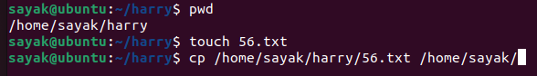***# By doing this, we can check the current directory. Then creating a new blank file in that (56.txt). we can copy that file after providing the full path where it is located (/home/sayak/harry/56.txt) and then providing the path where it is need to be copied (/home/sayak/).***

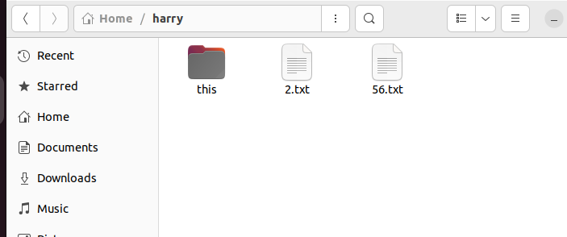***After creating file:***

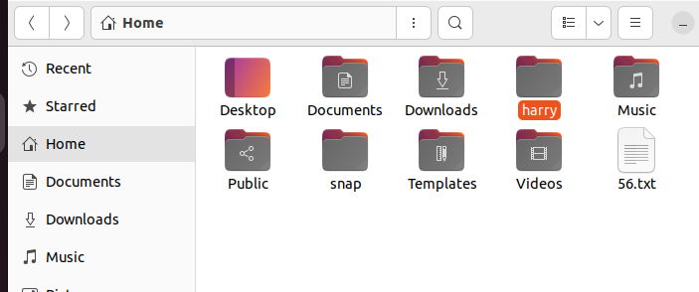***After moving in the desired location:***

## Users in Linux:

**1. Regular user -> Cannot see to others home directory.**

**2. Root user or super user -> Can do anything to anyone’s home directory. Full access. Called admin.**

**If we write ‘sudo’ before any command, the system can identify you as a root user.**

**If we write ‘sudo su’ before any command, for all the works it will obey you as asuper user. But, it is not recommended. As it is very riskful.**

**3.Service user:**

## Absolute and Relative path:

/ root

Bin

etc

Apps

. . . .

F1 f01

F2 f02

**Let , our present working directory is f01. If we want to go to f02 , we just need to write ‘cd f02’. So we nned to write relative path only.**

**But , if we are in ‘Apps’ directory and need to go to ‘f01’, We should write the full path (i.e. cd /*bin/f01). It is called the absolute path.***

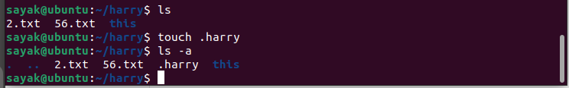***# If ‘.’ is present before a file name, it becomes a new hidden file. To include the hidden file in the list, ‘ls -a’ command is used.***

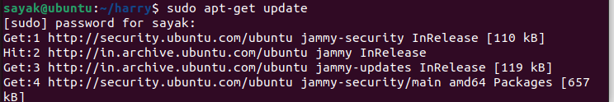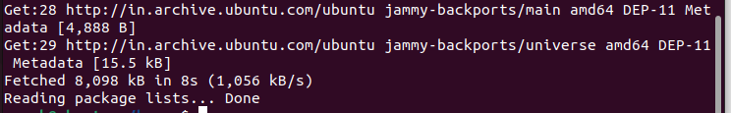***# ‘Sudo apt-get update’ this command makes the list of the softwares that are available to be updated.***

***# But, ‘Sudo apt-get upgrade’ this command installs all the upgraded versions of the softwares.***

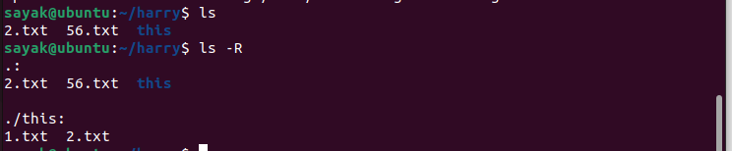***#Here , ‘ls’ lists the files and folders under the present directory. But, ‘ls -R’ lists the files and folders under the present directory and the all consecutive subdirectories also.***

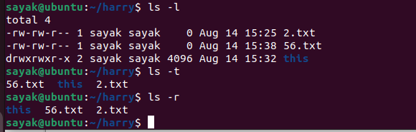***#ls -l. The -l option signifies the long list format. This shows a lot more information presented to the user than the standard command. You will see the file permissions (for user, for groups, for other public), the number of links, owner name, owner group, file size, time of last modification, and the file or directory name.***

***# ls -t. sort by time & date.***

***#The option "ls -r" lists all files and directories in reverse order. The files and directories are all arranged in reverse alphabetical order.***

**sayak@ubuntu:~/harry$ clear *# ‘clear’ command clears the terminal and make it to look fresh.***

**sayak@ubuntu:~/harry$ history *#Prints the history of all commands.***

**sayak@ubuntu:~/harry$ printf "This is a ball.\n"**

**This is a ball. *# This is the way to print a string.***

**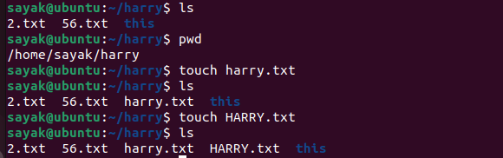*# In LINUX, file names are case sensitive. So, we can make two or more files with same name (word-cases are different) in a folder. But, we cannot do it in windows. But, this is confusing; so not recommended.***

**sayak@ubuntu:~/harry$ sudo apt install sanil  *# Command to install an app package named ‘snail’.***

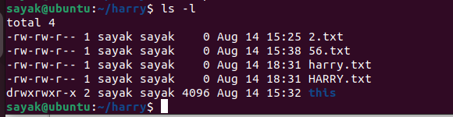***Here, drwx=> directory read write execute.***

***-rwe=> file read write execute.***

***# # To set permissions for owner, group and public we use Chmod calculator. ‘chmod’ is a command which changes the permissions of a file.***

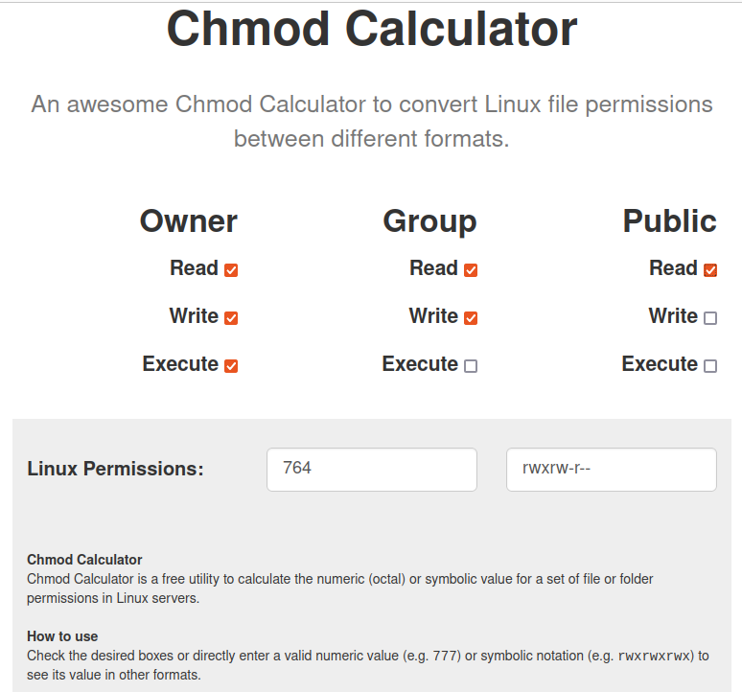***‘Chmod’ calculator works on the conversion of binary numbers of three groups(owner, group, public) to an octal number. Here, 111=7 {(111)₂ = (1 × 2²) + (1 × 2¹) + (1 × 2⁰) = (7)₁₀}, 110=6, 100=4. So, Linux permission is 764.***

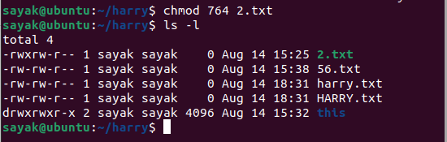***Here, the file permission of 2.txt file has been changed.***

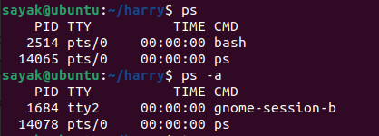

***# ‘ps’ command lists all the processes which are currently running. ‘ps -a’ lists all the background processes also.***

**sayak@ubuntu:~/harry$ top  *#This ‘top’ command shows which of the running processes takes most of the spaces as shown below.***

***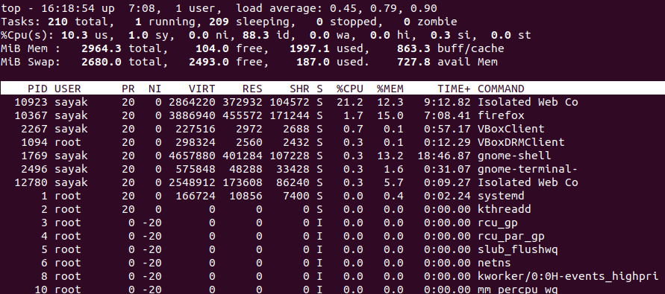*sayak@ubuntu:~/harry$ kill 10367  *#This ‘kill<space><PID>’ command closes any application. In this case, this command closes ‘firefox’ application.***

**Sayak@ubuntu:~/harry$ ls**

**2.txt 56.txt harry.txt HARRY.txt this**

**sayak@ubuntu:~/harry$ vim harry.txt  *# This command will open ‘harry.txt’ file in vim editor.***

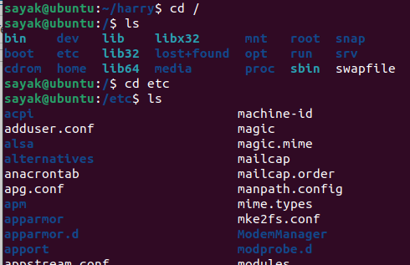***#This ‘cd<space><dir_name>’ command changes the current directory to a new directory named ‘dir_name’.***

**sayak@ubuntu:/etc$ cd ../**

**sayak@ubuntu:/$  *# ‘cd ../’ command takes us one step back.***

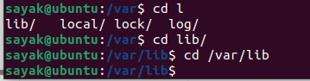

***# If we write ‘cd l’ and press ‘tab’ for two times, it will shows all the files in the current directory starting with ‘l’. Then we can choose any of these files. If we already know the full path of our desired file, we can write the full path ‘cd /var/lib’.***

[**sayak@ubuntu**](mailto:sayak@ubuntu)**:/$  *# ‘$’ sign means normal user.***

[***sayak@ubuntu***](mailto:sayak@ubuntu)**:/#  *# ‘#’ sign means super/root user.***

**sayak@ubuntu:~/harry$ mkdir Harry**

**sayak@ubuntu:~/harry$  *# This command makes a new sub-directory named ‘Harry’ in the current folder named ‘harry’.***

**sayak@ubuntu:~/harry$ rmdir Harry/**

**sayak@ubuntu:~/harry$ *#’rmdir’ commands removes of deletes the ‘Harry’ named subdirectory.***

**sayak@ubuntu:~/harry$ vim main.py  *# This command opens/creates a python file named ‘main.py’ in vim editor.***

**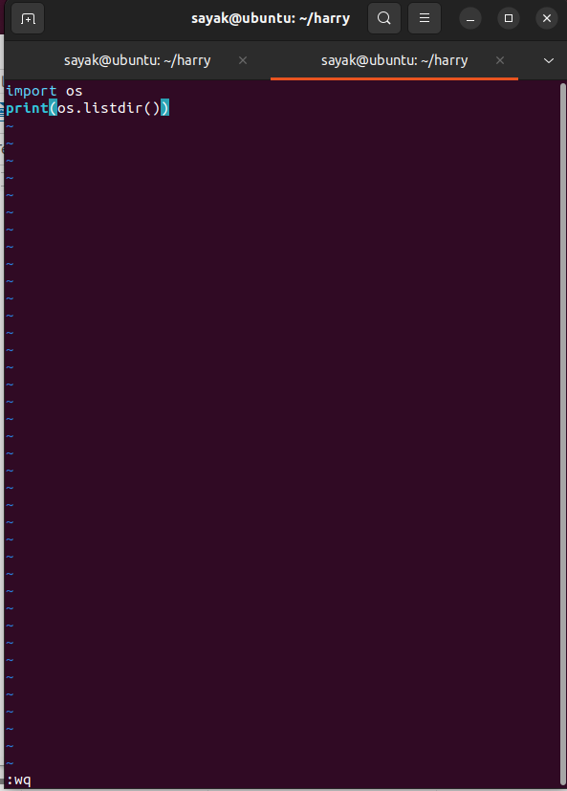*Then write the desired python code. After that, press ‘Esc’ and write ‘:wq’ to save and exit vim editor and go back to the terminal.***

***If we press ‘:q!’ , then it will exit without saving the file(Discard and exit). This is important if the file is somehow been corrupted while editing.***

**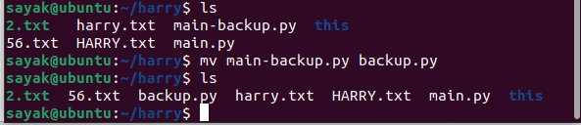*#This ‘mv main-backup.py backup.py’ command will move the file within the same folder. That means the file name should be just renamed from ‘main-backup.py’ to ‘backup.py’.***

**sayak@ubuntu:~/harry$ mkdir rohan**

**sayak@ubuntu:~/harry$ mv backup.py rohan/backup.py**

**sayak@ubuntu:~/harry$ cd rohan/**

**sayak@ubuntu:~/harry/rohan$ ls**

**backup.py**

***# Here, we made a directory named ‘rohan’ and moved ‘backup.py’ in that folder.***

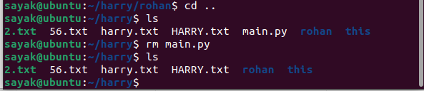***#‘rm’ command used to delete files, not the directories. Here, it removes ‘main.py’ from the folder named ‘rohan’.***

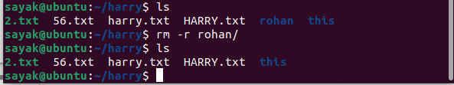***# Using ‘rm -r <directory name>/’ this command you can delete a folder or a directory.***

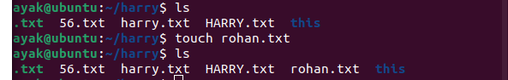***# Using ‘touch’ command you can make a new file.***

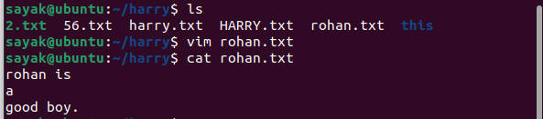***# Here we opened the file ‘rohan.txt’ in vim text editor and using ‘cat’ command we display its contents in the terminal.***

**sayak@ubuntu:~/harry$ man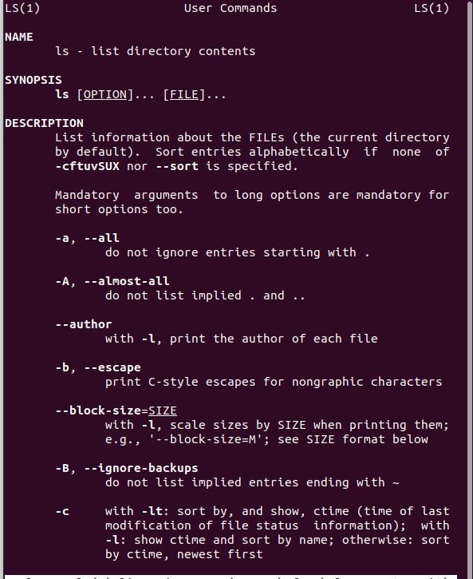 ls *#Using this ‘man’ command, you can open the manual which open all the details about a command. Just press ‘q’ to escape from the scrren and go back to the terminal.***

**sayak@ubuntu:~/harry$ htop  *# ‘htop’ is an interactive process between the viewer and system monitor. It displays cpu, monitor etc storage occupied. Press ‘q’ to escape the screen and return to the terminal. Shown below:***

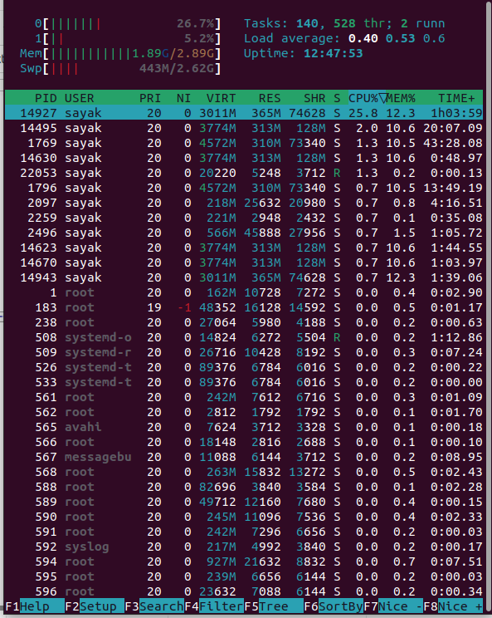

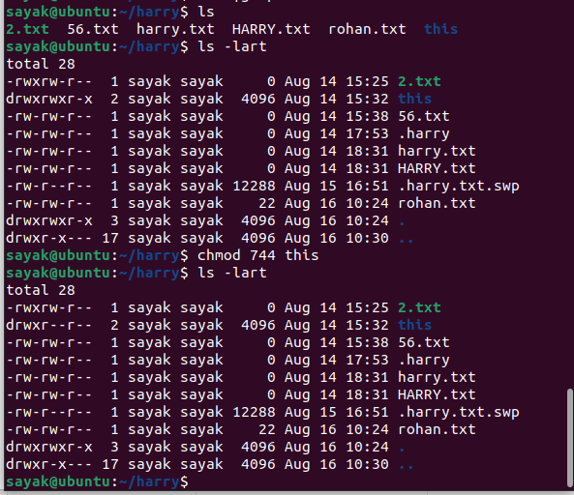***# ‘ls -lart’ command lists all files (also the hidden files) with their permissions. Using ‘chmod’ command user can change the (user- group-public) permission of a file or a folder. Here, you can see, the permission of ‘this’ folder has been changed.***

## To change the ownership of a file:

**sayak@ubuntu:~$ sudo apt install apache2  *#This software is installed when we want to give permission to the people to visit our websites. Here, user uses the ‘sudo’ command when he want to use his power of the root user. ‘apache2’ creates an user named ‘www-data’.***

**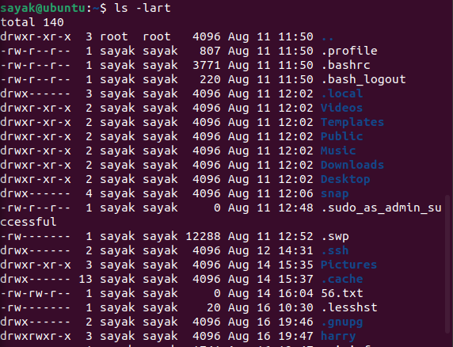*#using ‘ls -lart’ we can see the given permissions of all files and sub-folders in the current folder. Now, let us want to change the ownership of the folder of folder ‘harry’***

***Using this command, “*chown www-data harry*” we can change th ownership of the file from ‘sayak’ to ‘www-data’. So ‘ls -lart gives:***

**drwxrwxr-x 3 www-data sayak 4096 Aug 16 19:47 harry**

***“*chown www-data:www-data harry*” using this command, We can change the group also. So ‘ls -lart gives:***

**drwxrwxr-x 3 www-data www-data 4096 Aug 16 19:47 harry**

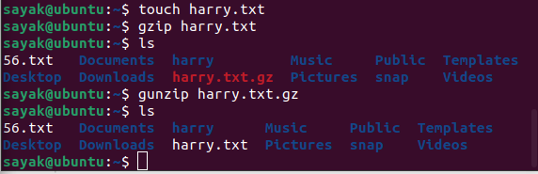To zip and unzip any file***.***

***First we crated an empty txt file. Then, it was zipped using ‘gzip’ command and unzipped by gunzip command.***

**sayak@ubuntu:~$ ssh** [***sayak@10.0.2.15***](mailto:sayak@10.0.2.15) ***# ‘ssh username@ipaddress’ this command is used to connect to a remote server.***

**sayak@ubuntu:~$ scp energy-calc** [***sayak@10.0.2.15***](mailto:sayak@10.0.2.15)***:*/home/sayak**

***# ‘scp’ is used when we want to copy something from a remote server. The format is scp <file name> <username>@<ip address>:<location where you want to save the file>. (Not sure!! Need to be verified).***

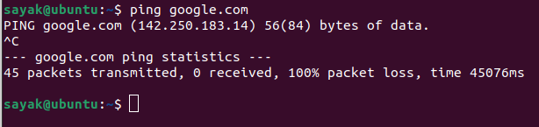***# ‘ping’ command checks the network connectivity. You can cancel this command with ‘crtl+c’.***

To display network connection information***:***

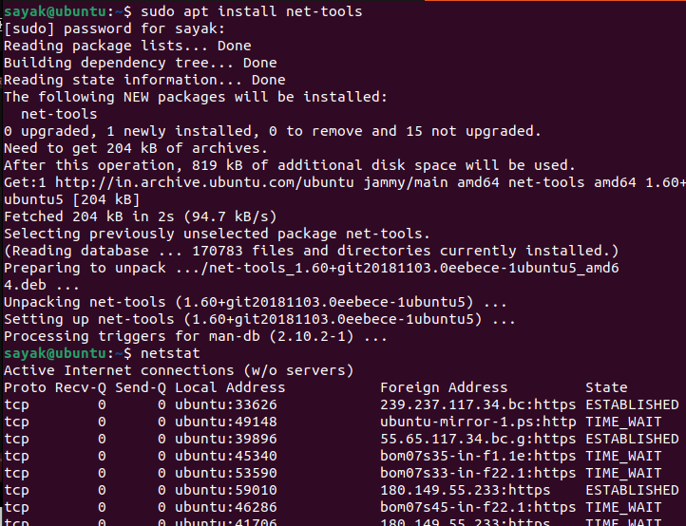***#’netstat’ command helps To display network connection information. First it was installed by ‘sudo apt install net-tool’ command.***

To display running processes***:***

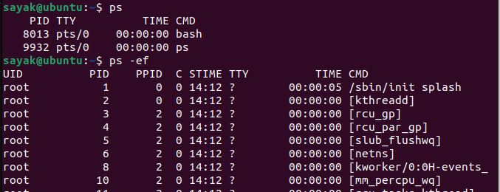

***# ‘ps’ command is used to display the running processes. Using ‘ps -ef’ we can get the detailed information.***

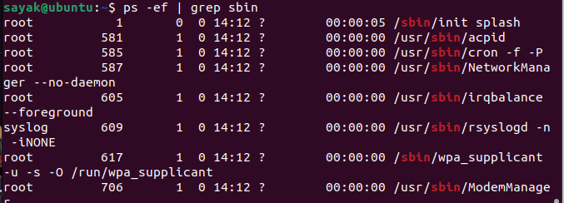**# *if we use ‘ps -ef | grep <some string>’ ; we can get the specific running processes with that particular string. Here, the string is ‘sbin’.***

## To kill any current running process:

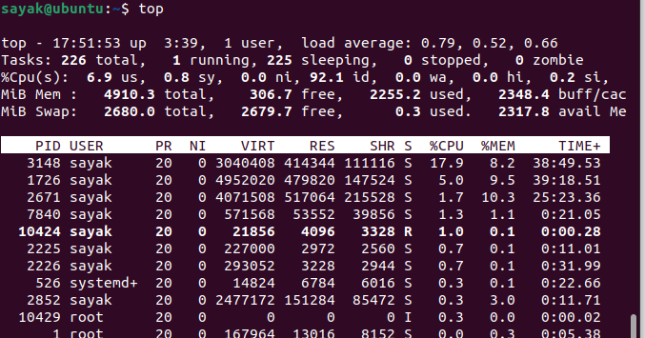 ***first we run ‘top’ command to show the current running processes. Then ‘kill <process id /PID>’ this command is used to kill a particular process.***

## Control system services and settings.

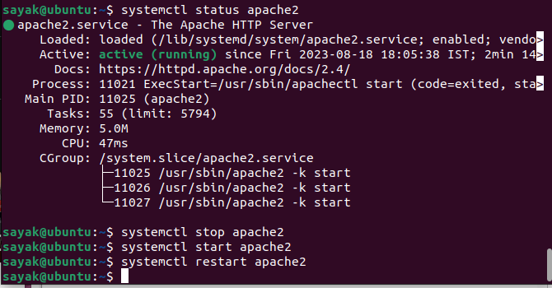***#‘systemctl status apache2’, ‘systemctl stop apache2’, ‘systemctl start apache2’, ‘systemctl restart apache2’ these command are used to check status, to stop, start and restart any services respectively.***

## To create a new user:

**sayak@ubuntu:~$ sudo useradd harry *# User named ‘harry’ added to the partocular system.***

**[sudo] password for sayak: ………  *# Provide the root user’s password.***

***s*ayak@ubuntu:~$ passwd harry *# Set password for the new user harry.***

**sayak@ubuntu:~$ ssh** [***harry@10.0.2.15***](mailto:harry@10.0.2.15)

[***harry@10.0.2.15***](mailto:harry@10.0.2.15)**’s password: ………  *# In the way, harry can login to the system from any other device with username, ip address and password.***

***(Did not work for me!!!!)***

**userdel harry  *# To delete a user named harry.***

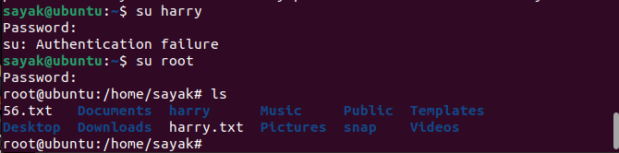Switch user***:***

***# ‘su harry’ command is used to become another user harry. Writing ‘su rrot’ you can return back to the root user.***

## Display disk space usage:

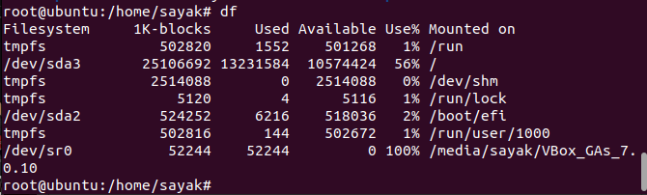***# ‘df’ command is used.***

Display disk usage by file or directory***;***

***# ‘du’ command is used here.***

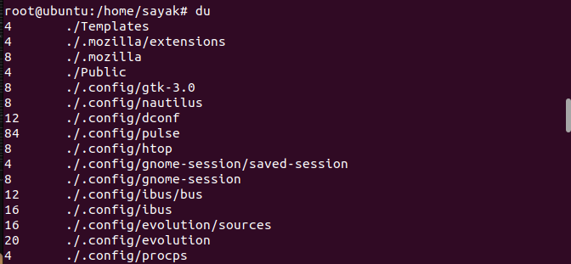

## To mount a file in a other location

sayak@ubuntu:~/harry3$ **sudo mount -o loop /home/sayak/harry3/def.txt /home/sayak/Documents *# Use command ‘sudo mount -o loop <path to your file> <point of mounting>’. (But, did not work for me!!!).***

mount: /home/sayak/Documents: wrong fs type, bad option, bad superblock on /dev/loop12, missing codepage or helper program, or other error.

## To see the date:

sayak@ubuntu:~$ **date**

Saturday 19 August 2023 11:30:50 AM IST

# Xmgrace

## Lecture 1

Open xmgrace from command line by typing ‘xmgrace’ in terminal.

### To open a file:

Data > import >Ascii

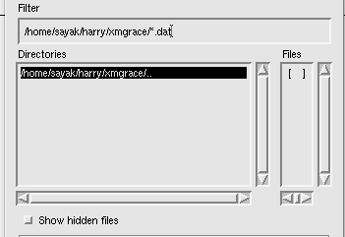

Delete this .dat to search for all kind of file.

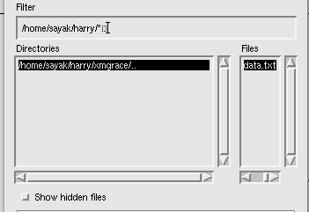

To open data directly with the command line,

xmgrace -nxy data.txt

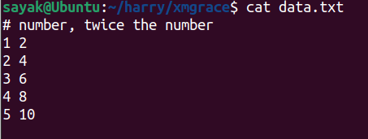

Reads data of 1st column as x axis, 2nd , 3rd, 4th etc columns as y axis.

Below is the first apparence.

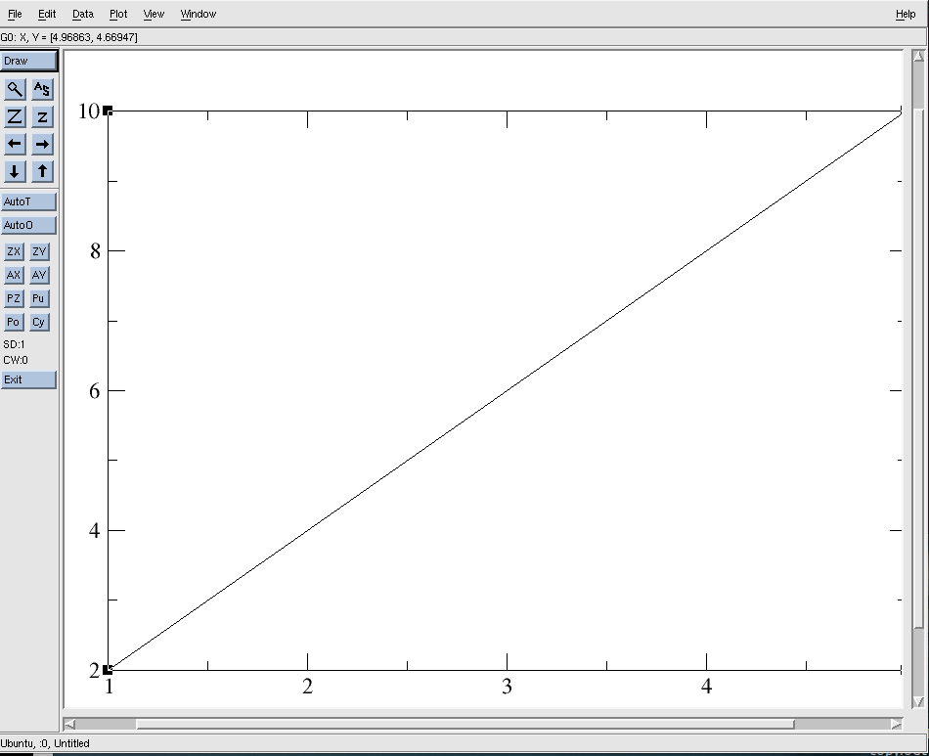

Plot > set apparence >main> symbol properties (circle) > apply > accept

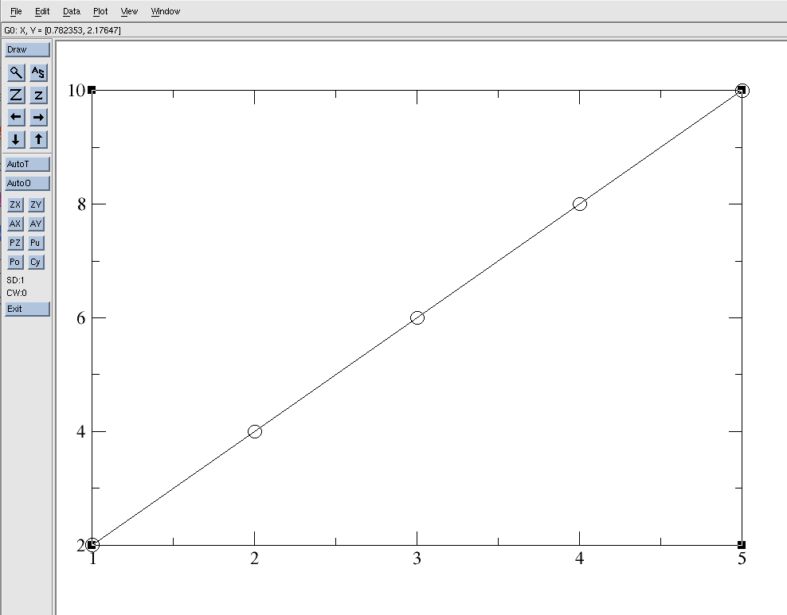

### To change the range of the axes:

plot >axis properties

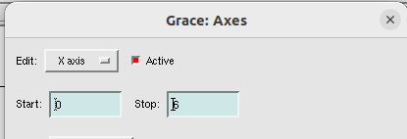

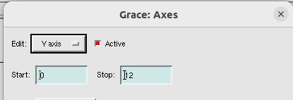

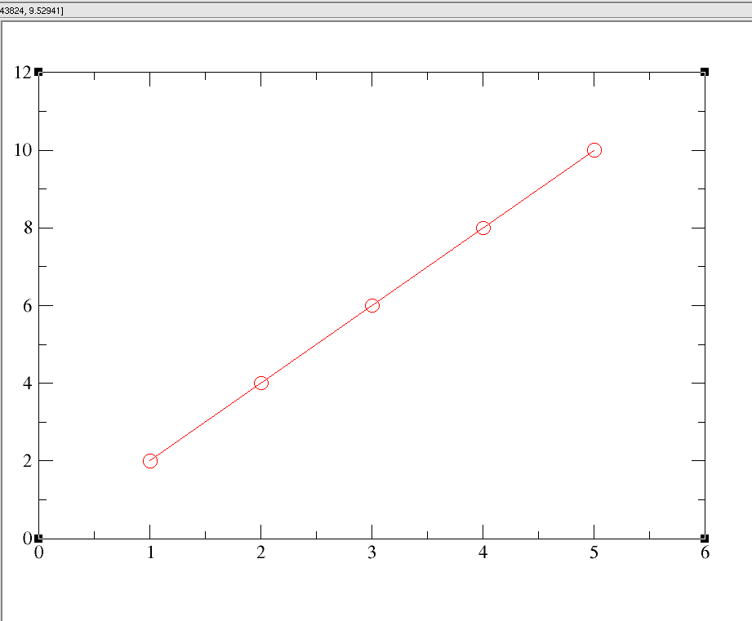

### Label the axes:

plot >axis properties> main

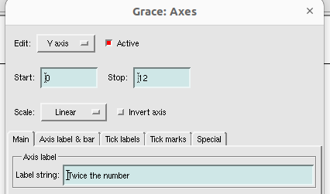

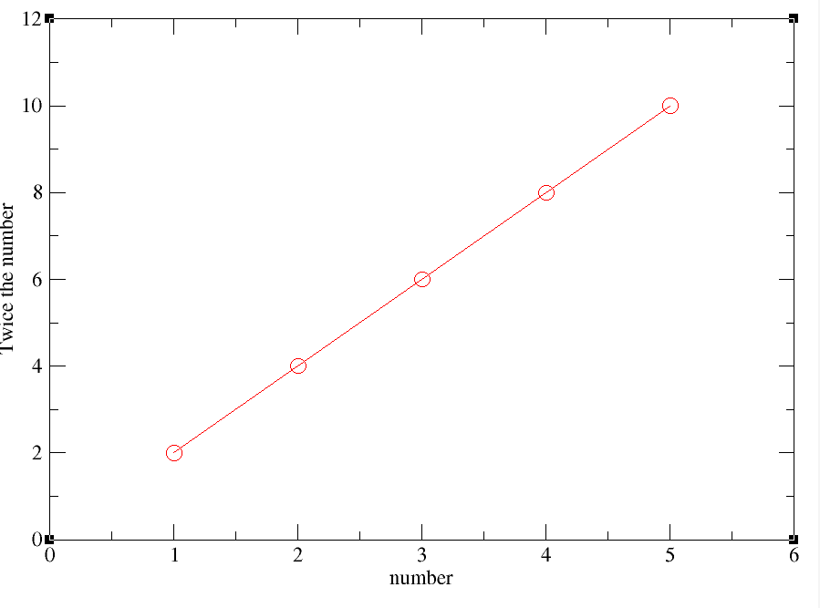

### save the file:

**File > save as**

xmgrace files are stored as standard .agr file format , which we can edit in xmgrace software.

Under ‘selection’ option, you have the directory path from where you opened xmgrace in the terminal. Name the file( here, line_plot.agr). Click ok.

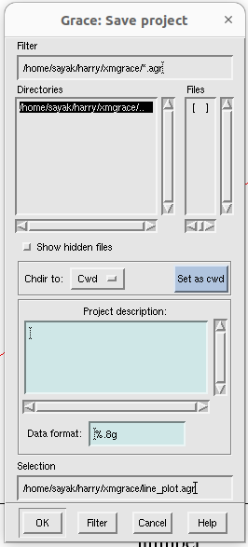

This agr file format is editable. If you want some common format, like png, jpg, pdf:

**file > print setup> Device(pdf/png) , size (custom), set resolution(dpi)** of the image. Then, again go to **file> print**. Now, saving is done.

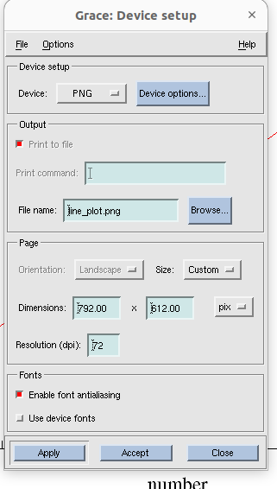

## 

## Lecture 2

### Changing frame width

Open the previous file with **xmgrace line_plot.agr** command in terminal.

Plot> graph appearance > titles> fonts(Helvetica bold)

Plot> graph appearance >Frame> Frame type(closed), width(3)> apply> accept.

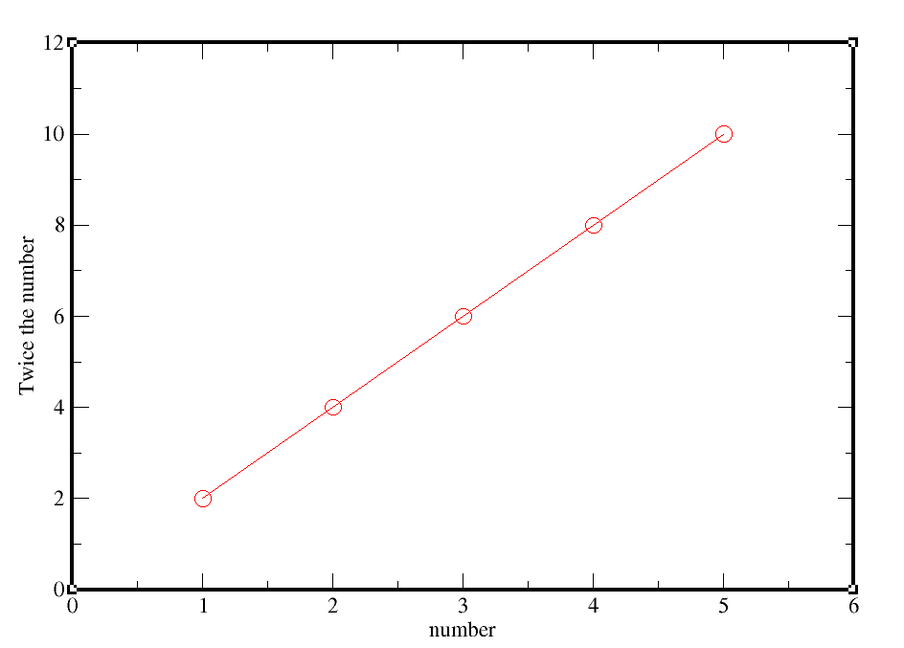Now if you want to save the changes to that already saved file, go to file>save.

### Changing tick properties:

Plot>axis properties >x axis > main> Tick properties(major spacing=0.5), Tick level properties(font: Helvetica-Bold)> apply

Plot>axis properties >x axis >tick labels> char size(100), Angle (30)> apply> accept.

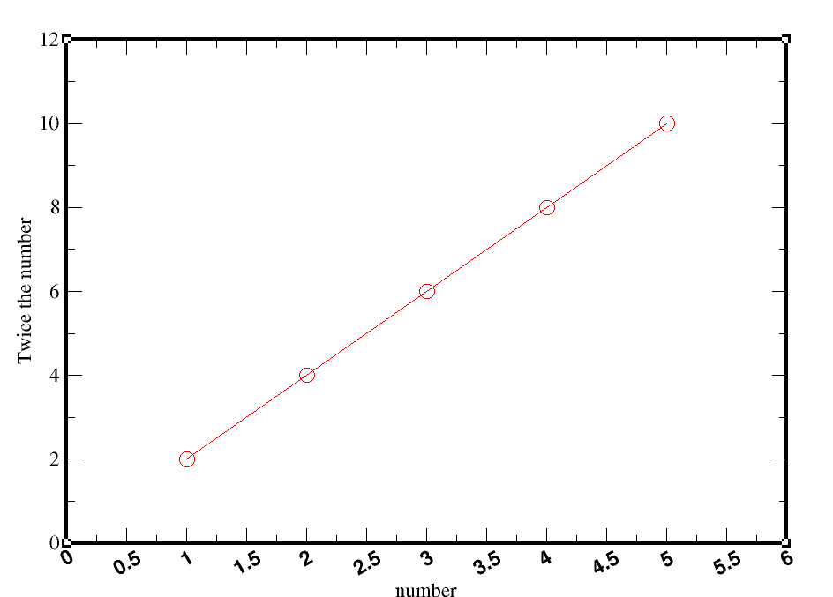

### Changing axis label size:

Plot>axis properties >x axis / y axis >axis label and bar>

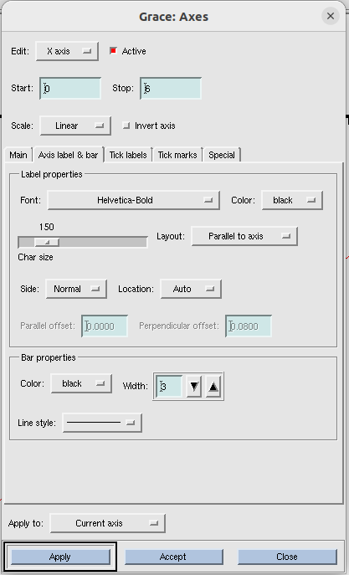

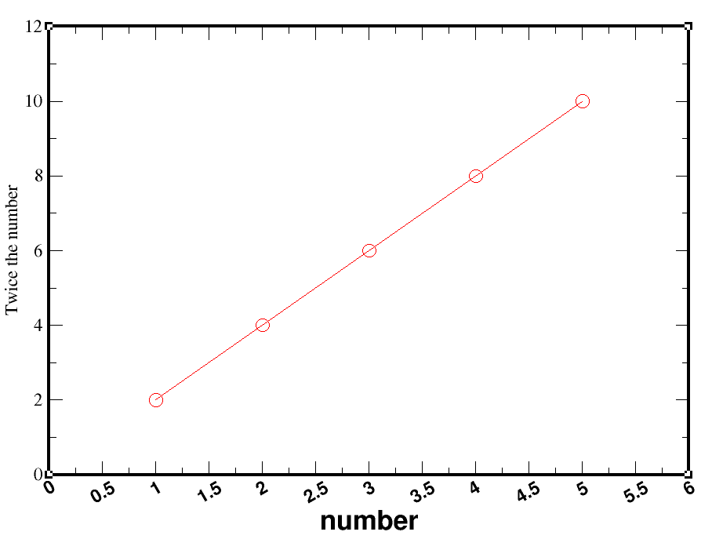

label of x axis (i.e ‘number’) has been changed to larger and bold. Tick labels also became larger and angled.

### To move the axis ticks outside:

Plot>axis properties >x axis >tick marks

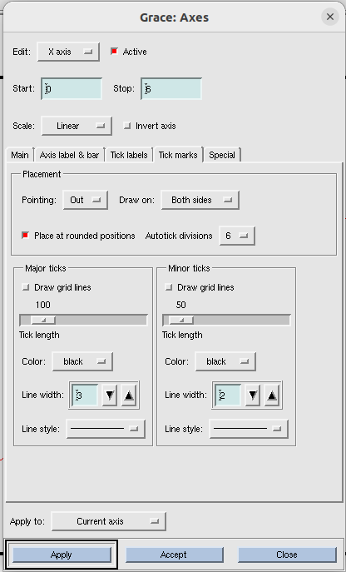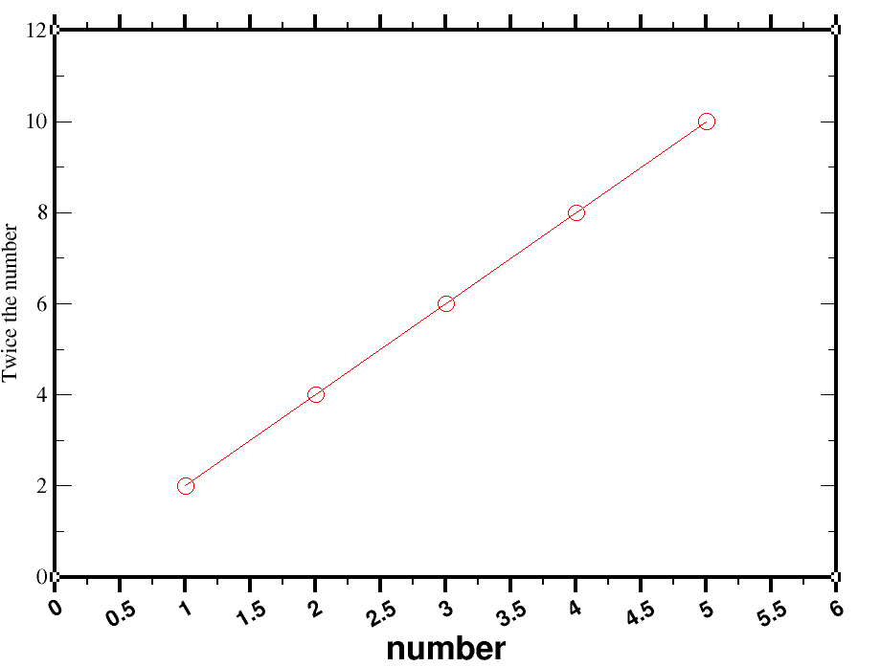

See tick marks of x axis went outside the box and it became bold. But it is not necessary to do.

### Changing size of symbols ( i.e points on graph):

Enlarge size of the symbols(we choose circle):

Plot> set appearance > main > symbol properties> size(300)

Enlarge width

Plot> set appearance > symbols> symbol outline> width(3)

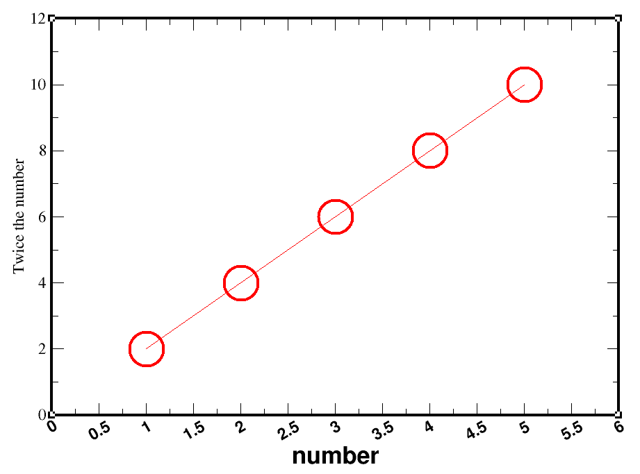

### Changing line of graph:

Plot> set appearance >main> line properties> width(3), color(black)

Plot> set appearance >symbols > symbol fill> color(red), pattern(..)

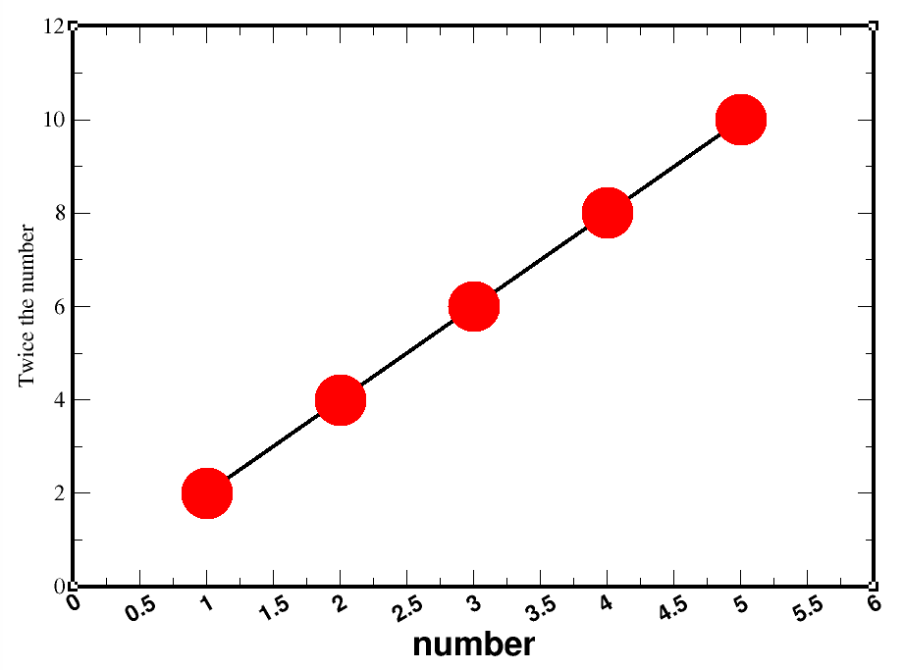

### cleaning out white spaces

Edit > arrange graphs > page offsets (change the amount of whitespace in left, right, top and bottom).

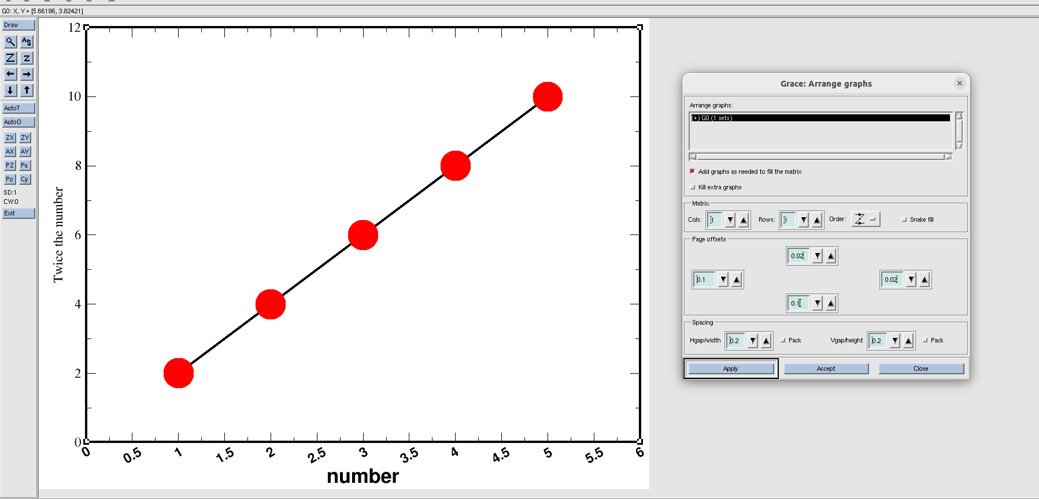

## Lecture 3

### How to make multiple plots in a single paper?

Type **xmgrace -nxy data.txt** in the terminal.

Now, one plot occupies entire window. But we want to accomodate 4 plots here.

### Shifting 1st graph to top left:

**Edit> arrange graph> page offsets**(top=0.05, bottom=0.6, left=0.1, right =0.7)

Always note this page offsets values for future references. Because next time when you open the graphs, you cant see those again.

### Plot 2nd graph:

Data> import >ascii> delete *.dat from filter and press enter> select 2_data.txt > right click on ‘read to graph’ > create new > click ‘ok’.(while clicking ‘ok’ **2_data.txt** and **(+)G1( 0 sets)** both should be clicked ).

Make sure that 2_data.txt and (+)G1 (0 sets) are selected before clicking ‘ok’. Otherwise, line of the graph will not be visible. Now it looks like below:

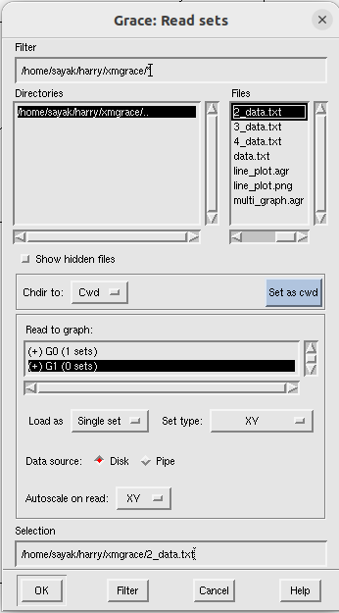

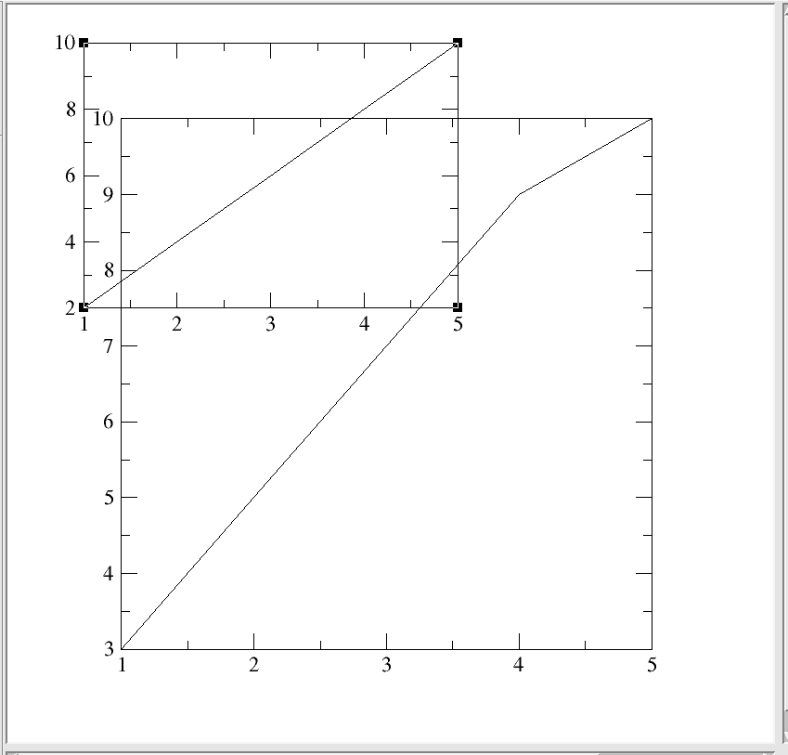

### put the 2nd graph in bottom left corner.

Edit> arrange graph> page offsets(top=0.55, bottom=0.1, left=0.1, right =0.7)

Make sure (+) G1 (1 sets) is selected while changing page offsets.

### Plot the 3rd graph at top right corner:

Data> import >ascii> delete *.dat from filter and press enter> select 3_data.txt > right click on ‘read to graph’ > create new > click ‘ok’(while clicking ‘ok’ **3_data.txt** and **(+)G2( 0 sets)** both should be clicked ).

Edit> arrange graph> page offsets(top=0.05, bottom=0.6, left=0.76, right =0.04) > apply>accept.

Make sure (+) G2 (1 sets) is selected while changing page offsets.

### Plot the 4th graph at top right corner:

Data> import >ascii> delete *.dat from filter and press enter> select 4_data.txt > right click on ‘read to graph’ > create new > click ‘ok’.(while clicking ‘ok’ 4**_data.txt** and **(+)G3( 0 sets)** both should be clicked ).

Edit> arrange graph> page offsets(top=0.55, bottom=0.1, left=0.76, right =0.04) > apply>accept.

Make sure **(+) G3 (1 sets)** is selected while changing page offsets.

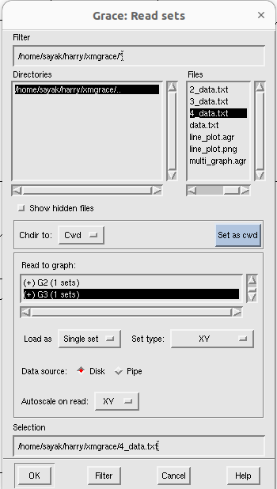

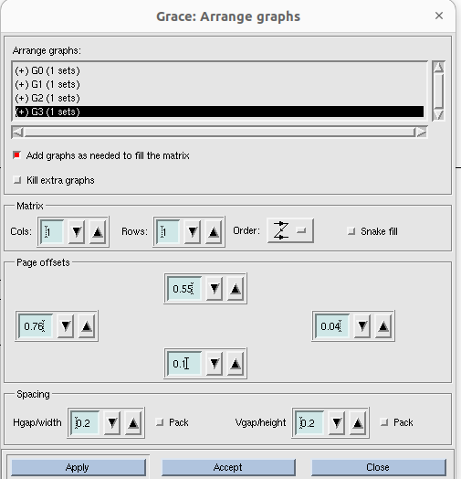

Now , finally it looks like below:

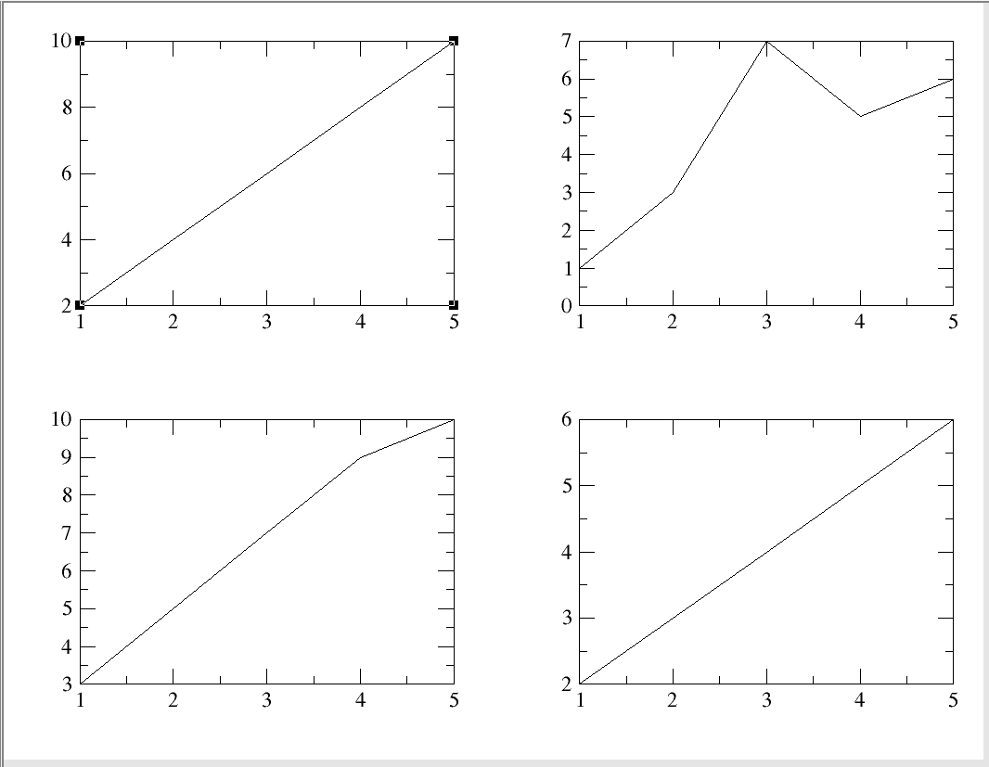

Now you can change the axis properties for each graph. To select the graph, whose axis property you want to change, ~~go~~ **~~plot> graph~~****~~apperaance~~** ~~and select the graph. Lets select 2~~~~nd~~ ~~graph~~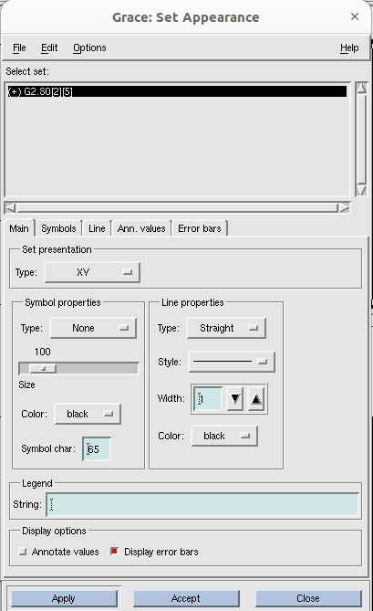 ~~(i.e G1):~~

Double click on the graph and the graph automatically got selected.

Now, go to plot > axis properties, and do all the changes that you want.

S now it looks like:

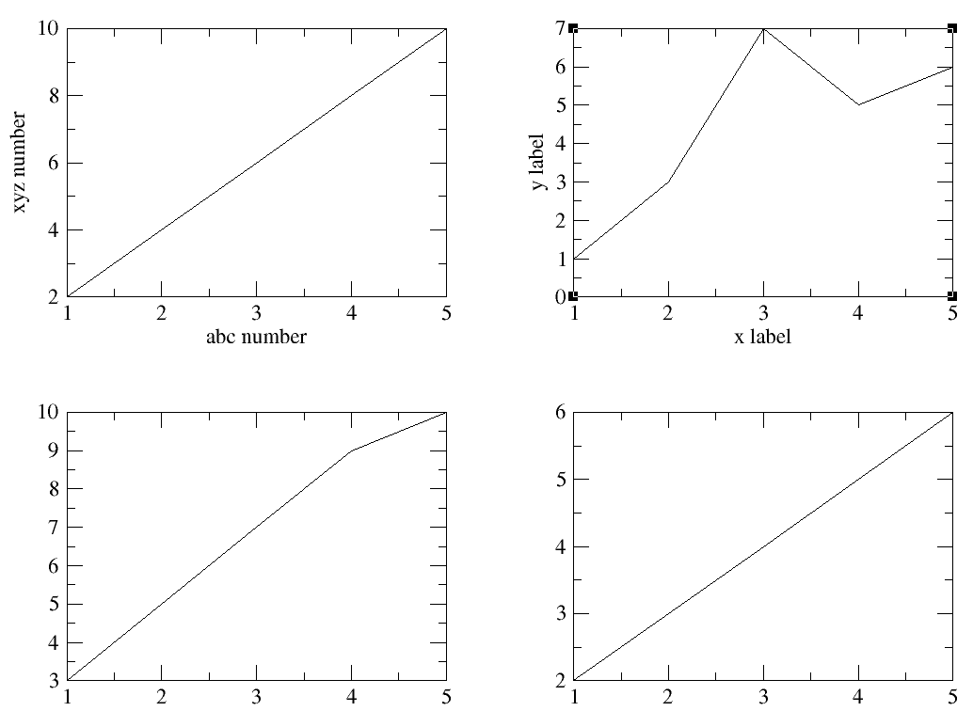

### How to remove a particular tick level only:

Plot > axis properties > special > special ticks (tick marks and labels), Tick location-label (make the box corresponding to that location blank)> apply> accept.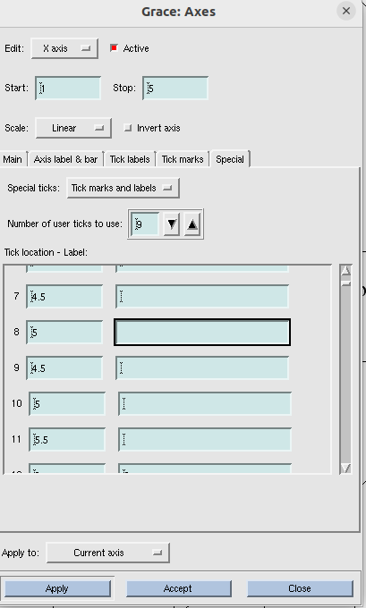

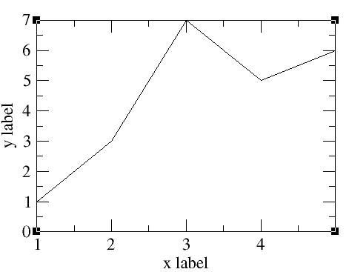

So, here we removed tick ‘5’ from the x axis.

To exit xmgrace, you can click file > exit and return to terminal.

Margins for multigraphs are sorted below:

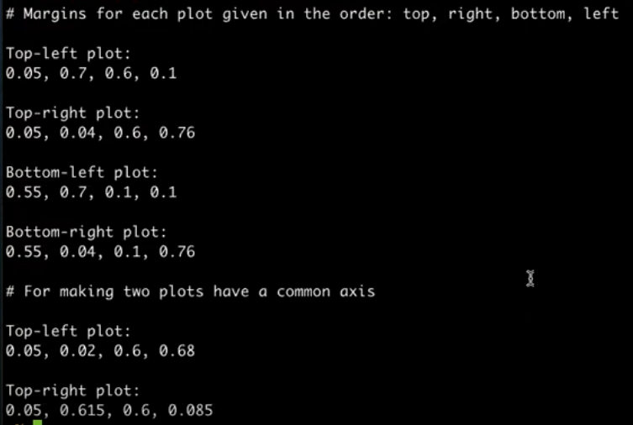

## Lecture 4: Bar plots

Here is the text file that we need for the bar plots:

apple appricot, berries, melon, banana

Serial number of fruits, number of people who like them

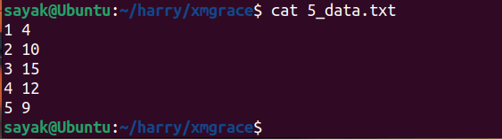

After writting xmgrace -nxy 5_data.txt in terminal, this is how it looks like:

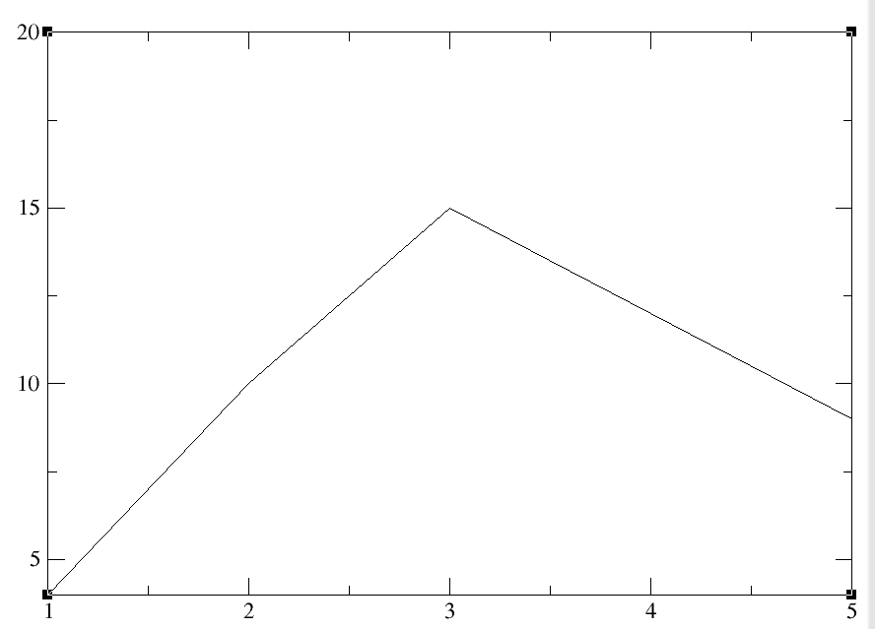

Here, y axis starts from 4 and x axis from 1. We should change it first. Go to plot > axis properties> x axis (Start 0, stop 6); yaxis (Start 0, stop 16).

Now:

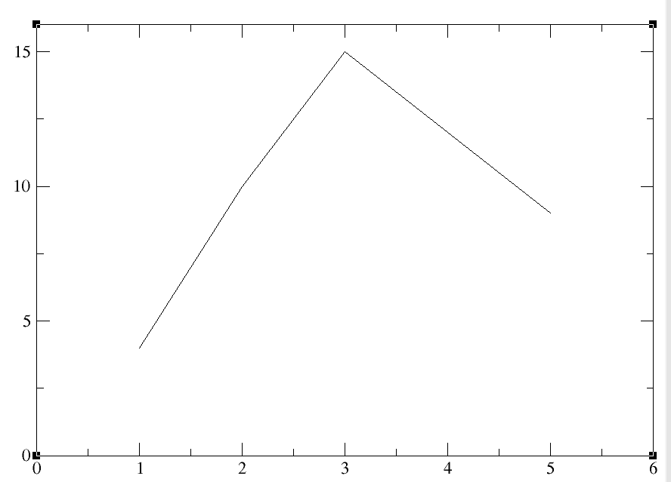

**Now we will plot bar graph and delete line graph:**

plot > set appearance >main> set presentation > type: BAR

plot > set appearance >main> line properties> None

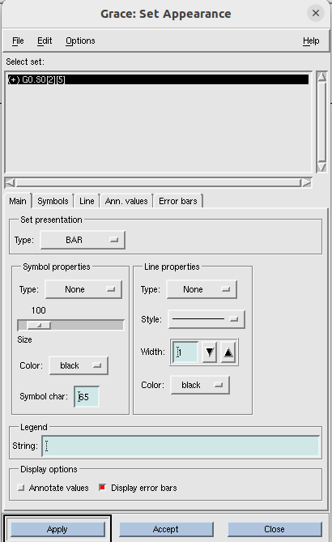

Now:

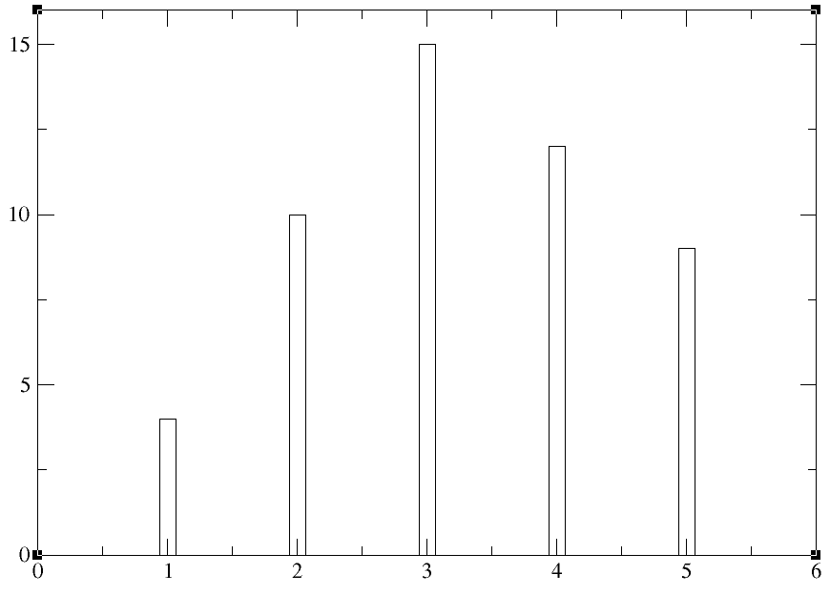

### To change the bar width

plot > set appearance > main > symbol properties > size(300), type(none).

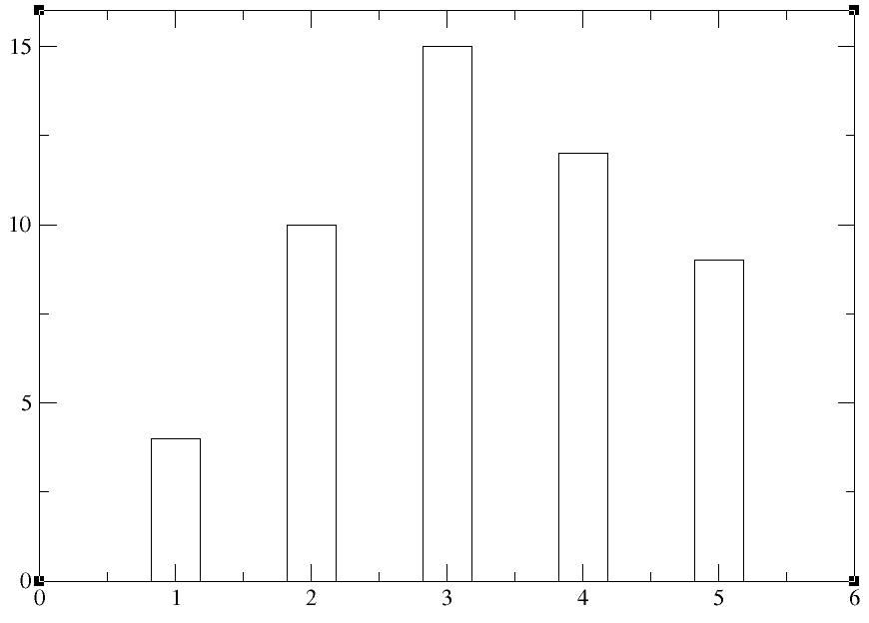

Here, we are representing data wrt some fruits name. So minor ticks do not make any sense. Lets delete them.

Plot > axis properties > x axis > special> special ticks (select: tick marks and labels), tick location-label ( do customize the tick locations and labels), number of ticks to use(5).

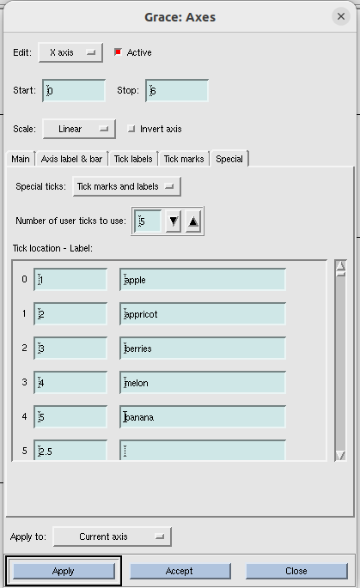

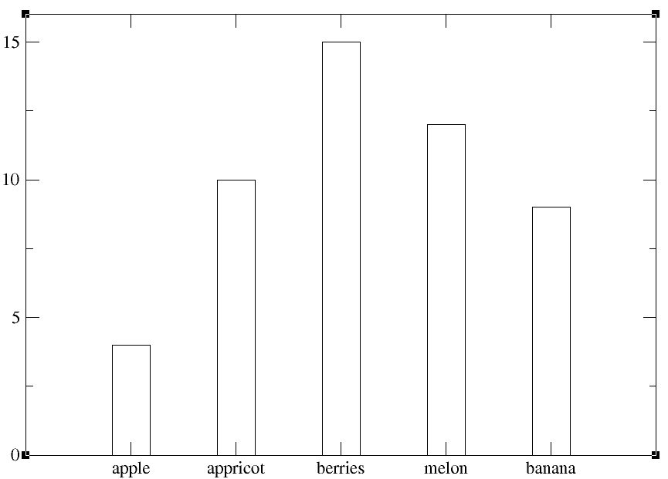

plot > axis properties > then do different things that you learnt previously.

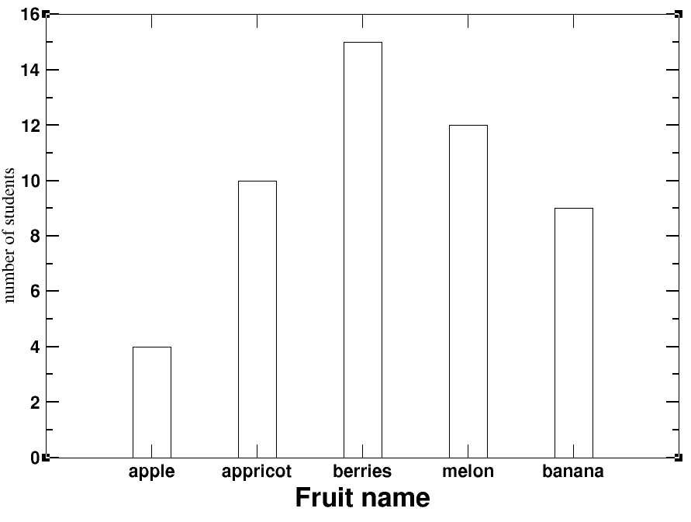

To make bars look beautiful,

plot> set appearance > symbols > symbol outline> width (3);

plot> set appearance > symbols > symbol fill> change color and pattern.

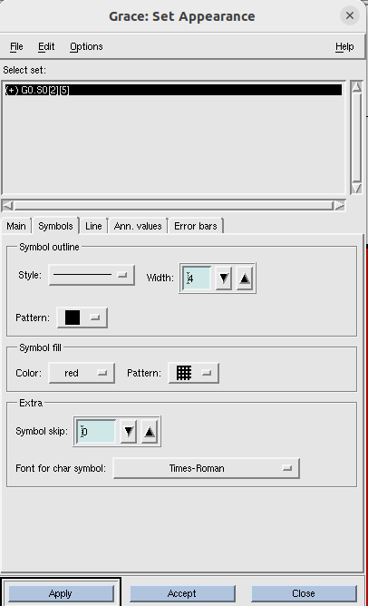

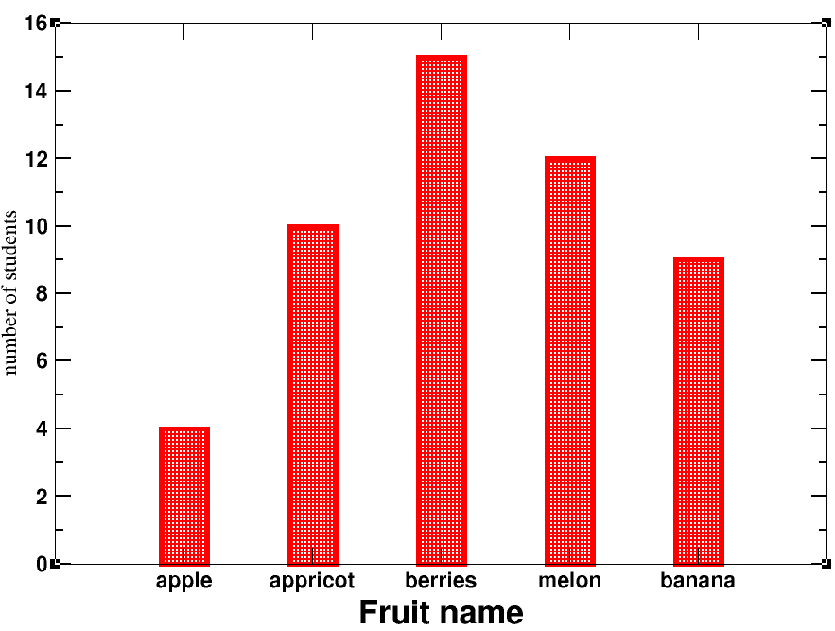Save the file from file > save as in editable *.agr format.

Then from file > print setup, to save in pdf/ jpeg/ png format. Finally , file > print.

## Lecture 5- Customize structure of each bar

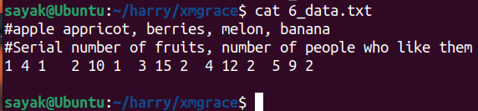We want to import data column by column. So, we want to import blocks of data seperately. Here each bar will be a seperate graph. So we should have 5 different graphs. Then superimpose each other to get 1 graph.

For each block, first column denotes the index for fruits, 2nd column for no of students, third column represents error bar.

So this will be a bar graph with error bars on it. Lets start.

Write xmgrace in command line and open it.

Plot > graph appearance > main > presentation >**type (xy chart)** > accept

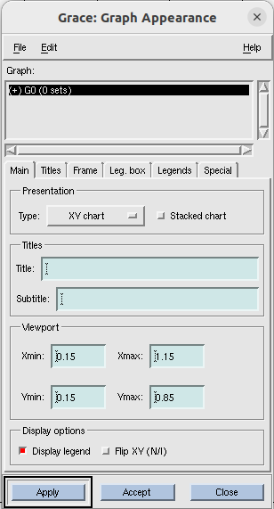

Now import data:

**Data> import >ascii> delete *.dat from filter and press enter> select 6_data.txt ; Load as (block data) > click ok.**

then another dialogue box comes named as ‘edit block data’.

**Set type (BARDY) ; x from column(1); y from column(2); Y1 from column(3) > click accept.**

#{ BARDY is used to load the error bars. Column 1 corresponds to apple, 2 for no of students, 3 for error}.

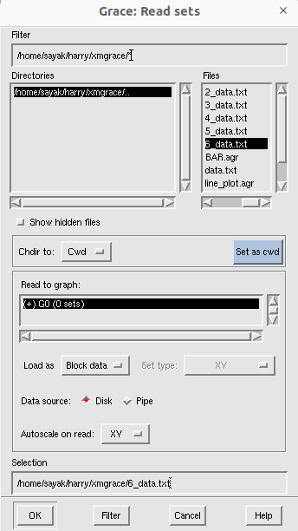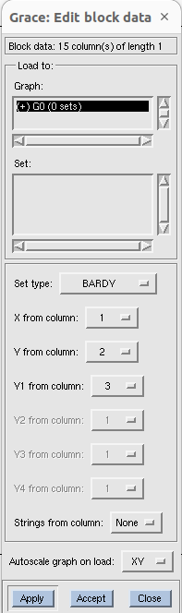

Now you have this:

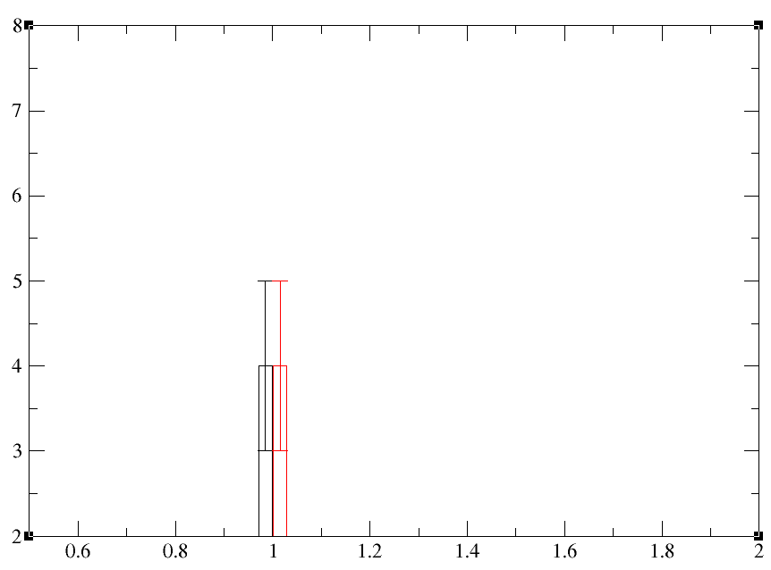

Now, we need to do this things for 4 different times. Before that, follow this below mentioned way:

**edit > arrange graphs > matrix > cols(1); rows(5) > accept**

#{ column1 and row 5 means five different graphs in one column.}

Now:

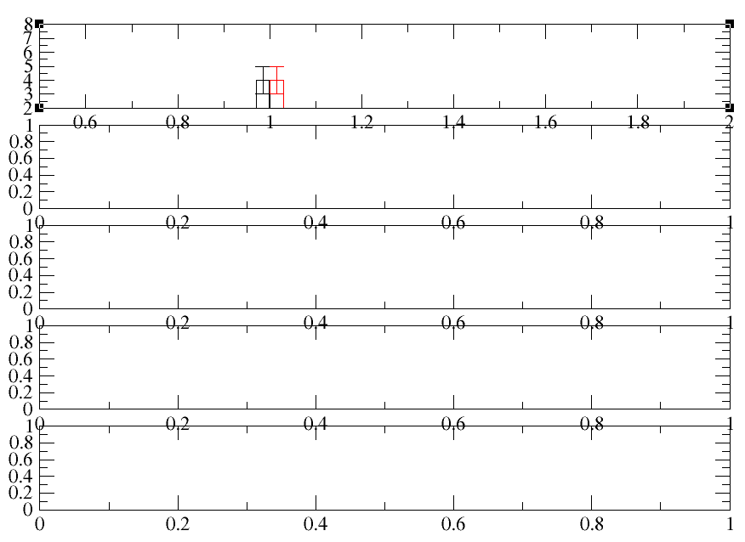

You can see 1st bar graph is the top one here. For the below 4 graphs, you can see default axis ranges. These are for empty graph actually. Now we will import 4 different blocks of data one in each of the graphs here.

**Data > import > ascii > Files(6_data.txt); Read to graph(G1 0sets); load as (Block data) > click ok.**

Now another dialogue box comes.

**Set type (BARDY) ; x from column(4); y from column(5); Y1 from column(6) > click accept.**

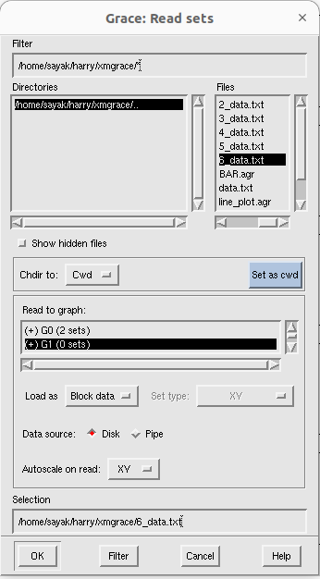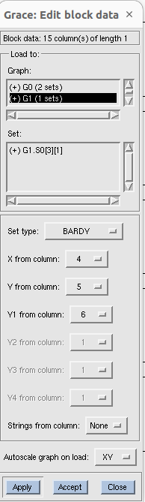

Now, it looks like below:

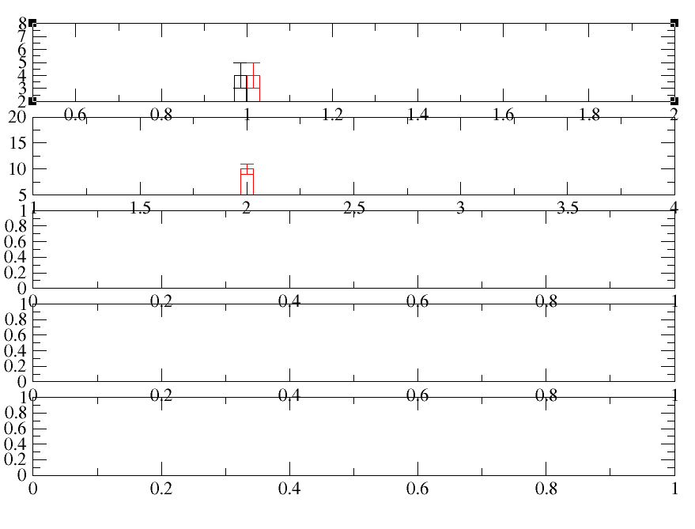So, now we have 2 different bar plots.(I.T=> for 1st plot data got plotted for two times mistakenly).

# Now, do the similar process for plotting 3rd , 4th, 5th bars. Then:

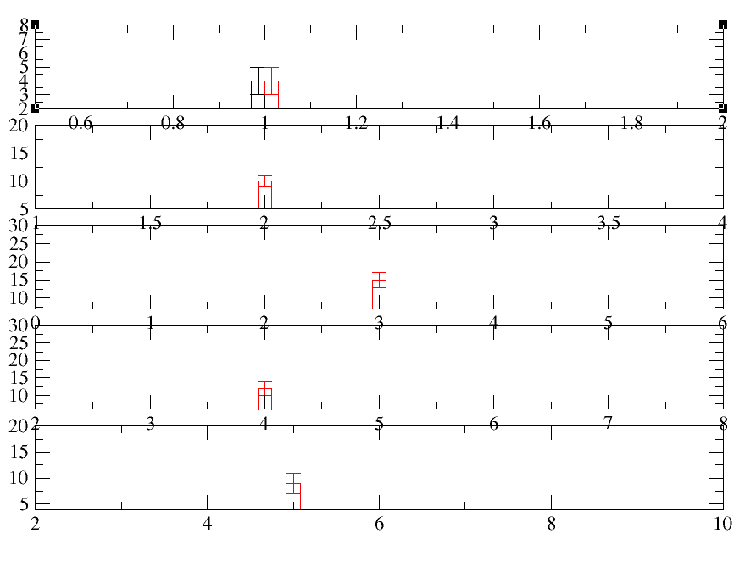

Now, before overlapping the graphs, we need to ensure that those have same axis ranges.

**plot > axis properties >x axis > start(0.5); stop (5.5); major spacing (1); apply to(current axis, all graphs).**

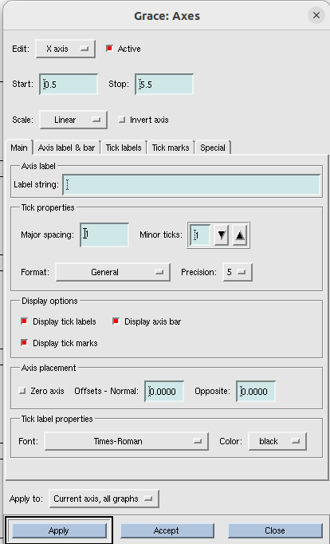

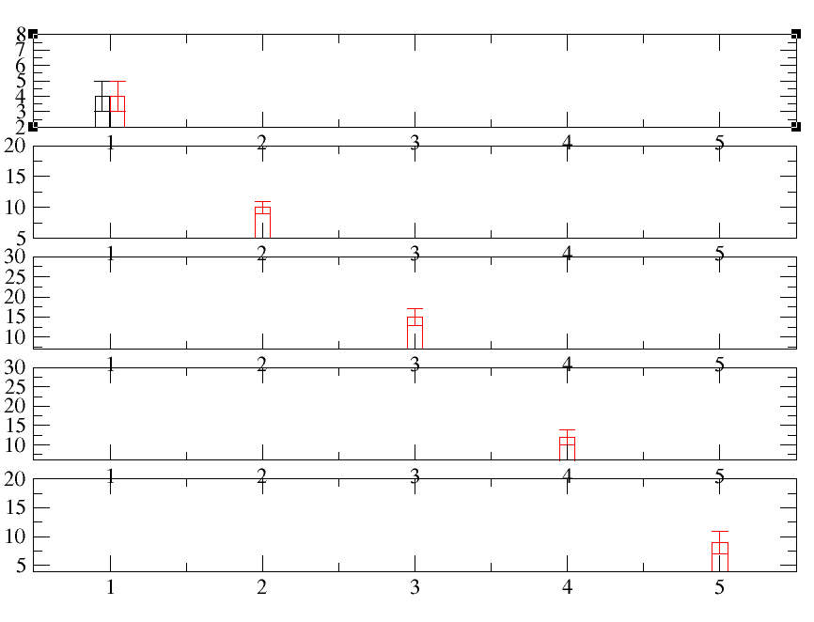

Now apply some changes in ticks, fonts and axes as per tutorial 2.

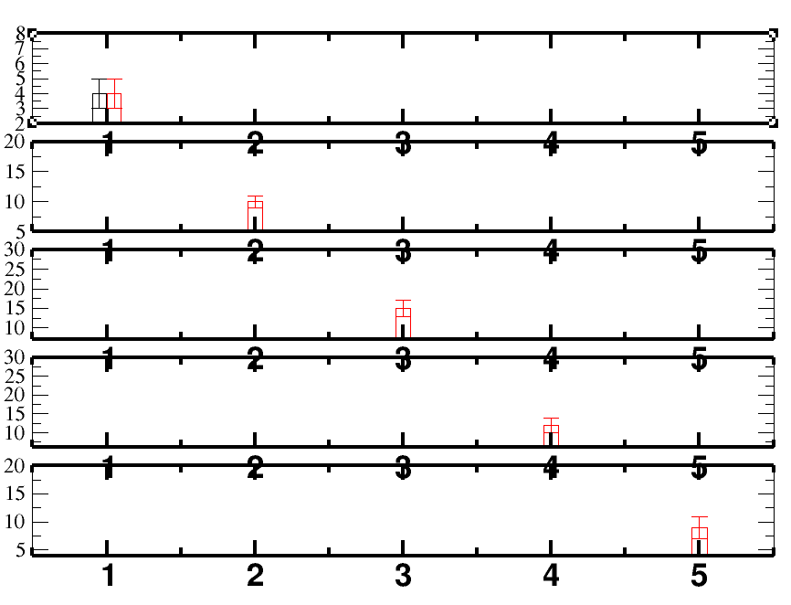

Showingtick labels in every bars is not necessary.

Go to x axis> Uncheck the display options > click apply.

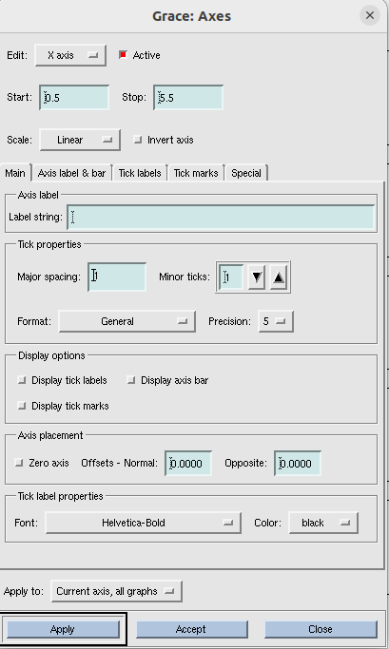

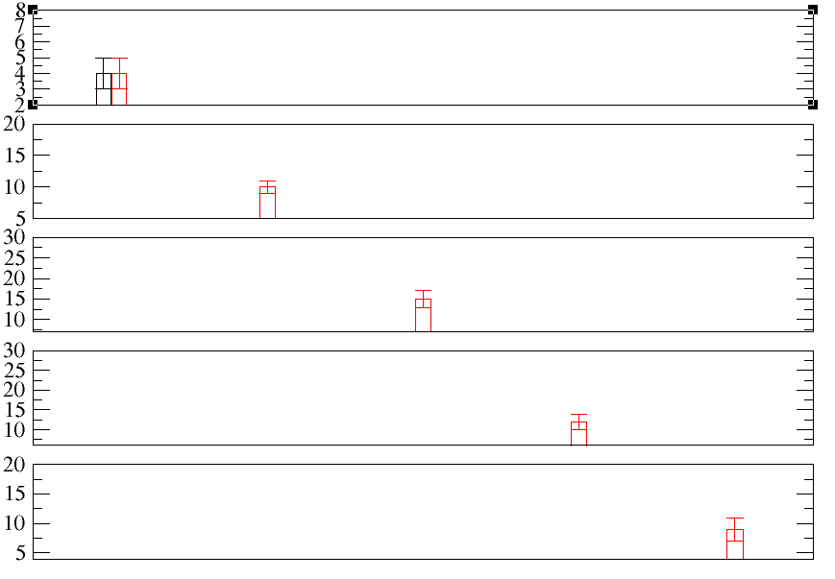 **All tick marks gone because you did it for ‘ Apply to : current axis all graphs’. If you want to show tick marks for only one graph, re-check the display options and do “Apply to : Current axis”.**

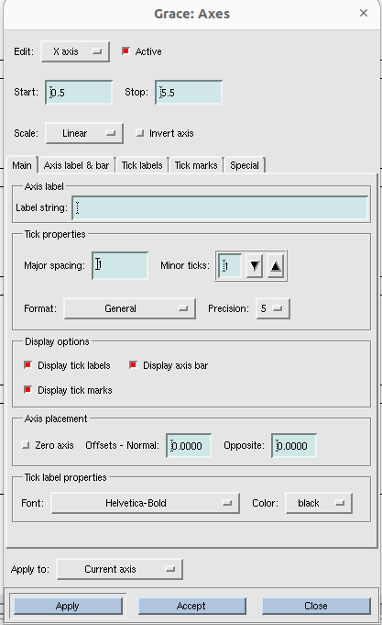

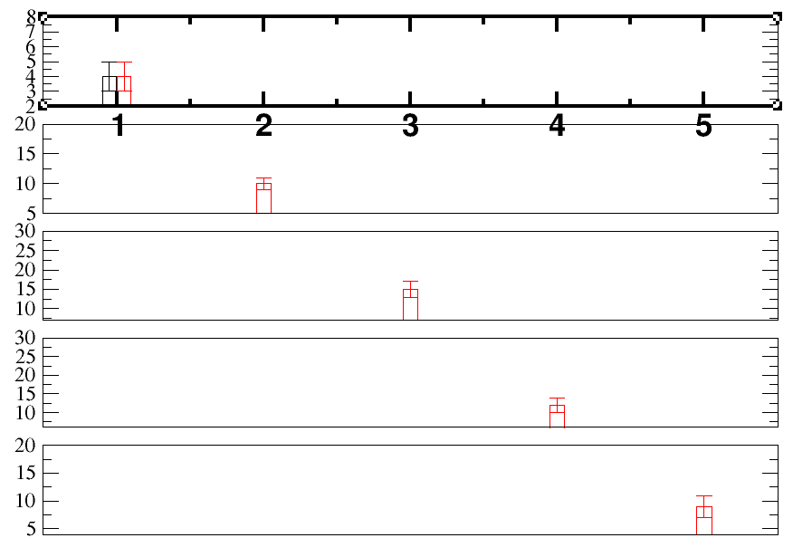

Now, go to : plot > axis properties >x axis > special and do the followings:

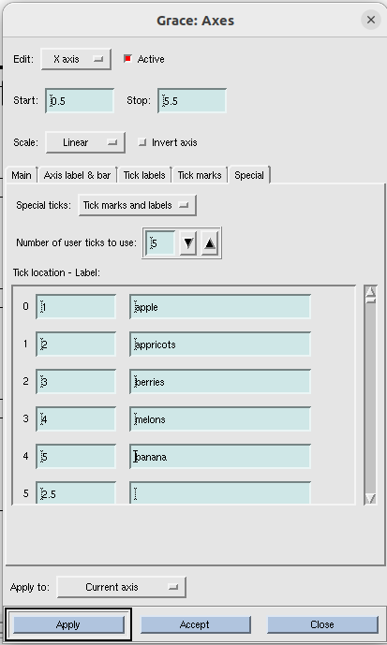

Now go to : plot > axis properties >y axis > start (0); stop (18);

plot > axis properties >y axis > main/ axis label and bars/ tick labels/tick marks > do different changes as your wish > apply to(current axis, all graphs).

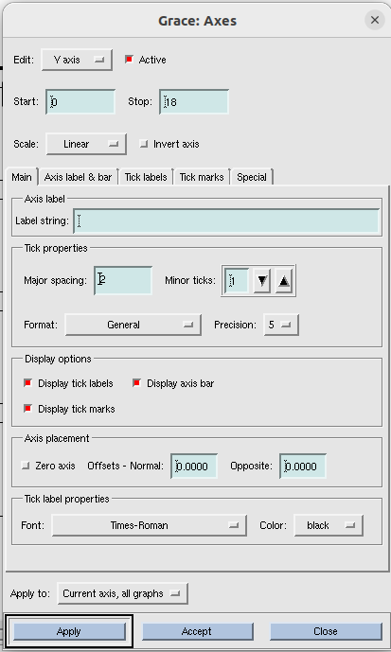

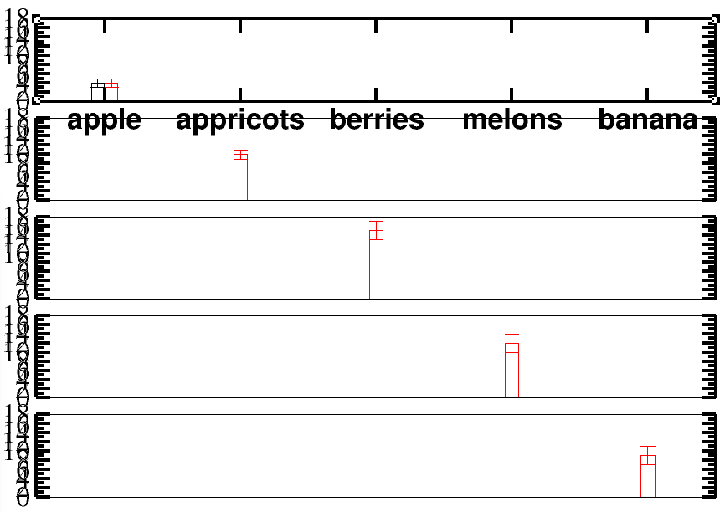

Now, Showing tick labels in every bars is not necessary.( Do same thing like x axis.)

Go to x axis> Uncheck the display options > click apply.

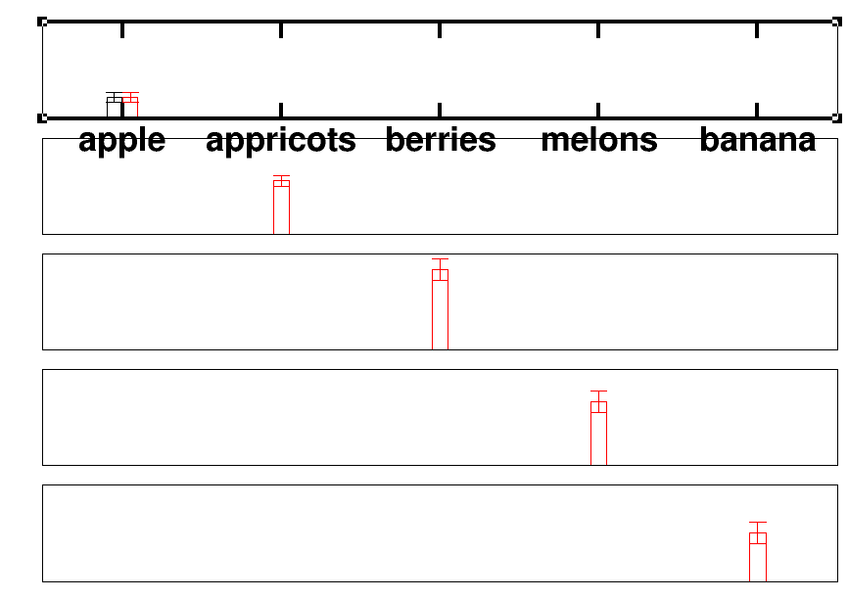

Now to restore ticks for at least one bar, re-tick the display options ( same as like what you have done in case of x axis) and “apply to( current axis)”.

Also give some axis label in this case.

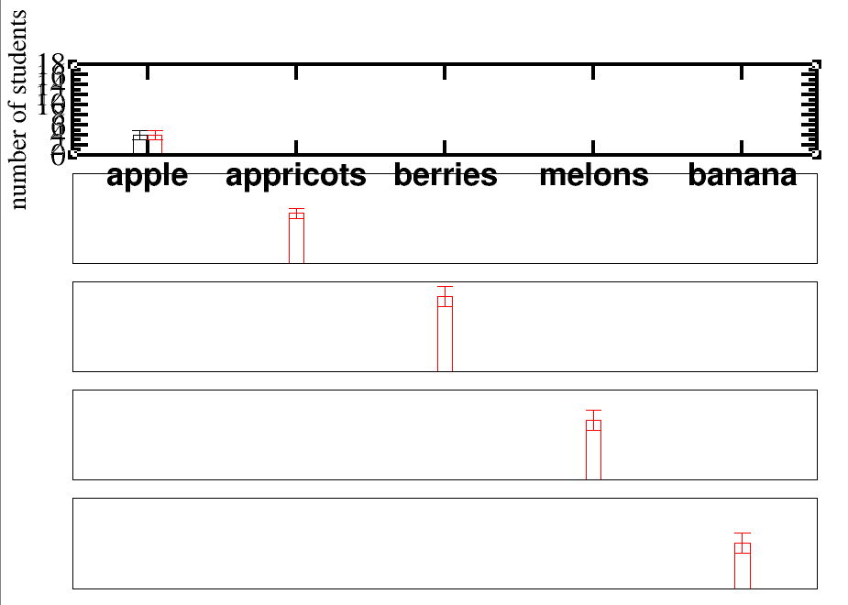

### Process for superimposing:

Plot > graph appearance > select G0 > viewport (Xmin=0.1, Xmax=1.285, Ymin=0.05, Ymax =0.96)> apply

#{we need to change the viewport. Change Xmin, Xmax, Ymin, Ymax accordingly so that graph perfectly fits to the page. And do same Change for Xmin, Xmax, Ymin, Ymax for G1, G2, G3, G4 also and click accept}.

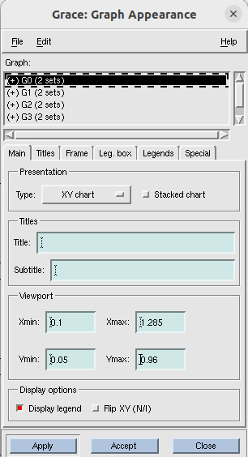

Now it looks like this:

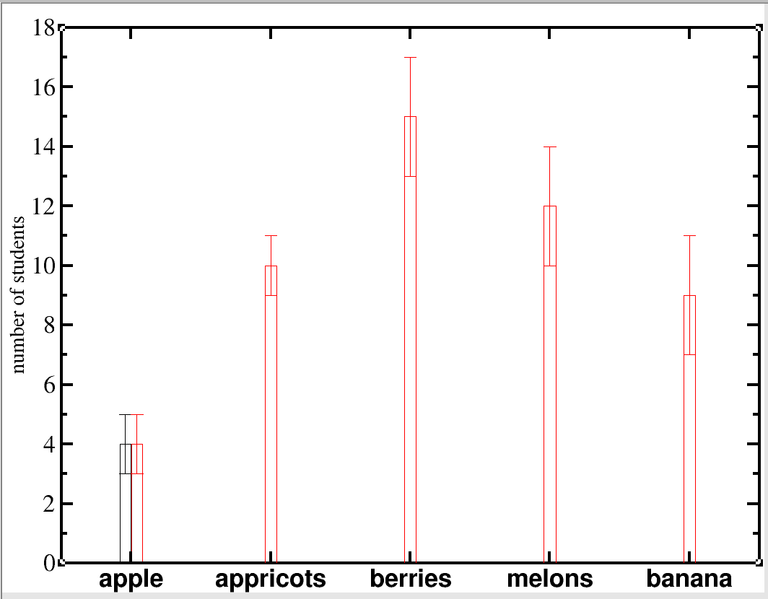

plot > graph appearance

plot > set appearance

open this two dialogue box simultaneously. Now, we want to customize each bar graph. While editing, make sure that, in both boxes same graph is selected ( e.g, G0).

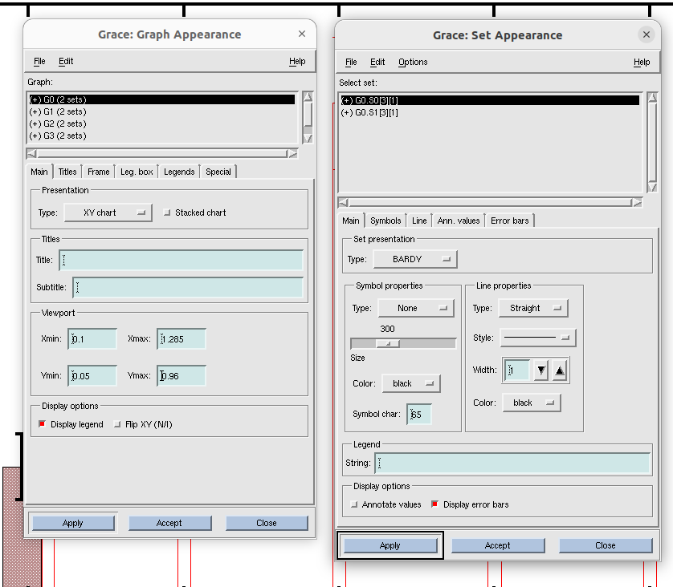

To change the appearance of error bars, go to plot > set appearance >error bars.

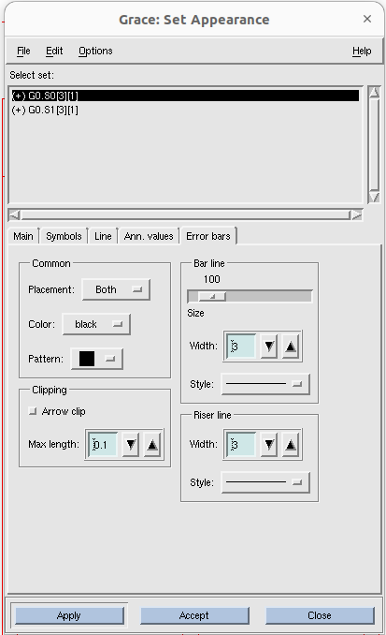

Now apply different settings for other bars also. To select other bars to edit , **double click on G1 or G2 or G3 in graph apparance box.** Then set apparance box will show set for that graph. Now, change properties for those as your wish.

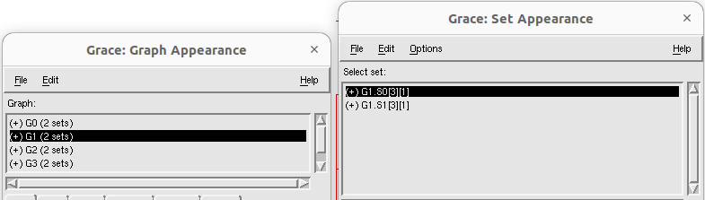

Now finally we get a bar graph which have different looks for different bars as shown below:

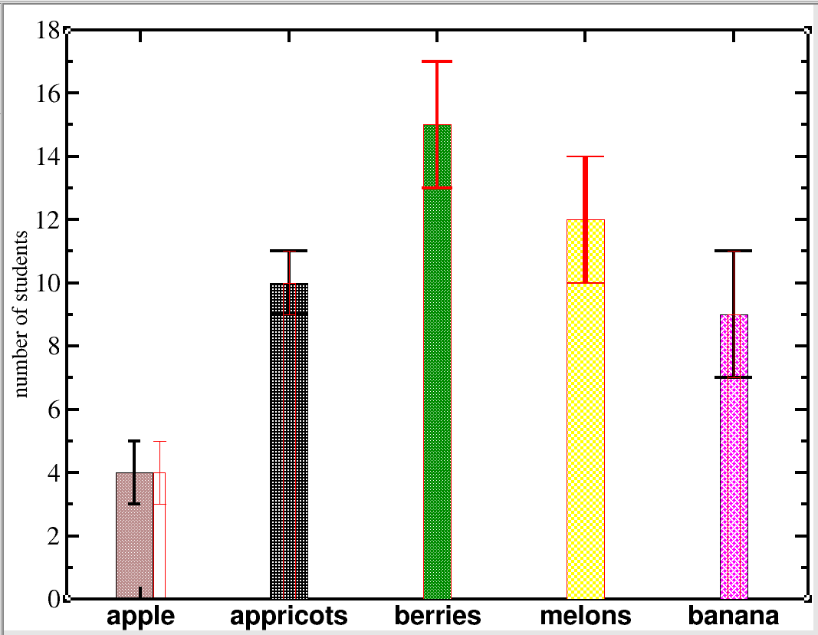

## Lecture 6 – Histogram:

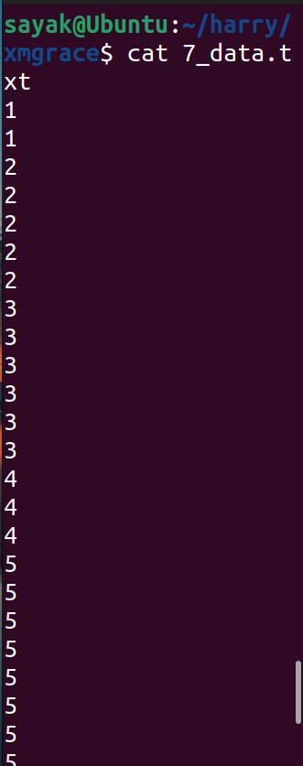

Open 7_data.txt using the command line **xmgrace -block 7_data.txt -bxy 1:1**

Now it looks like:

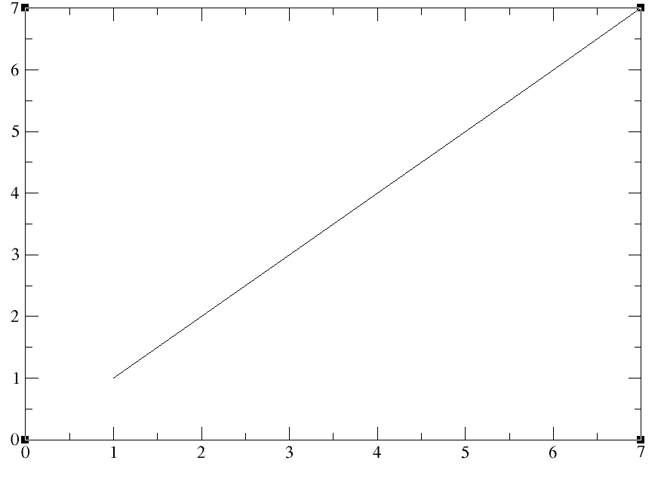

To transform this data to histogram,

Data > transformations > histograms

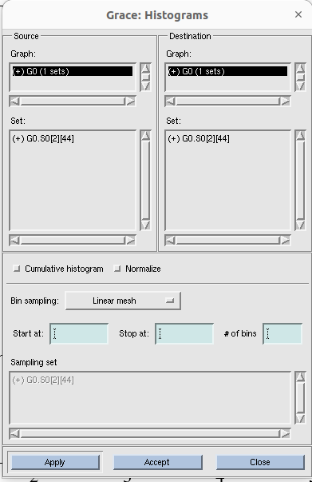

Right click on source set and click ‘duplicate’. We get:

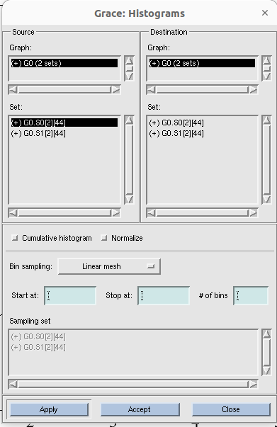

Again, right click on 1st source set ( here, G0.S0[2][44]) and click ‘hide’. See, here ‘+’ changed to ‘-’. ( IDK, why are we doing these?!may there be some reason,). Then provide start at(0), stop at (8); of beans(8).

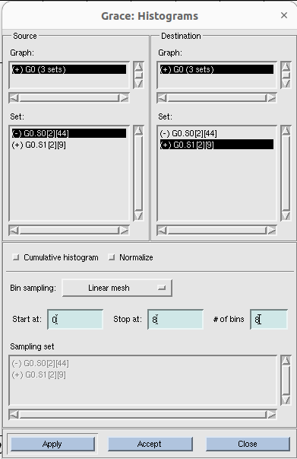

Note that, in source set (-)G0 is selected and in destination set, (+)G0 is selected (I.T=> this is because to hide the line graph and to show only the histogram). Then click apply. Histogram looks like:

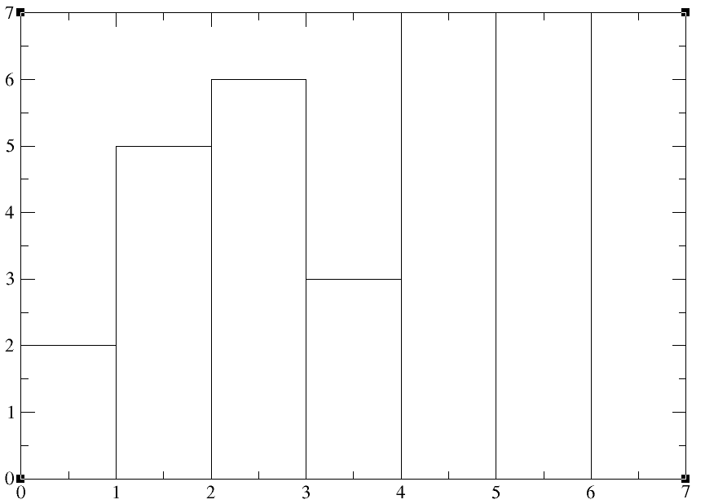

Now, plot > set apparence > edit (x axis) > start (0); stop (8)

plot > set apparence > edit (y axis) > start (0); stop (14)

Now it shows like:

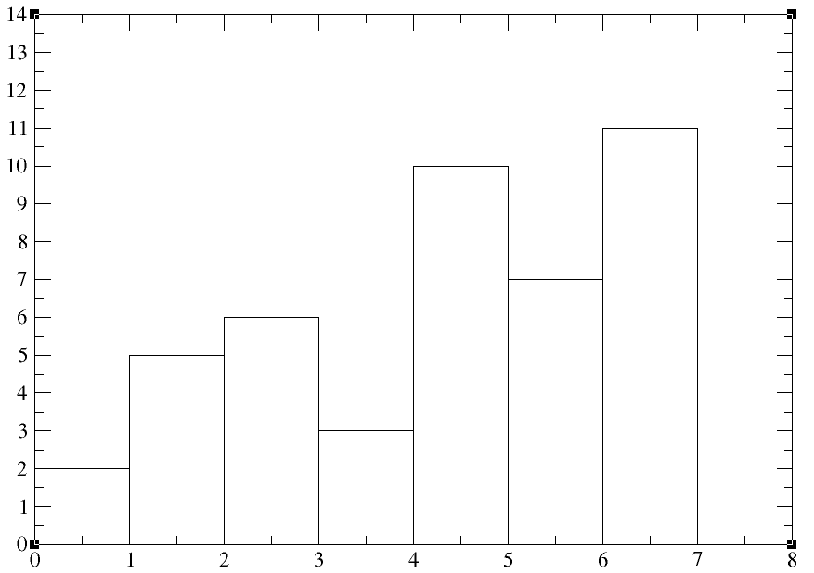

Now, to change the looks of the graph, go to

Plot > set appearance >

Remember, if you want to change the looks of the graph, make sure that, visible set is selected (i.e, **(+)**G0.S1[2][9]), not the hided one (i.e, **(-)**G0.S[2][44]). Otherwise, you can not see any change.

# See, in line properties > type (left stairs) has been there. Left stair means, no of 2’s in 7_data.txt file is represented by the bin from 1-2. So, if you select the ‘left stair’ option, make sure that you start your x axis 1 smaller than the smallest value. if you select the ‘right stair’ option, make sure that you stop your x axis at least 1 larger than the largest value.

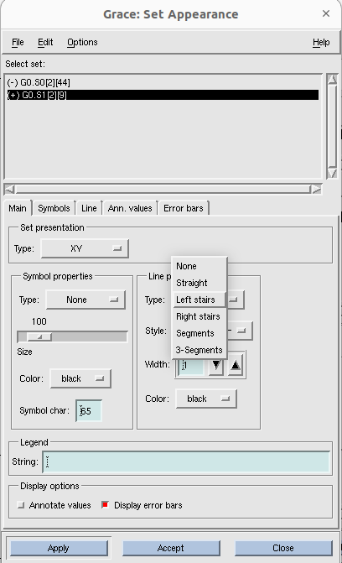

Now, go to ‘Histogram’ box and click ‘ normalize’ then click accept ( normalize means, sum of y vaules of all the bins will be 1).

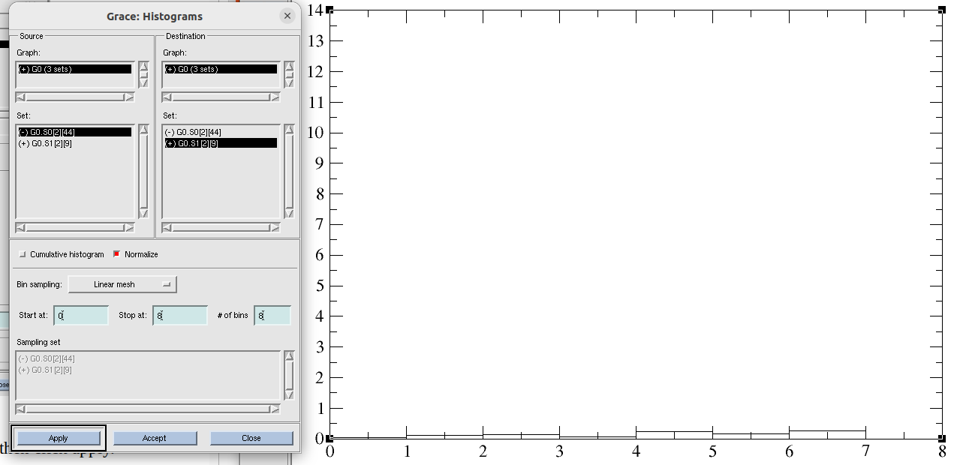This looks y axis values went down! Go to :

plot >> axis properties >> start (0) ; stop (0.3); tick properties > major spacing(0.05)>> apply>>accept

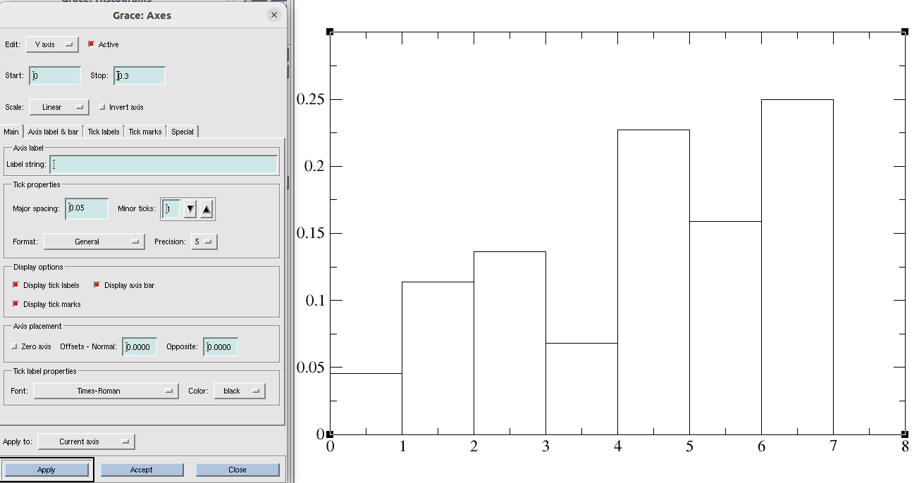

Go to Plot > set appearance > and change the look of the graph.

Plot > set appearance > line > uncheck ‘Draw drop lines’

# unchecking ‘Draw drop lines’ will remove the lines which seperates two bars.

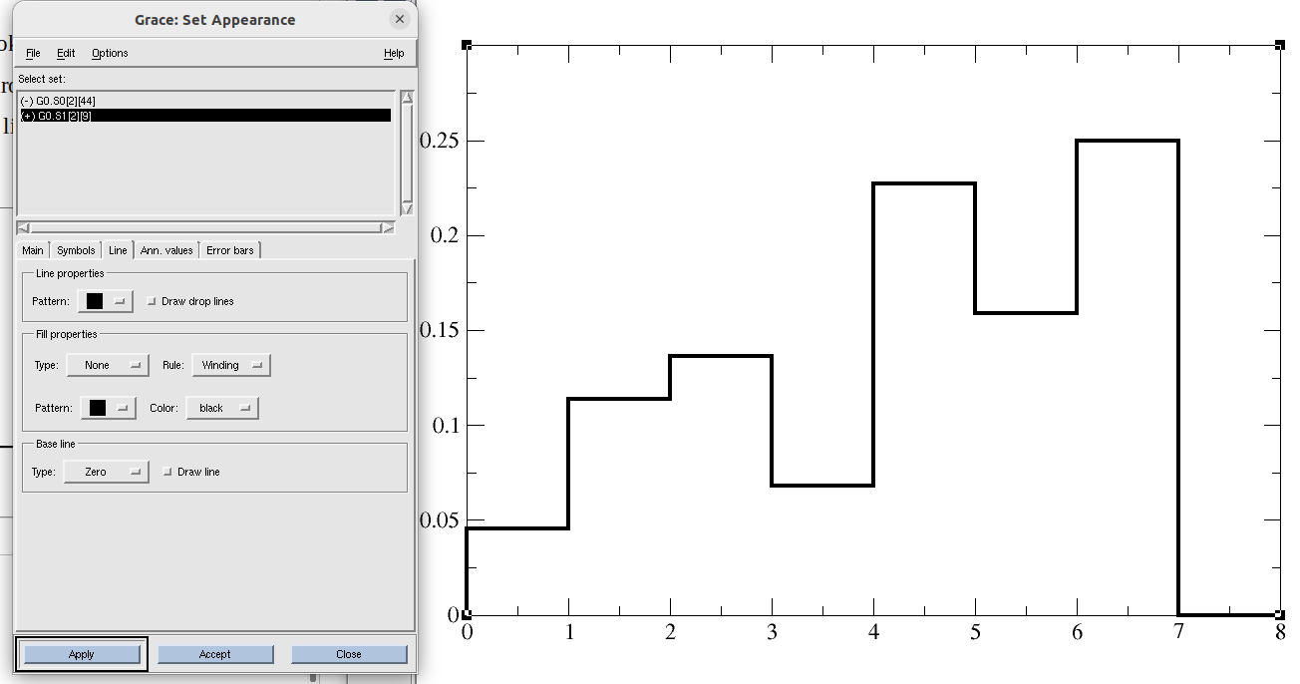But, we will continue with drop lines here. Go and check that box.

If you color the bins , Plot >> set appearance >> line >> fill properties> type(to baseline) >> apply

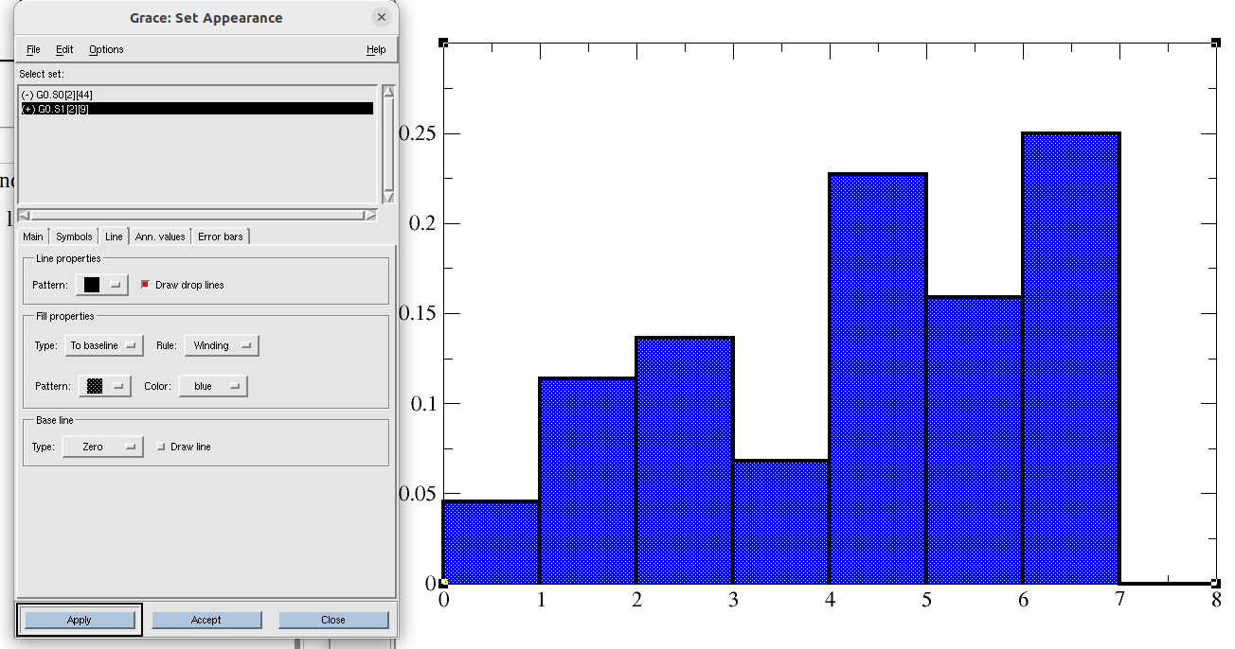

If you want to see y-axis tick values upto a particular decimal point,

plot >> axis properties >> edit (y axis) >> main>> tick properties > format (decimal); precision (2) >> apply

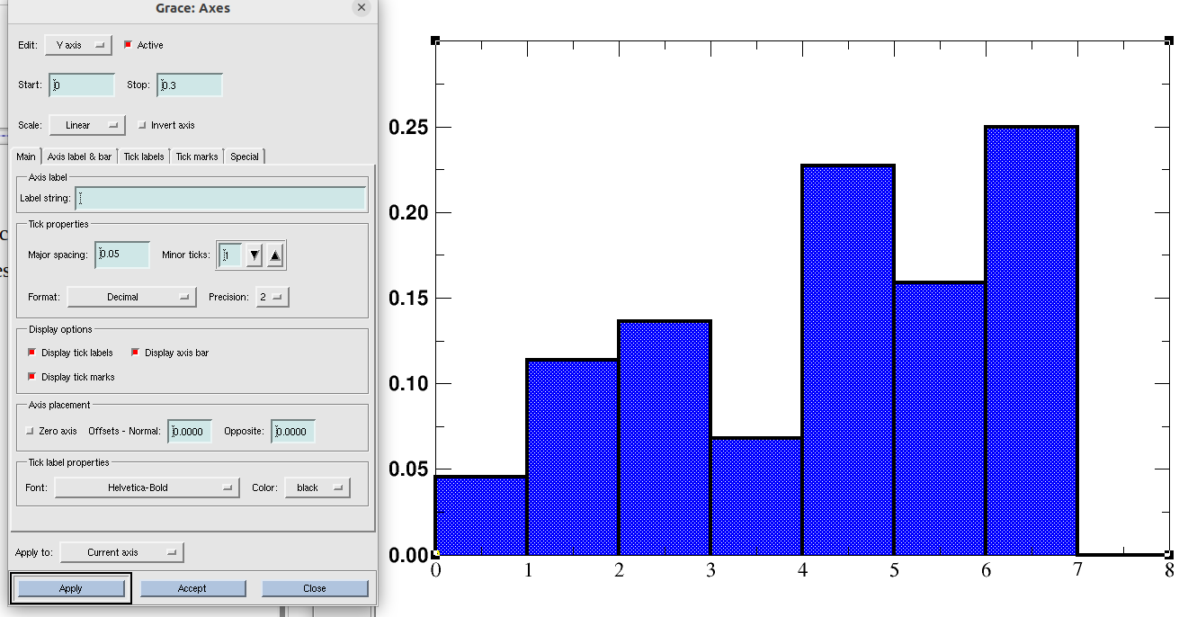

After modifications, final normalized histogram looks like:

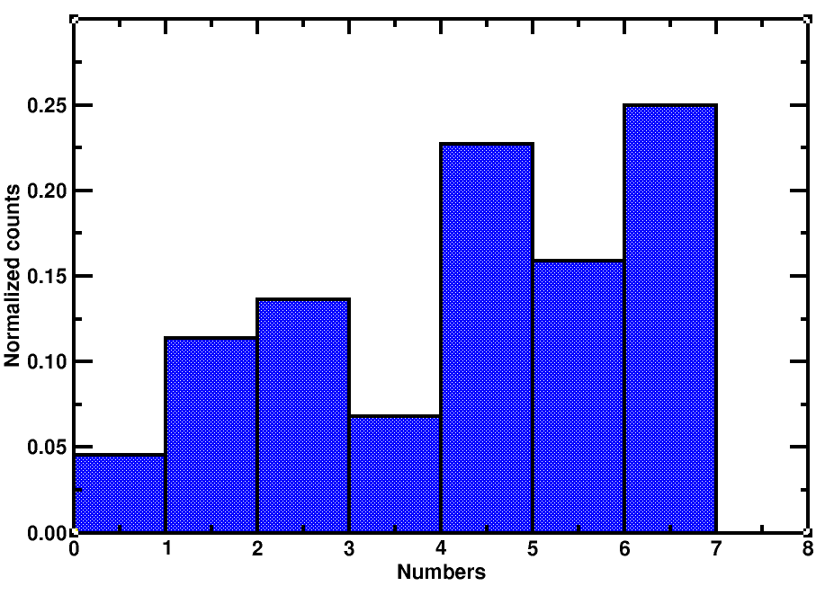

## Tutorial 7: Making overlapping graphs using xmgrace:

We have two data files. One for the previous histogram (i.e, 7_data.txt), another is for parabola (parabola.txt). We will plot the histogram on the top of the parabolic curve.

Write **xmgrace -nxy parabola.txt** in the terminal and press enter.

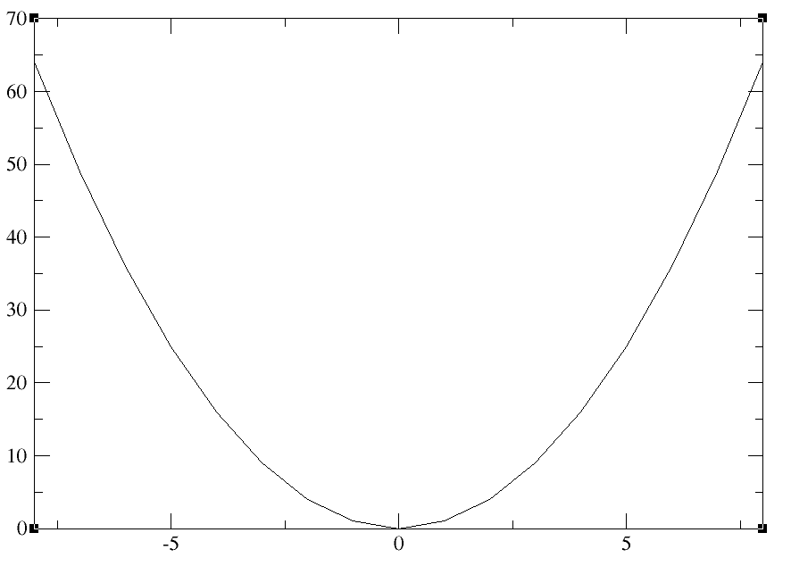

Data>> import >>ascii >> delete *.dat from filter and press enter> select 7_data.txt ; Right click on read to graph > create new > select G1(0 sets) ;Load as (block data) > click ok.

Now, another dialogue box comes. Nothing to change. Click accept.

#{because, 7_data.txt only has one column. So , x and y values will be taken from column 1 only.}

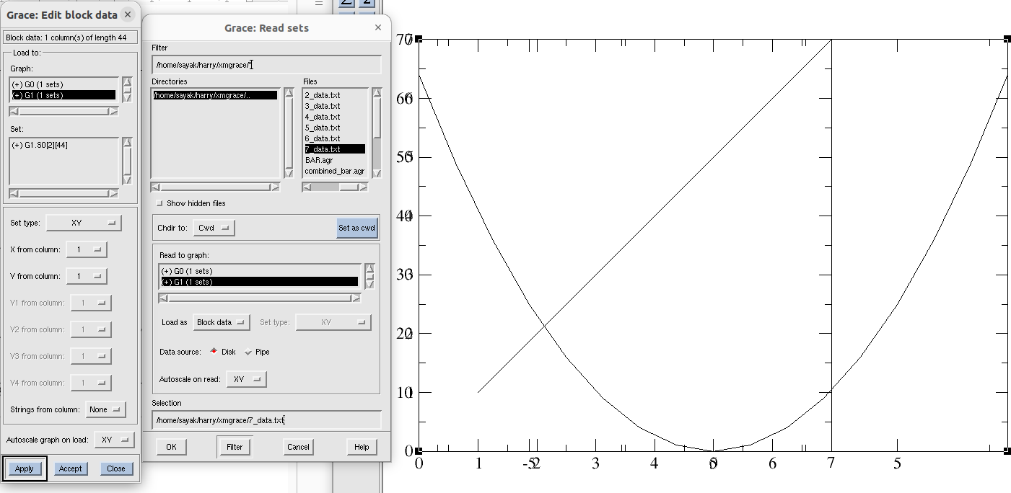

You can see, 1st and 2nd graphs have different width.

Go to edit >> Arrange graphs >> check whether page offsets of both the graphs (G0 and G1) are same. >> click accept.

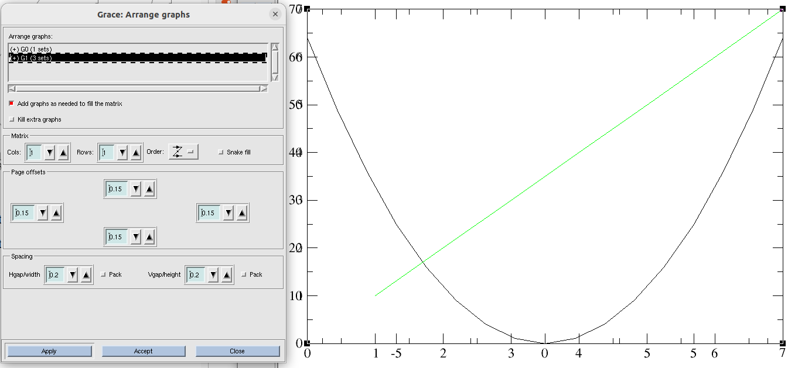

Now we need to make the 2nd plot as histogram.

Data >> transformations >> histogram >> From Source graph’ and ‘destination graph’ select ‘(+) G1(1 sets)’{#As that is our histogram data}; From ‘Source set’ right click on G1 and duplicate it. > Now, from the ‘source set’hide the first G1 ( # because we do not want to see the line graph anymore). Note that, data selection should be hided data of source graph (i.e, -G1.S0[2][44], line graph) and shown data of destination graph( i.e, -G1.S1[2][44], histogram graph). > In this case, lets try without normalizing histogram. Do uncheck ‘normalize’ box. > Start at(0); stop at (8); of bins(8) >> click accept.

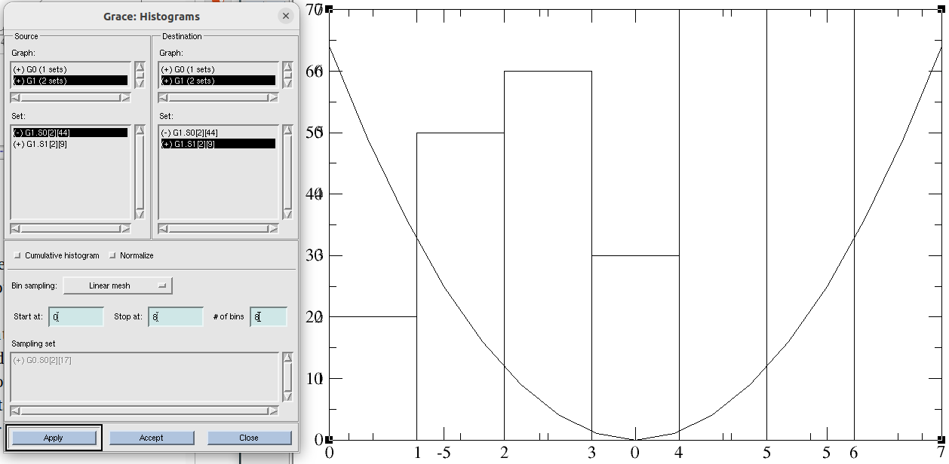

plot > graph appearance >

plot > axis properties >

# {Open this two dialogue box simultaneously. To change axis properties of any of this two graphs you should double click on G0 or G1 from ‘ Graph Appearance’. For details, see next page figure}.

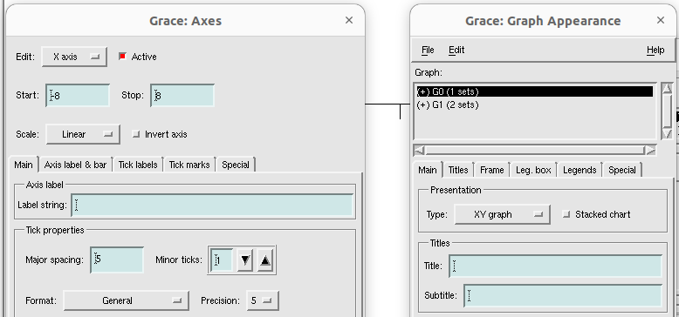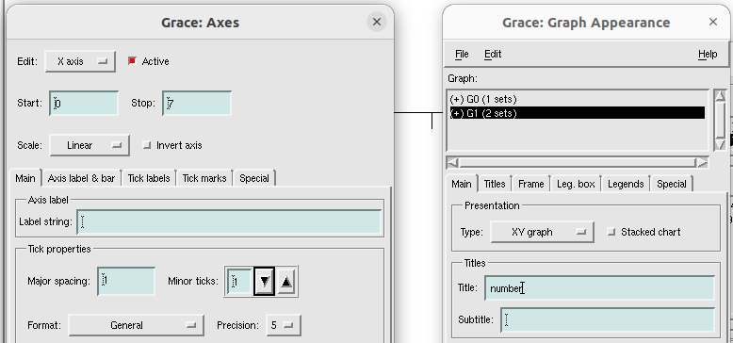

start and stop of x axis for parabola and histogram should have same value, so that they do not overlap. For histogram, change (start 0, stop 7) to (start -8, stop 8). Now:

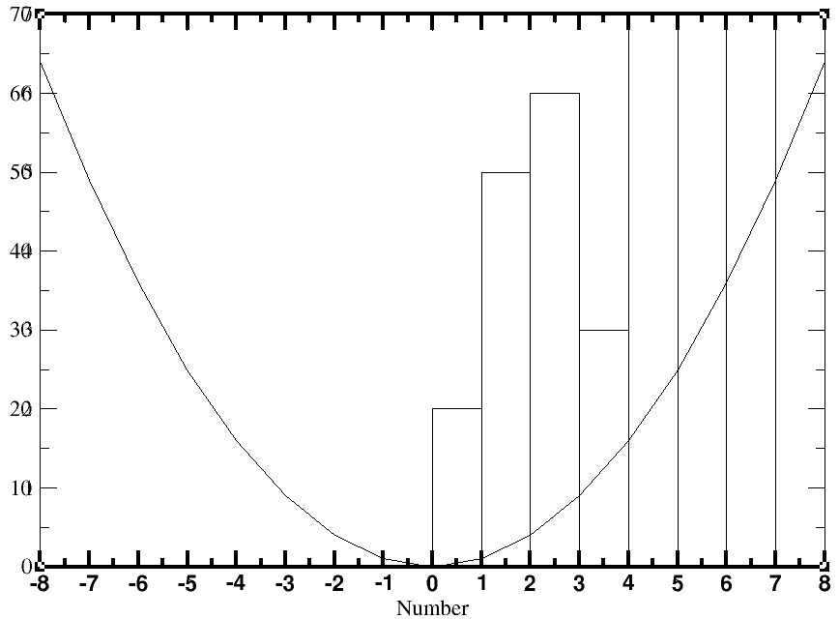

Now we need to resolve the issue of the y axis.

plot > graph appearance >

plot >> axis properties >> edit (y axis)

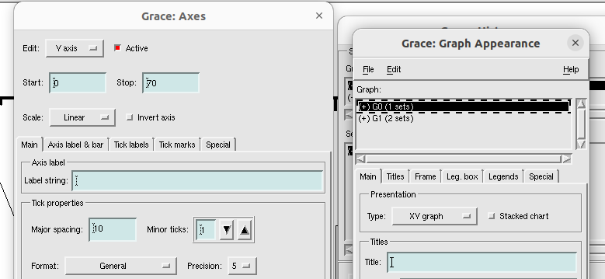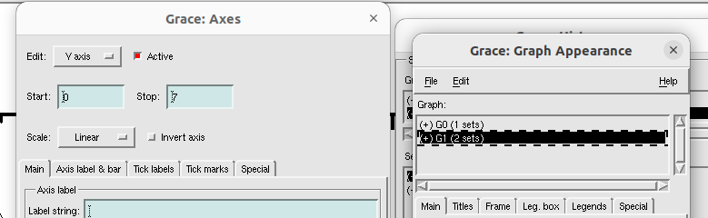

First see, y axis for the histogram is cut and incomplete one. Change the range to ‘start(0); stop(14)’

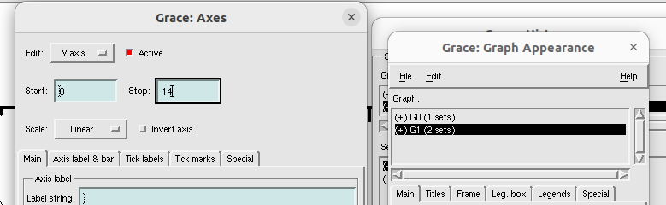 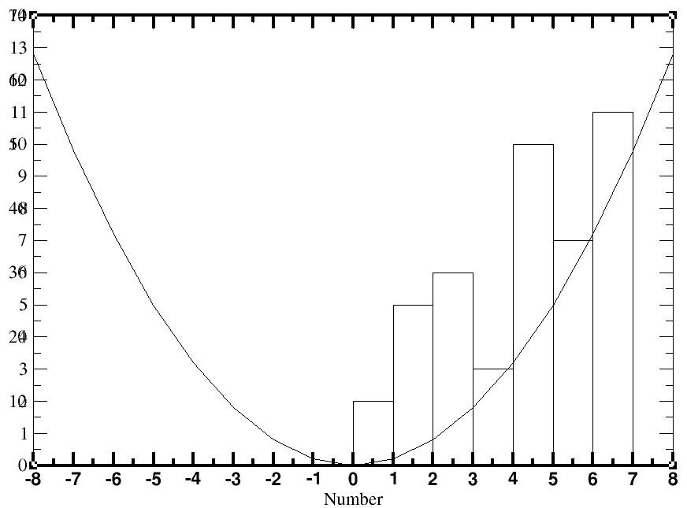

Now, bar graphs look better for histogram bins.

Now, we will use two y axis at left and right for two different graphs. Lets do histogram count at the right side.

From plot >> graph appreaance >> select and double click G1(#because G1 is for histogram data)

then, plot >> axis properties >> edit (y axis) >> **axis label and bar** > **side (opposite) >>** apply

then, plot >> axis properties >> edit (y axis) >> **tick labels >** **side (opposite) >>** apply

then, plot >> axis properties >> edit (y axis) >> **tick marks >** **side (opposite) >>** apply

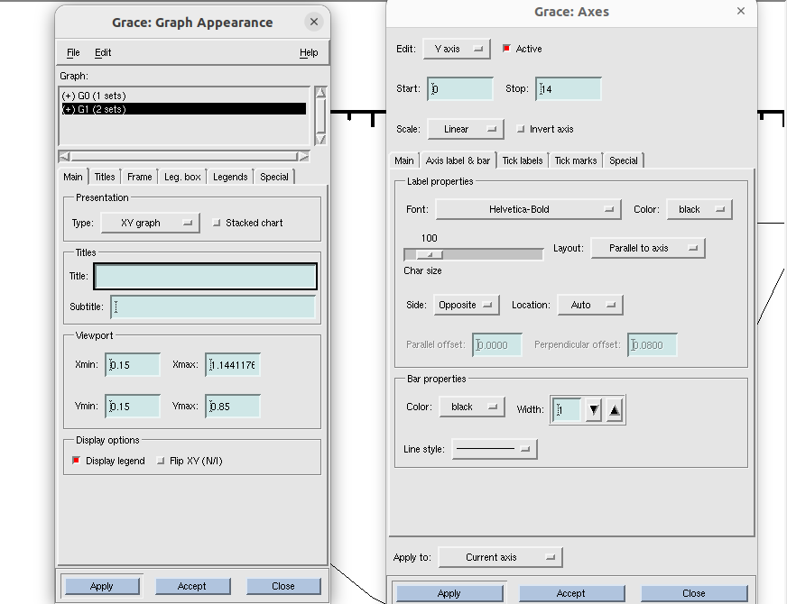

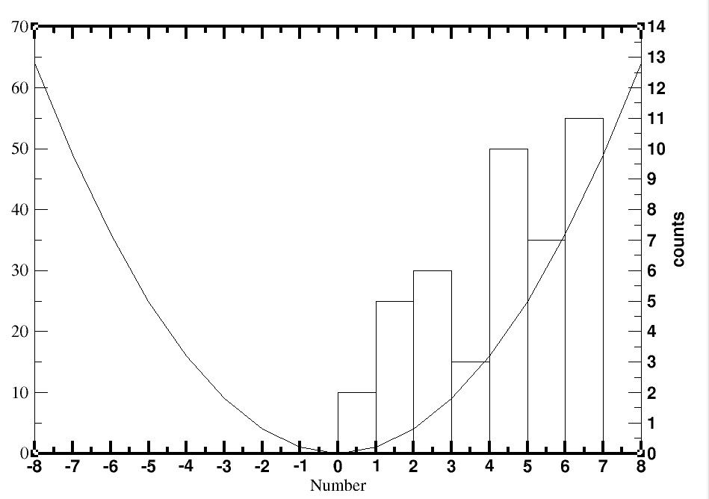

Also, make sure that axis mark and label, tick label, tick marks of parabola’s y axis are on the ‘normal side’.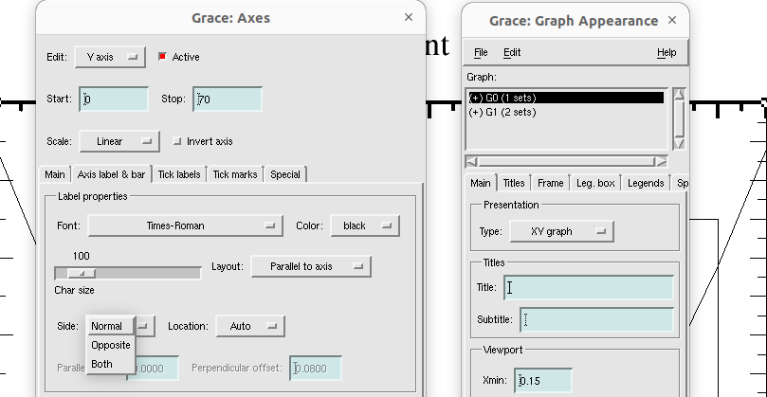

Now, we should have distinguish particular graph for a particular y axis data between the two. In order to do that we use different color code for them.

From plot >> graph appreaance >> select and double click G0(# because G0 is our parabolic data)

Plot >> set appearance >> main >> line properties > color(red)

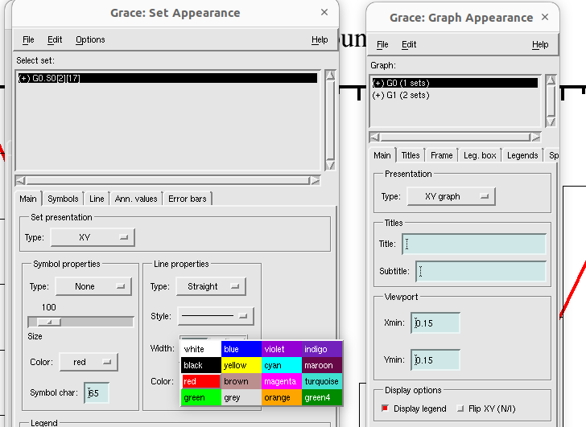

From plot >> graph appreaance >> select and double click +G1

Plot >> set appearance >>select +G1(# because +G1 is our shown histogram data, -G1 is the hidden one ) >> change line and fill properties from ‘main’ and ‘line’ options.

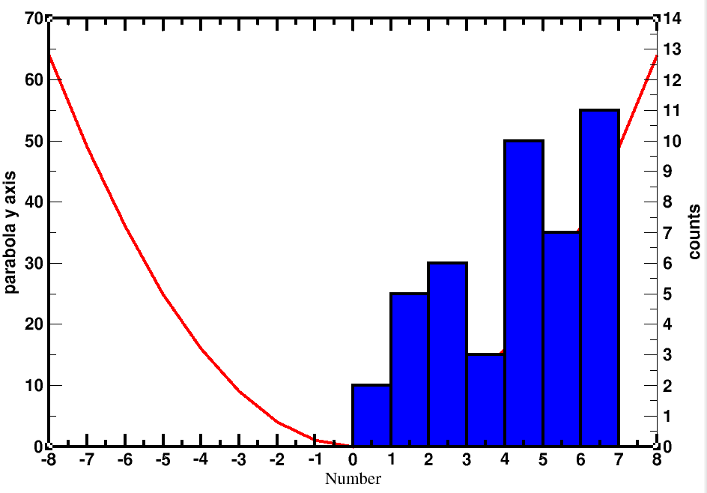

See, here parabola went behind the histogram and became invisible. Because, in graph appearance, G0(parabola) comes before G1(histogram).

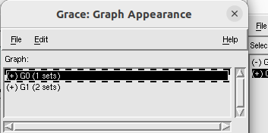

So, go to plot >> graph appearance>> right click on ‘(+)G0(1 sets)’ >>Duplicate >> ‘(+)G2 (1 sets)’ appears >> right click on ‘(+)G0(1 sets)’ and click “kill” >> accept.

Now:

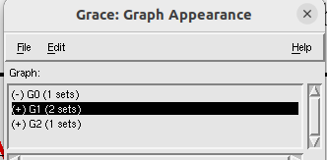

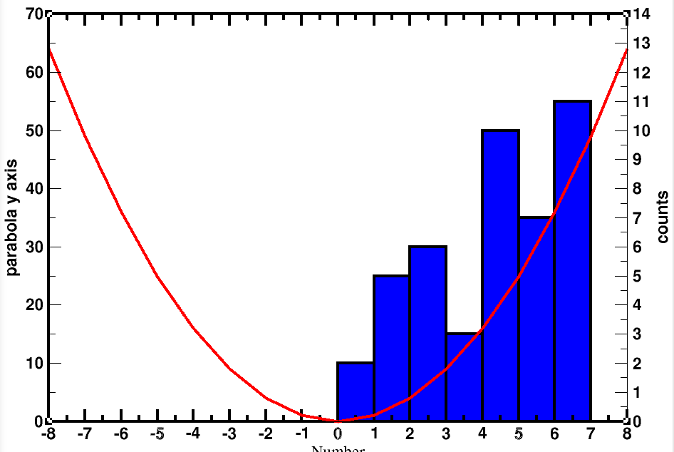

now G2 is our parabola which comes after the histogram (i.e, G1).

.......................................

Now, we need to colour two y axes accordingly.

From plot >> graph appreaance >> select and double click +G1

Plot>> axis properties >> edit (y axis) >> main >> tick label properties (color:blue)

Plot>> axis properties >> edit (y axis) >> Axis label and bar >> label properties (color:blue) >> apply

..........................................................................

From plot >> graph appreaance >> select and double click +G2

Plot>> axis properties >> edit (y axis) >> main >> tick label properties (color:red)

Plot>> axis properties >> edit (y axis) >> Axis label and bar >> label properties (color:red) >> apply.

Finally:

